Using three-dimensional rapid prototyping in the design and development of orthopaedic screws in standardised pull-out tests

LJ Leslie¹, A Connolly², JG Swadener², S Junaid², K Theivendran³, SC Deshmukh³
1 – Aston Institute of Materials Research, School of Engineering & Applied
Science, Aston University, Birmingham, UK.
2 – School of Engineering and Applied Science, Aston University, Birmingham. B4 7ET. UK.
3 – Sandwell and West Birmingham Hospitals NHS Trust, Birmingham. UK.

Corresponding Author:
Dr Laura J Leslie
Aston Institute of Materials Research,
School of Engineering and Applied Science,
Aston University,
Birmingham.
B4 7ET.
Email address: l.j.leslie@Aston.ac.uk
Phone: +44 121 204 3747

Abstract
The majority of orthopaedic screws are designed, tested and manufactured by existing orthopaedics companies and are predominantly developed with healthy bone in mind. The timescales and costs involved in the development of a new screw design, for example for osteoporotic bone, are high. In this study standard wood screws were used to analyse the concept of using 3D printing, or rapid prototyping (RP), as a viable stage of development in the design of a new bone screw. Six wood screws were reverse engineered and printed in polymeric material using Stereolithography. Three of the designs were also printed in Ti6Al4V using Direct Metal Laser Sintering, however these were not of sufficient quality to test further. Both the original metal screws (Metal) and polymeric RP screws (RP) were then tested using standard pull-out tests from low density polyurethane blocks (Sawbones). Results showed the highest pull-out strengths for screws with the longest thread length and the smallest inner diameter. Of the six screw designs tested, five showed no more than a 17 % variance between the Metal and RP results. A similar pattern of results was shown between the screw designs for both the Metal and RP screws in five of the six cases. Whilst not producing fully comparable pull-out results to orthopaedic screws, the results from this study do provide evidence of the potential usefulness and cost effectiveness of RP in the early stages of design and testing of orthopaedic screws.

Key words
Bone Screws, Orthopaedic Materials, Osteoporosis, 3-D printing, Rapid prototyping

Introduction
Orthopaedic screws are used in numerous surgical procedures including fracture fixation, both as a standalone treatment and, more commonly, in conjunction with fixation plates. The efficacy of screws is vital to the success of the fracture fixation.

There have been a number of studies investigating the pull-out strength of various existing screw designs, including both cortical and cancellous (1, 2). These studies have employed a variety of testing substrate including human and non-human animal bone and bone substitutes in the form of polyurethane (PU) foam. Investigations have focussed on the depth or angle of the screw insertion (3) as well as the thread type (3, 4) along with other variables such as pilot hole depth and diameter (5, 6) and insertional torque (7).

A review of clinical findings in 2008 showed that a clear link between osteoporosis and the failure of fracture fixations could not be clearly defined due to the difficulty of measuring and classifying osteoporosis (8). However, studies such as that by Tingart et al. (9) which investigated the holding power of screws in cadaveric humeral heads found a significant effect of bone mineral density on the holding power of screws. A study by Ramaswamy (10) showed the density of the bone to be directly related to the pull-out strength of the screws, with a low density bone resulting in comparatively low pull-out strength. And anecdotal evidence from clinicians certainly points towards a reduced efficacy of standard fracture fixation in osteoporotic bone. Furthermore, poorer quality cortical and cancellous bone also results in low screw torque and higher risk of stripping. In a clinical setting, this is a serious problem, with poor bone health being common amongst older adults. According the National Osteoporosis Society, one in five men and one in two women over the age of fifty will suffer with a fracture as a result of osteoporosis (11).

There are currently very few commercially available fracture fixation devices which are designed for osteoporotic bone, though there have been reports of such (12). In order to improve the pull-out strength of fracture fixation devices, new screws for osteoporotic bone must be developed. However, these studies have been performed using orthopaedic screws already on the market. There exists very little literature describing the results of new or adapted screw designs with the design of orthopaedic screws staying predominantly in the realm of commercial suppliers due to the costs involved. The development and manufacturing process of a new screw design involves significant time and resources, such as specialised machining tools and equipment. Orthopaedic screws are often machined rather than cast and can have a highly specialised design in terms of thread profile and diameters and development can be costly. However further independent research and development is needed to test and validate new screws designed for osteoporotic bone.

3-D printing, or Rapid Prototyping (RP), has been used in medical applications such as maxillofacial reconstruction (13). However, to date there is nothing in the literature to support the use of 3-D printing in the design and development phases of medical devices and fracture fixation components.

RP components can be made using a number of different techniques and materials. The resolution of the prototyped parts can vary greatly depending on the machine, material, step size and orientation. Studies have looked in particular at the orientation of the deposition of material and shown it to make a difference to the finish of the final part (14).

The aim of this study is to analyse the effectiveness of 3-D printing in the design phase of a vital medical product such as the orthopaedic screw, and to optimise the methodology using our in house Stereolithography (SLA) capabilities, which are widely available.

Materials and Methods
Screw design analysis
In order to ascertain the correlation between the testing of metallic and RP screws, several commercially available wood screws were obtained. The choice of screw was based both on availability and similarity in dimensions such as length and diameter to a standard cortical bone screw. Orthopaedic screws were not used due to the availability and high cost of obtaining such screws. However, the screws purchased for this study provide a proof of concept option. The screws were visualised and the dimensions obtained using a Shadowgraph (Nikon 6CT2 Optical Profile Projector Shadowgraph, Nikon UK Ltd., Kingston on Thames, UK). The screw designs were modelled using Solidworks (Dassault Sytemes SolidWorks Corp., Waltham, MA, USA).

3D Printing and Optimisation – Polymer
The screw designs were rapid prototyped using Stereolithography (SLA) on a Viper si2 (3D Systems Europe Ltd, Hertfordshire, UK). A vat of photo-curable polymeric resin Accura (3D Systems Europe Ltd, Hertfordshire, UK), in liquid form, was UV cured layer-by-layer into the shape and orientation specified by the STL file (StereoLithography specific file) from a CAD programme (Solidworks, Dassault Systemes,Waltham, Massachusetts, USA). As part of this process, a series of supports are also cured, to ensure the structure can be built according to the design. The orientation, resolution, size and shape of the specimen determine the positioning of these supports. The position of the supports can impinge upon, and affect, the finish of the printed sample. In order to achieve the highest accuracy and closest finish as possible from the RP process, optimisation of the SLA process was required. This was achieved through the analysis of samples printed at varying orientations (0°, 10°, 20°, 30°, 45° and 90° from the screw shaft to the horizontal), and resolutions (75, 50 and 25 µm), according to the manufacturers settings. Shadowgraphs of samples on one of the screws (design AR) were ascertained after printing at the various orientations.

3D Printing – Metal
Three screw designs were sent for Direct Metal Laser Sintering (DMLS) in metallic materials (Proto Labs, Ltd., Telford, UK). The resolution was 20 µm in Titanium alloy (Ti6Al4V). Due to the high cost of this manufacturing process, only a limited number of designs were printed under one set of parameters.

Pull-out Tests
Pull-out tests were performed to meet section A3 of the ASTM standard for the testing of medical bone screws (15). A rig was designed and built which would allow screws of length 20 mm or longer to be inserted into a block of polyurethane (PU) foam at three revolutions per minute with constant downwards force. A small torque screwdriver was used at a torque of 0.03 Nm to manually provide complete insertion of the last thread of each screw to ensure there was no over tightening and destruction of the threaded Sawbone. Pilot holes were drilled prior to screw insertion that matched the inner diameter of each screw (Table 1). The experimental set-up used to perform the pull-out test is shown in Figure 1. A custom-made rig ensured the bone block and screw could be securely held to the table, whilst the overhead crosshead was used to grip the bracket under the screw head to apply an upwards movement. A Chatillon LTCM-500 (Lloyd Instruments Ltd., Bognor Regis, UK) motorised force tester was used to apply the upwards displacement at 5 mm/min, and a 1,000 N load cell (Applied Measurements Ltd., Aldermaston, UK) was used with a DAQ system (National Instruments, Newbury, UK) in order to obtain and record the maximum pull-out force during each test. A minimum of three screws were tested for each design in each material.

Artificial Bone Blocks
Solid rigid PU foam blocks from Sawbone (Sawbones Inc., Washington, USA) were purchased. Sawbones was chosen due to its compliance with the ASTM standard for PU foam used in the testing of orthopaedic devices (16). Blocks of PCF5 Sawbone (0.08 g/cm³), simulating severely osteoporotic cancellous bone, were used. The blocks were cut to size 60 x 65 mm, with a depth of 40 mm.

Statistical Analysis
Student t-tests were used to analyse the difference between data sets including Metal vs. RP pull-out test results for the same screw design using Microsoft Excel (Microsoft Corporation, Redmond, Washington, USA).

Results
Design Analysis
Six different wood screws were analysed using the Shadowgraph and the dimensions used to create computer models of the designs in Solidworks. The key dimensions for the screws are shown in Table 1. The Shadowgraph images and corresponding CAD models are shown in Figure 2.

Table 1 Dimensions of wood screws and original orthopaedic screw used in testing. Dimensions are provided in mm unless otherwise stated.
Sample Name | Total screw length | Thread length | Outer diameter | Inner diameter | Pitch | Thread angle (°) | Pilot hole diameter (mm)
Ortho | 25.0 | 20.0 | 3.5 | 2.9 | 0.8 | 60 | n/a
B2 | 35.0 | 30.0 | 3.5 | 2.1 | 1.6 | 60 | 2.1
B5 | 25.0 | 20.0 | 3.5 | 2.1 | 1.7 | 60 | 2.1
B8 | 38.0 | 33.0 | 3.5 | 2.2 | 1.5 | 60 | 2.2
AR | 33.0 | 30.5 | 3.5 | 2.3 | 1.5 | 60 | 2.3
N61 | 25.0 | 22.0 | 3.5 | 2.3 | 1.4 | 60 | 2.3
YZ | 25.0 | 20.5 | 3.5 | 2.2 | 1.6 | 60 | 2.2

RP Optimisation and Resultant Prototypes – Polymeric Materials
Two areas for optimisation within the polymeric 3D-printing methodology were orientation and resolution. Of the orientations used, the screw printed at 90° appeared to be the most inaccurate, with very little definition to the screw thread profile (Figure 3). The original metal screw and the 3D printed screw were placed side by side on the Shadowgraph for comparison. Horizontal (0° to the horizontal bed) had a consistent outer diameter of 3.3 mm (original screws were 3.5 mm) and showed the greatest definition around the thread profile. The samples printed vertically (at 90° to the horizontal bed) also showed good definition in the thread angle, however, the thread tips did not form resulting in an outer diameter of only 3.1 mm.

Screws were therefore printed at 0° to the bed for all prototypes. In addition, different resolutions were investigated and the highest resolution (25 µm) was adopted for printing due to the greatest accuracy in printed thread profile.

Photographs were taken using a USB Microscope (RS Components Ltd. Northants, UK) of three of the printed screws aligned with their metal counterparts (Figure 4). Screw length, thread length and pitch appear to match. Thread profile is more difficult to achieve due to the capabilities of the SLA i.e. resolution and therefore layer size (the smaller the layer, the sharper the features which can be printed).

RP Prototypes – Metallic Materials
Three screw designs were printed in Titanium alloy using DMLS. The resultant screws were inspected and deemed not suitable for testing due to the poor resolution of the resultant thread. Images of these screws are shown in Figure 5.

Pull-out Tests
Pull-out tests were performed on six different designs of wood screw, (Table 1), manufactured in metal (various metallic materials) and RP materials (Accura). Results, showing the pull-out forces for each screw designs are shown in Table 2. Screw thread length was the primary factor accounting for differences between screws, which all had the same outer diameter and thread angle.

Table 2 Results from the pull-out tests showing the number of tests performed (n), the mean pull-out strength and the standard deviation (SD) for all samples in both materials.
Material | Metallic |  |  | RP
Sample Name | n | Pull-out strength (N) | SD | n | Pull-out strength (N) | SD
B2 | 5 | 124.7 | 8.7 | 5 | 105.4 | 5.6
B5 | 5 | 73.8 | 6.6 | 5 | 66.1 | 6.1
B8 | 5 | 117.5 | 7.3 | 5 | 97.4 | 7.1
AR | 8 | 98.0 | 22.2 | 5 | 111.5 | 3.4
N61 | 3 | 87.5 | 3.3 | 5 | 57.9 | 2.5
YZ | 3 | 54.8 | 5.4 | 5 | 56.0 | 3.8

The metal screws showed consistently significant higher pull-out strength compared to the polymer RP screws, with the exception of the AR and YZ design, showing the reverse. However, the difference in metal and RP screws for both the AR and YZ designs were not significant. Of the six screw designs tested, five showed no more than a 17 % difference in pull-out strength when using RP screws. The statistical analysis of these relationships is shown in Table 3.

In order to better see the relationship between the metal and RP screws, all results were normalised against the screw with the highest pull-out strength; the B2 design. The normalised results are shown in Figure 6.

Table 3 Statistical analysis of pull-out test results comparing the metal and RP screws
Screw design | Percentage difference between mean results | p-value (Metal vs. RP) | Statistically significant difference
B2 | -16 % | 0.002 | Yes
B5 | -10 % | 0.045 | Yes
B8 | -17 % | 0.001 | Yes
AR | +14 % | 0.105 | No
N61 | -34 % | 0.000 | Yes
YZ | +2 % | 0.358 | No

Discussion
The aim of this study was to evaluate the use of 3D printing in the early stage design and test of bone screws, for particular use in osteoporotic bone. In order to achieve this, six ‘off the shelf’ wood screws with similar dimensions to a standard cortical orthopaedic screw were reverse engineered and 3D printed in polymeric material using an in-house SLA machine and in Titanium alloy using DMLS. The manufacture of these designs in polymeric material was optimised by selecting the highest resolution possible and the most suitable orientation for printing the screw threads. The titanium screws manufactured using the latest metal 3D printing methods were not suitable for further testing due to poor printing resolution (Figure 5).

The pull-out strength of orthopaedic screws has been shown to be affected by the level of osteoporosis in the bone (17) and the density of PU bone block used has been shown to have a significant outcome on pull-out test results (3, 6, 10). The designs were analysed using pull-out tests in PCF 5 Sawbone, the lowest density cancellous bone substitute, in order to closely simulate the properties of severely osteoporotic bone.

The results from the pull-out tests were in line with previous studies (6, 10) with the screws with the longest thread lengths producing the highest pull-out strengths, particularly when coupled with a relatively small inner diameter and/or short pitch. A smaller inner diameter and/or shorter pitch results in a greater surface area of thread to grip onto the bone along the length of the screw. This data agrees with previous studies which have shown that pull-out strength is correlated to implant depth and therefore thread length or number of threads inserted (6, 10).

Of the six designs tested, all but two showed a significant difference between the results from the Metal and RP screws when comparing different designs. However, the pattern of results between the designs remained fairly consistent, with the RP screws producing results different than metal, but in a similar pattern across the designs. The particularly anomalous result for the AR design could be due to a number of factors. The standard deviation for the tests run with the metal screws is large compared to the other screws, this indicates a possible error with the screws themselves, possibly in the finish or tolerances. The use of PCF 5 PU foam, whilst useful for demonstrating the effect in severely osteoporotic bone, does provide its own problem with its delicate and easily damaged nature. With a longer screw, there is more scope for damage of the foam during insertion, which may account for the high variability in data.

A limitation of this study is that the wood screws were made of various materials which may not be representative of the medical grade stainless steel (316L) typically used in orthopaedic screws. The difference in Youngs Modulus of these materials would not be a factor in the tests due to the low strength and stiffness of the bone blocks themselves which were predicted to fail well before the strength of the screws themselves were tested. However, the surface roughness and coating of the materials could have played a factor in the pull-out strength of the metallic screws.

The aim of this research was to evaluate 3D printing as a useful tool in the prototyping of new bone screw designs. Our results show that screw design can be optimised using 3D printing and that basic pullout testing suggests polymeric prototyping is sufficient as a first approximation for design purposes to test the role of changes in design, and that this process can be optimized in the future to produce more accurate results.

Whilst our results show that there is not a perfect correlation between the results obtained when using metal vs. polymer RP screws, the general trend in results is comparable and we believe this does show the usefulness of this approach when comparing screw designs at an early stage. However, without a repeatable correlation between the metal and RP results, there is still work to be done in achieving a perfect substitute for the machining of new bone screw designs.

The time and costs involved in the design, build and test of these designs was relatively low compared to the manufacturing resources required to produce these designs in medical grade stainless steel or titanium alloy through either machining or rapid prototyping. This allows researchers to produce a large array of results from different designs at a relatively early stage of testing, resulting in a smaller number of viable options to take forwards to the more expensive phase of testing. In addition, our experience with metal 3D printing in DMLS showed that this process could not provide the high resolution (compared to commercially available machined screws) in terms of thread quality for smaller designs. This highlights the current limitation of 3D printing in metal.

To date this study is the first to test the biomechanical pullout of polymer RP screws and compare them to their metal counterparts. This proof of concept study has the potential advantage in that RP screws can be used in pre-clinical testing before more expensive methods are employed after refining the designs as a result of iterative RP screw development and this process can be developed further to improve accuracy in results.

The next stage of this testing is to obtain currently used cortical and cancellous bone screws which may be reverse engineered and printed as per the method above. A comparison between the commercially produced metallic bone screws and the polymeric 3D printed screws could then be made in order to further clarify the usefulness of this method in the design phase of bone screw development. In addition, new designs of osteoporotic bone screw will be designed, printed and tested in both polymeric and metallic materials in order to measure for improved pull-out forces in bone blocks and the potential for improved clinical outcomes. In the future, this technique could also be used to prototype bio-degradable screws for some applications.

Conflict of Interest Statement
The Authors declare that there is no conflict of interest.

Acknowledgements
This work was funded by the Birmingham Orthopaedic Charity (BOC) to whom we are sincerely grateful. The authors would like to acknowledge the following placement and project students who worked on various aspects of the project: Katie Lamb, Hanit Bansal, Edward Rhodes, George Heaven and Amarpal Gill. We also acknowledge the technical staff at Aston University who helped with the set-up of the testing equipment and the 3-D printing, including Mr James Duggins and Mr David Palmer.

References
1. Ansell RH, Scales JT. A study of some factors which affect the strength of screws and their insertion and holding power in bone. Journal of Biomechanics. 1968;1(4):279-302.
2. Nunamaker DM, Perren SM. Force measurements in screw fixation. Journal of Biomechanics. 1976;9(11):669-75.
3. Patel PSD, Shepherd DET, Hukins DWL. The effect of screw insertion angle and thread type on the pullout strength of bone screws in normal and osteoporotic cancellous bone models. Medical Engineering & Physics. 2010;32(8):822-8.
4. Gracco A, Giagnorio C, Incerti Parenti S, et al. Effects of thread shape on the pullout strength of miniscrews. American Journal of Orthodontics and Dentofacial Orthopedics. 2012;142(2):186-90.
5. Steeves M, Stone C, Mogaard J, et al. How pilot-hole size affects bone-screw pullout strength in human cadaveric cancellous bone. Journal Canadien De Chirurgie. 2005;48(3):207-12.
6. Wu Z, Nassar SA, Yang X. Pullout performance of self-tapping medical screws. Journal of Biomechanical Engineering. 2011;133(11):111002.
7. Inceoglu S, Ferrara L, McLain RF. Pedicle screw fixation strength: pullout versus insertional torque. The Spine Journal. 2004;4(5):513-8.
8. Goldhahn J, Suhm N, Goldhahn S, et al. Influence of osteoporosis on fracture fixation - a systematic literature review. Osteoporosis International. 2008;19(6):761-72.
9. Tingart MJ, Lehtinen J, Zurakowski D, et al. Proximal humeral fractures: Regional differences in bone mineral density of the humeral head affect the fixation strength of cancellous screws. Journal of Shoulder and Elbow Surgery. 2006;15(5):620-4.
10. Ramaswamy R, Evans S, Kosashvili Y. Holding power of variable pitch screws in osteoporotic, osteopenic and normal bone: are all screws created equal? Injury. 2010;41(2):179-83.
11. NOS. National Osteoporosis Society; 2017 [23/02/2018]. Available from: https://nos.org.uk/.
12. S&N. Evaluation of the Stripping Torque and Pull-out Strength of the PERI-LOC VLP Osteopenia Bone Screw. Presented at the 11th Biennial International Society for Fracture Repair: Smith & Nephew Inc.; 2008.
13. Saijo H, Igawa K, Kanno Y, et al. Maxillofacial reconstruction using custom-made artificial bones fabricated by inkjet printing technology. Journal of Artificial Organs. 2009;12(3):200-5.
14. Singhal SK, Pandey AP, Pandey PM, et al. Optimum Part Deposition Orientation in Stereolithography. Computer-Aided Design and Applications. 2005;2(1-4):319-28.
15. ASTM. F543 − 13 Standard Specification and Test Methods for Metallic Medical Bone Screws. ASTM International; 2013.
16. ASTM. F1839 - 01 Standard Specification for Rigid Polyurethane Foam for Use as a Standard Material for Testing Orthopaedic Devices and Instruments. ASTM International; 2002.
17. Zindrick MR, Wiltse LL, Widell EH, et al. A Biomechanical Study of Intrapeduncular Screw Fixation in the Lumbosacral Spine. Clinical Orthopaedics and Related Research. 1986;203:99-112.

Figures
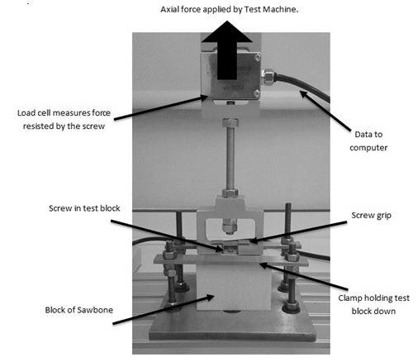
Figure 1 Experimental set-up for the pull-out tests to meet the requirements of the ASTM standard for pull-out testing of orthopaedic screws.

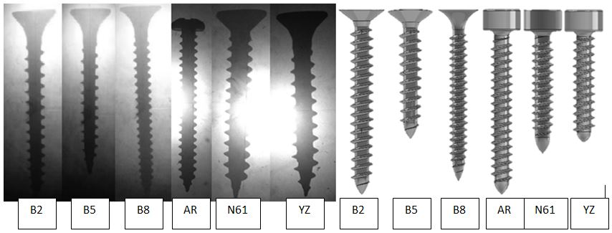
Figure 2 (a) Shadowgraphs and (b) CAD models for the wood screws examined. From left to right: B2, B5, B8, AR, N61, YZ. Note that in some cases the shape of the head was altered to ensure correct gripping and positioning during pull-out tests.

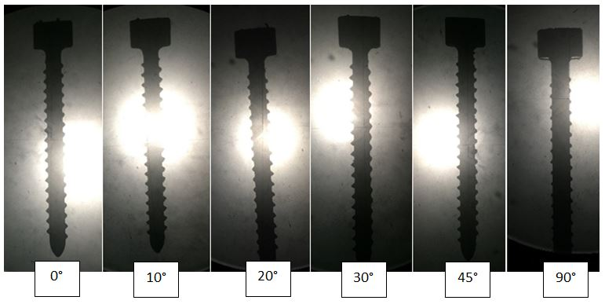
Figure 3 Shadowgraphs of the AR screw printed, from left to right, at 0°, 10°, 20°, 30°, 45° and 90° from the screw shaft to the horizontal bed.

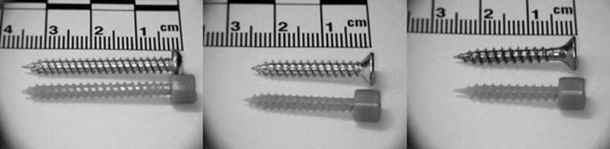
Figure 4 Images of three of the screws obtained by RP methods positioned alongside their metal counterparts. From left to right: AR, N61, YZ. The screw heads were altered to provide a suitable gripping platform during pull-out tests.

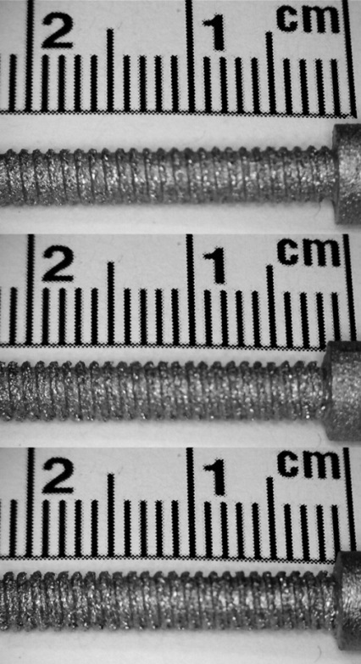
Figure 5 Images of the rapid prototyped metallic screws showing lack of resolution in the thread profiles. These screws were not suitable for pull-out testing.

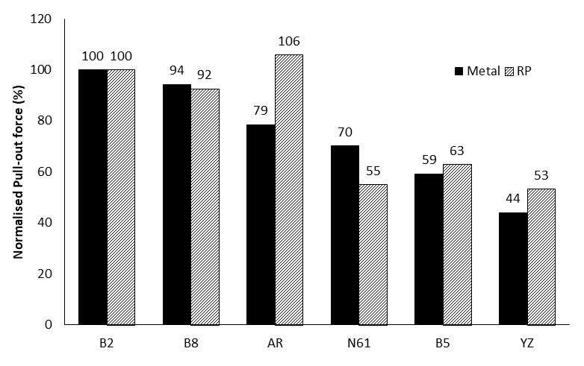
Figure 6 Mean pull-out test results in PCF5 Sawbone with results normalised against screw B2, the screw with the highest pull-out strength. Results show both the Metal and RP screw values. n≥ 3.

