Efficient Long - Range Electron Transfer Processes in Polyfluorene – Perylene Diimide Blends
Anna Isakova,¹ Safakath Karuthedath,² Thomas Arnold,³ Jonathan R. Howse,⁴ Paul D. Topham,⁵ Daniel T. W. Toolan,⁶* Frederic Laquai,² Larry Luer¹*
- Madrid Institute for Advanced Studies, IMDEA Nanoscience, Calle Faraday 9, Campus Cantoblanco, 28049 Madrid, Spain.
- King Abdullah University of Science and Technology (KAUST), KAUST Solar Center (KSC), Physical Sciences and Engineering Division (PSE), Material Science and Engineering Program (MSE), Thuwal 23955-6900, Saudi Arabia.
- Diamond Light Source Ltd., Harwell Science and Innovation Campus, Didcot OX11 0DE, U.K.
- Department of Chemical and Biological Engineering, University of Sheffield, Sheffield. S1 3JD. U.K.
- Aston Institute of Materials Research, Aston University, Birmingham, B4 7ET, U.K.
- Department of Chemistry, Dainton Building, University of Sheffield, Sheffield, S3 7HF, U.K.
* Corresponding authors: d.toolan@sheffield.ac.uk; larry.luer@imdea.org.
Abstract
In bulk heterojunction donor-acceptor (D-A) blends, high photovoltaic yields require charge carrier separation to outcompete geminate recombination. Recently, evidence for long-range electron transfer mechanisms has been presented, avoiding strongly-bound interfacial charge transfer (CT) states. However, due to the lack of specific optical probes at the D-A interface, a detailed quantification of the long-range processes has not been feasible, until now. Here, we present a transient absorption study of long-range processes in a unique phase consisting of perylene diimide (PDI) crystals intercalated with polyflourene (PFO), as widely used non-fullerene electron acceptor and donor, respectively. The intercalated PDI:PFO phase possesses specific well-separated spectral features for the excited states at the D-A interface. By use of femtosecond spectroscopy we reveal the excitation dynamics in this blend. PDI excitons undergo a clear symmetry-breaking charge separation in the PDI bulk, which occurs within several hundred femtoseconds, thus outcompeting excimer formation, known to limit charge separation yields when PDI is used as an acceptor. In contrast, PFO excitons are dissociated with very high yields in a one-step long-range process, enabled by large delocalization of the PFO exciton wavefunction. Moreover, both scenarios circumvent the formation of strongly-bound interfacial CT states and enable a targeted interfacial design for bulk heterojunction blends with near unity charge separation yields.

Introduction
Organic photovoltaic devices (OPVs) have unique properties that facilitate their use in specific applications: light weight, flexibility, ease of installation & integration, and a tunable transparency window.^{1–4} Readily fabricated by high-throughput roll-to-roll deposition at low cost, current devices can boast power conversion efficiencies of more than 10% combined with good (photo)stability.^{5–8} The most effective single layer systems are so-called bulk-heterojunction (BHJ) devices, in which the active layer is essentially a blend of donor (D) and acceptor (A) materials, which form interconnected domains. Careful morphology optimization is required to obtain the best compromise between efficient exciton dissociation (requiring a large interfacial area) and charge transport (requiring continuous percolation pathways).^{9–11} The most widely used acceptor material is [6,6]-phenyl-C61-butyric acid methyl ester (PCBM), a fullerene derivative that readily forms BHJs with donor polymers, induces ultrafast charge separation, and can act as triplet quencher protecting the BHJ from premature photodegradation.¹² However, low light absorption in the visible range and high electron affinity of PCBM tend to limit the external quantum yields and the open circuit voltage, respectively, of the devices, which triggered research into non-fullerene acceptors in recent years.^{13–15}
Efficient formation of free charges from photogenerated bound exciton states is one of the main requirements for high performance BHJ OPV. Intense research efforts have been directed towards unambiguously detecting the nature of the intermediate, namely a spatially correlated charge transfer (CT) state across the D-A interface.¹⁶ The observation of delocalized CT states^{16,17} and quantum coherence¹⁸ has explained rapid charge separation at room temperature, which would be inhibited from a localized nearest neighbour CT state across the interface due to its high Coulomb binding energy. Furthermore, a long-range charge transfer mechanism, mediated by tunnelling, has been proposed,¹⁹ leading directly to separated charges without passing through a bound CT state. Indeed, femtosecond Raman studies of the BHJ blend PCDTBT:PC₇₀BM showed the absence of a bound CT state.²⁰ In order to gain detailed insight into long-range electron transfer, specific optical probes for neutral and charged excited states at the D-A interface are needed in order to distinguish between bulk and interfacial states.
Here, we present a transient absorption study of a blend consisting of poly(9,9-di-n-octylfluorenyl-2,7-diyl) (PFO) as donor and a perylene diimide (PDI) derivative as non-fullerene acceptor (for chemical structures see Fig. 1a). Derivatives of PDI are among the most intensely investigated non-fullerene acceptors because of their strong light absorption in the visible region and their high structural and chemical stability.¹³ Efficiencies of OPV devices comprising PDI so far remain below their predicted heights, which has in part been attributed to excimer formation competing with charge separation.^{21,22} In our work we show that when blended with PFO, excimer formation in PDI is outperformed by a symmetry breaking charge transfer within the PDI phase.
Structural determination by grazing incidence wide angle scattering (GIWAXS) indicates a formation of unique morphology comprising agglomerated PDI crystals, intercalated with β-phase PFO. In such morphology, excitons and charged states at the interface have specific optical signatures that are distinct from those in the respective bulk phases. These allow us to directly probe the exciton dissociation dynamics at the D-A interface. When resonantly exciting the PDI phase, clear evidence for a two-step transfer mechanism is revealed, by which a symmetry breaking charge separated state is formed in the PDI phase, followed by a hole transfer across the D-A interface. This novel mechanism avoids formation of a bound interfacial CT state, which makes it a candidate for highly efficient exciton dissociation in BHJ systems.

Experimental details
PFO was purchased from Ossila, PDI was synthesized as described elsewhere.²³ The films were deposited from 2 wt.% xylene solution at 1:3 ratio of PDI to PFO. PFO has shown to be poorly soluble in xylene, so solutions were heated to 80 °C and deposited from hot solution by doctor blading at different blade speeds, as shown in the Supporting Information. The PDI reference was deposited as a blend with polystyrene of 3:1 PS:PDI ratio. Polystyrene was chosen as a photophysically inert polymer matrix that enabled processing conditions of the PDI to be similar to those in the PDI:PFO blend, whilst omitting the strongly interacting species. Due to significantly lower viscosities and therefore higher evaporation rates, blade-coating without a matrix polymer species generated highly inhomogeneous PDI crystals due to the deeper quench through the phase diagram. GIWAXS data (see ESI, part I) confirmed that PDI:PS blend had the same features as pure PDI crystals, however, allowed less scattering and thus much better transient absorption signal. For absorbance studies nanocrystals were obtained by dissolving PDI in 1 part of toluene and mixing it with 99 parts acetone (by volume); solution studies were done in toluene.
Fluorescence microscopy images where taken using a Nikon Eclipse episcopic microscope under either fluorescence (UV2A beamcube) or crossed polarised illumination conditions, utilising a Nikon x10 objective coupled with a Cannon EOS camera (field of view: 208.8 x 150 μm). Absorbance measurements were performed using a Cary 5000 (Varian) ultraviolet-visibile (UV–Vis) spectrometer. Fluorescence measurements were performed using Varian Cary Eclipse fluorometer. Grazing Incidence Wide Angle Scattering (GIWAXS) was performed on I07 (λ = 0.992 Å, using a Pilatus 2M 1475 × 1679 pixel detector with pixel size 172 μm)²⁴ at the Diamond Light Source, Rutherford, UK. The maximum resolution (scattering vector, q max) of the detector was determined as q_{xy} = 35.6 nm^{–1} and q_{z} = 40.5 nm^{–1} using a silver behenate standard.
Transient absorption (TA) spectroscopy was carried out using a home-built pump-probe setup. Two different configurations of the setup were used for either short delay, namely 100 fs to 8 ns experiments, or long delay, namely 1 ns to 300 μs delays, as described below:
The output of a titanium:sapphire amplifier (Coherent LEGEND DUO, 4.5 mJ, 3 kHz, 100 fs) was split into three beams (2 mJ, 1 mJ, and 1.5 mJ). Two of them were used to separately pump two optical parametric amplifiers (OPA) (Light Conversion TOPAS Prime). The TOPAS 1 generates tunable pump pulses, while the TOPAS 2 generates signal (1300 nm) and idler (2000 nm) only. For measuring TA across the whole visible range, the 1300 nm (signal) of TOPAS 2 was used to produce a white-light super continuum from 350 to 1100 nm. For short delay TA measurements, the TOPAS 1 was used for producing pump pulses while the probe pathway length to the sample was kept constant at approximately 5 meters between the output of the TOPAS1 and the sample. The pump pathway length was varied between 5.12 and 2.6 m with a broadband retroreflector mounted on automated mechanical delay stage (Newport linear stage IMS600CCHA controlled by a Newport XPS motion controller), thereby generating delays between pump and probe from -400 ps to 8 ns.
For the 1 ns to 300 μs delay (long delay) TA measurement, the same probe white-light supercontinuum as for the 100 fs to 8 ns delays was used. The excitation light (pump pulse) was provided by an actively Q-switched Nd:YVO4 laser (InnoLas picolo AOT) frequency-doubled (tripled) to provide pulses at 532 nm (355 nm), and triggered by an electronic delay generator (Stanford Research Systems DG535), itself triggered by the TTL sync from the Legend DUO, allowing control of the delay between pump and probe with a jitter of roughly 100 ps.
Pump and probe beams were focused on the sample with the aid of proper optics. The transmitted fraction of the white light was guided to a custom-made prism spectrograph (Entwicklungsbüro Stresing) where it was dispersed by a prism onto a 512 pixel NMOS linear image sensor (Hamamatsu S8381-512). The probe pulse repetition rate was 3 kHz, while the excitation pulses were mechanically chopped to 1.5 kHz (100 fs to 8 ns delays) or directly generated at 1.5 kHz (1 ns to 300 μs delays), while the detector array was read out at 3 kHz. Adjacent diode readings corresponding to the transmission of the sample after excitation and in the absence of an excitation pulse were used to calculate ΔT/T. Measurements were averaged over several thousand shots to obtain a good signal-to-noise ratio.

Results and discussion
In Fig. 1b, the ground state absorption (GSA) spectra are shown for the blend and for pure PFO films (blue lines), deposited at different blade speeds to ensure that higher shearing force produces more ordered films. Both the blend and the higher blade speed PFO films show contributions from the glassy phase of PFO, causing a broad absorption band around 3.2 eV, and a sharp feature at 2.85 eV exhibiting vibronic progression, ascribed to the so-called β-phase, highly organised regions of PFO chains.²⁵ In this phase, the strong vibronic structuring is explained by intermolecular interaction, reducing the torsional mobility towards a more planar structure with extended conjugation;^{26,27} the concomitant anisotropic polarizability in such an ordered structure is expected to cause an additional red shift, as in the related case of regio-regular P3HT films.^{28,29} Additional bands in the PDI:PFO GSA spectrum at 2.35 and 2.55 eV are due to PDI and are analysed in the next section. The GSA spectral features in the range 2.75 - 3.5 eV are due to the lowest energetic S₀-S₁ absorption of PFO.
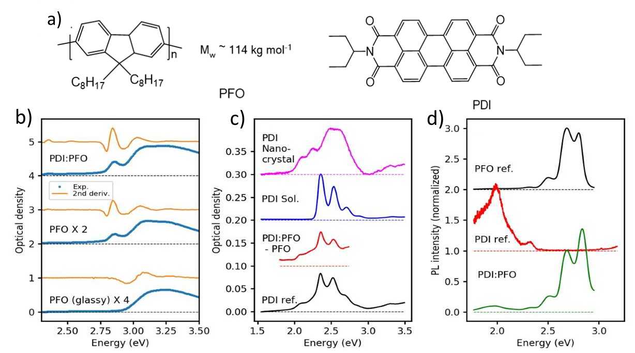
Figure 1. a) Chemical structures of PFO and PDI used in this study. b) Absorption spectra and their inverted second derivatives (blue and orange, respectively) of pure glassy PFO, PFO containing β-phase (deposited at a higher blade speed), and PDI:PFO. c) Absorption spectrum of PDI in PS (black line); scaled PDI:PFO spectrum after subtraction of PFO spectrum (containing β phase and glassy phase) and spectra of PDI solution in toluene and PDI nanocrystals (blue and pink curves, respectively). d) Photoluminescence spectra of PFO and PDI reference films, and of PDI:PFO (black, red and green lines, respectively). The curves are vertically shifted for clarity, with the baseline in all cases given by a thin dashed line of same colour.
Orange curves in Fig.1b are inverted second derivatives of the GSA spectra, increasing band separation and thus highlighting vibronic structures. For the samples containing the β-phase, we find a clear vibronic progression with the (0-1) vibronic transition at 3.05 eV, offset against the (0-0) transition of the β-phase by about 0.2 eV. In contrast, the PFO sample containing only the glassy phase shows a single maximum at 3.08 eV in the second derivative spectrum, which can be considered as the strongly disordered (0-0) transition of the glassy phase, given the fact that the (0-0) transition of PL from the glassy phase is at 2.93 eV.²⁹
In Fig. 1c, we compare the residual PDI:PFO spectrum after subtraction of PFO absorption to a PDI reference film. They show very similar spectral features in the region of 2.0-2.5 eV, namely sharp vibronic progressions at 2.35, 2.55, and 2.65 eV, which agrees with the GSA spectrum of PDI in toluene solution (blue curve), and an unstructured broader absorption around 2.1 eV caused by face-to face dimers of PDI molecules, matching the red part of a PDI nanocrystal (pink line, Figure 1c). From this, we conclude that the PDI crystal in the intercalated PDI:PFO phase does not lead to a significant change in π – π interaction between monomers. For both the PDI reference and the blends, the ratio of the (0-1) and the (0-0) transition is significantly below the value of 1.61 found in toluene solution, demonstrating significant H-type excitonic coupling between the monomers.³⁰
Photoluminescence (PL) spectra of the samples are shown in Fig. 1d. The PL spectrum of pure PFO (deposited at 30 mm s⁻¹ blade speed, black curve) shows a (0-0) vibronic transition at 2.85 eV, followed by a vibronic progression with an energetic offset of 0.18 eV between the vibronic transitions. Due to reabsorption of the emitted PL at the absorption edge, the (0-0) transition at 2.85 eV is significantly narrowed compared to the other vibronic transitions. The PL spectrum of the PDI:PS film (red curve in Fig. 1d) shows a broad band at 2.0 eV characteristic of excimer emission.³⁰ A small secondary band at 2.35 eV was assigned to PL from the excited state of the monomer.
The PL spectrum of the blend (Fig. 1d) exhibits features of the PL spectra of both PFO and PDI:PS, from which one can conclude that: (i) the quenching of PFO excitons by PDI does not occur with 100% efficiency, (ii) one pathway for the quenching of PFO excitons is excitation energy transfer towards PDI, and (iii) there is no significant contribution of the PL of the intercalated PDI:PFO phase, such as emission from an interfacial charge transfer state. The yields of these quenching processes were not quantified here. We note, however, that the absence of CT emission is in agreement with a lifetime of the charge-separated state extending to several microseconds (see ESI, part H).
Indeed, the fluorescence microscopy image (following excitation at 370 nm) of PDI:PFO films shows mixed blue and red emission from both components (Fig. 2a). The blend consists of similarly shaped dendritic crystals, 400-500 µm long, with which show some spatial correlation of emission: while the PDI excimer emission is more visible in the origin of the dendrites, the blue PFO emission becomes relatively stronger in its branches. However, there is significant PDI emission even in the regions dominated by PFO emission allowing us to study photoexcitation dynamics occurring on the nanoscale between PFO and PDI. At the same time, the pure PDI film (Fig.2b) consists of non-homogenously distributed well-defined dendritic crystals with homogeneous red excimer emission.
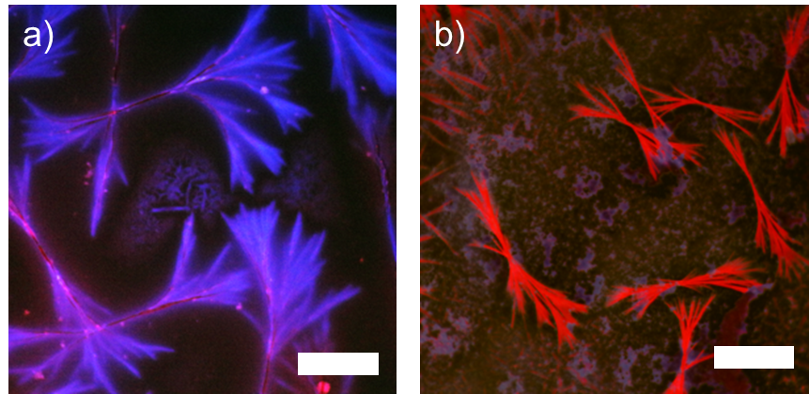
Figure 2. Fluorescence microscopy images of the PDI:PFO blend (a) and pure PDI reference film (a) and. Scale bar is equal to 200 µm.
In order to evaluate the morphology and interactions between the PDI and PFO components within the blend with a large amount of agglomerated crystals, we conducted GIWAXS measurements (Fig. 3). The pattern of the blend film is significantly different from the scattering pattern of the PDI, although a single peak of the original PDI pattern is observed at q= 3.8 nm⁻¹, indicating that regular PDI crystals are also present. Additional peaks at 3.5 nm⁻¹ and 6.23 nm⁻¹ cannot be attributed to crystallization of PDI alone and are therefore a result of interaction of PDI with PFO. The d spacing of the first order peak in the blend film is slightly higher (d=17.7 Å compared to 16.6 Å), reflecting an increased tilting angle between the PDI stacks.³¹ Furthermore, the peak originating from PFO β-phase contributions to the scattering pattern of the blend is pronounced at q = 5.05 nm⁻¹.^{27,32,33} As shown in the 2D GIWAXS images (Fig. 3a), PFO features exist both as parallel, and as perpendicular to the stacks of PDI. The morphology of the crystalline structures observed in the PDI:PFO blend likely consists of agglomerated PDI crystals intercalated with a PFO β-phase that are able to organise into much larger scale features that thus possess mixed blue and red emission arising from contributions of both components. For simplicity, this phase will subsequently be referred to as the intercalated PDI:PFO phase, with a tentative model for the organisation of components in this phase shown in Fig. 3c, where the intimate interplay between the PDI and PFO side chains is the driving force for reorganisation of PDI molecules into a more ‘relaxed’ state. Scattering components are distributed within the amorphous PFO matrix, which is not detectable by GIWAXS, but by steady-state UV-Vis absorption spectroscopy (discussed before).
To assess the size of single crystalline domains, the crystal correlation length (CCL) was calculated according to the Scherrer equation^{21,34} (ignoring instrumental resolution) for the ‘original’ PDI structure (at 3.8 nm⁻¹) the ‘relaxed’ PDI structure (3.5 nm⁻¹) for the blend (Fig.3c). The CCL for the ‘original’ PDI in the reference films were 60 nm, whereas it decreased to 26 nm in the blend. The ‘relaxed’ PDI crystal length was 38 nm. Applying the calculations to the first order peak of β-PFO in the blends yielded an approximate length of PFO ordered regions of 14 nm.
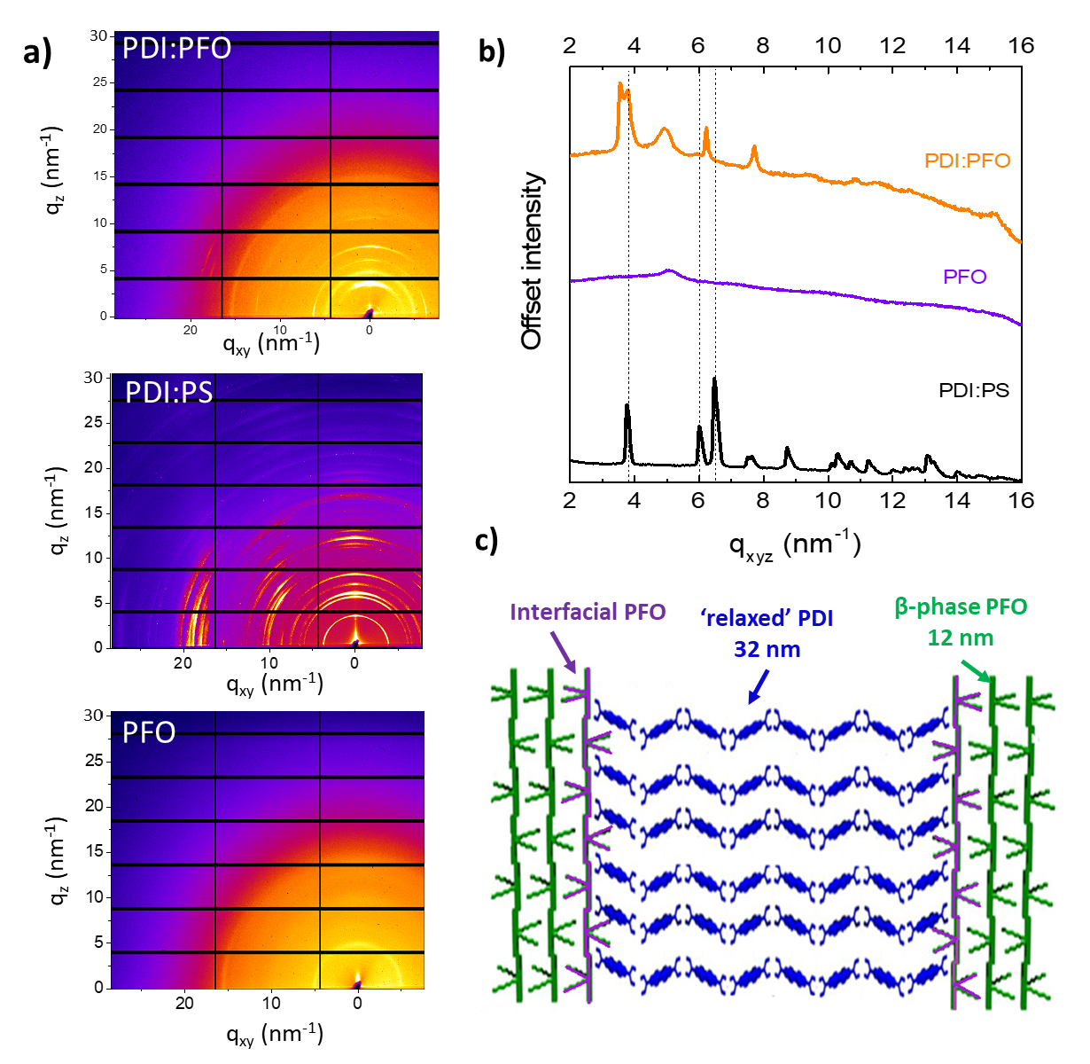
Figure 3. a) 2D GIWAXS images of PDI:PFO blend, PDI:PS and PFO films. b) 1D radially integrated GIWAXS of PDI:PFO (orange), PDI:PS reference (black) and PFO reference (purple). c) Tentative model proposed for the organisation of components within the intercalated PDI:PFO phase.

In order to elucidate the actual photoexcitation dynamics in neat films and blends, femtosecond transient absorption (TA) spectroscopy experiments were performed. According to Fig. 1b, either the PFO or PDI phases can be selectively excited at 370 nm or 520 nm, respectively. In Fig. 4, TA spectra of neat PFO and a PDI:PFO blend are shown (symbols in panels a and b, respectively) after exciting selectively the PFO phase at 370 nm. For pump-probe delay times t < 1ps, the spectra of the neat film and the blend are virtually identical, confirming the exclusive excitation of PFO (black symbols in Figure 4b and a, respectively). In the near-infrared (NIR) spectral region, a broad and strong positive band is observed at 1.55 eV, which was assigned to photoinduced absorption (PA) from the singlet exciton S₁ to higher-lying singlet states.^{35–37} Henceforth, the optical probes of PFO and PDI are distinguished by the suffixes “D” and “A”, as in these blends the components play the role of electron donors and acceptors, respectively; singlet and charged states are symbolized by the capital letters S and C, respectively. The β phase of PFO is labelled “β”, while the glassy phase is labeled “g”. The band at 1.55 eV, assigned to singlet excited state absorption in the donor phase, thus attains the label S_{D}.
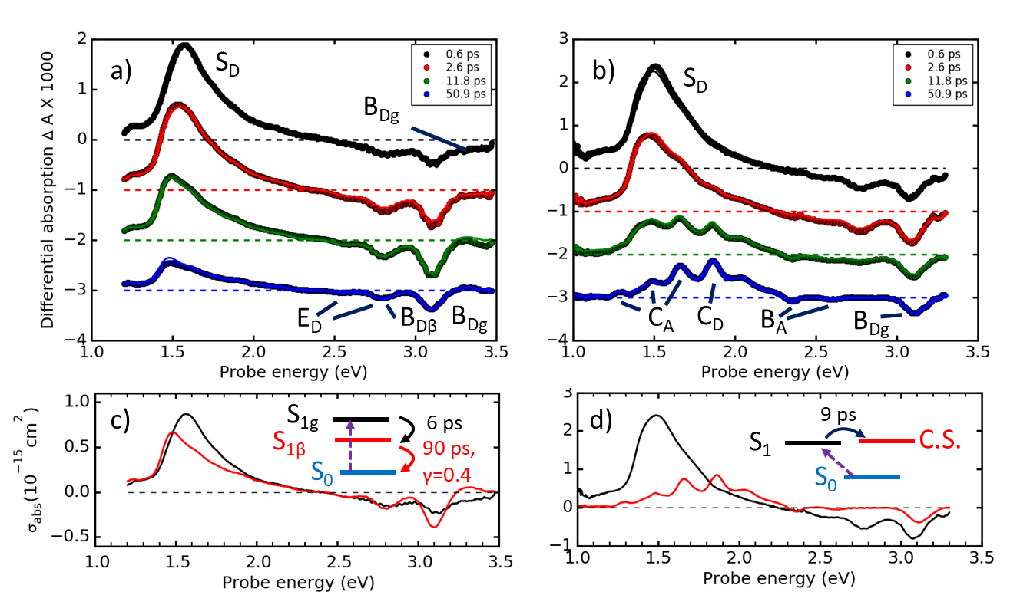
Figure 4. Transient absorption (TA) spectra after pumping at 370 nm with 150 fs pulses (main absorption of PFO) in pure PFO and the blend PDI:PFO (symbols in panel a and b, respectively). Solid lines in panels a) and b) are global fits according to a target analysis using the model given in panel c) and d), respectively. Panels c) and d) show the characteristic spectra, resulting from the target analysis, in the same color as the corresponding states in the target model. Dispersive kinetics has been assumed if the value for the dispersive parameter γ is given; otherwise time-independent rate constants have been assumed. The dashed arrow gives action of the pump pulse. “C.S.” denotes a charge separated state in the intercalated PDI:PFO phase.
In the blue and ultraviolet (UV) spectral region of Fig. 4a, a group of bands was observed with formally negative TA. The band at 3.1 eV coincides with the maximum of the second derivative of the glassy phase PFO in Fig. 1b and is therefore assigned to transient ground state bleach (B_{Dg}), while the band at 2.8 eV coincides with the (0-0) transition of the ordered β-phase, and is therefore assigned to a superposition of B_{Dβ} and stimulated emission (E_{Dβ}). The S_{D} band shows a clear red shift with a time constant of 6 ps; on the same time scale, we observe a loss of the broad B_{Dg} bleach contribution and a slight build-up of the β-phase signal. Since the pump pulse is centered at 3.25 eV, predominantly exciting the glassy phase, the observations are in agreement with excitation energy migration from the glassy phase into the β-phase.³⁸
After spectral relaxation, there is no further spectral evolution, demonstrating that in pristine PFO, singlet excitons remain the dominant photoexcited states, and no further states, such as triplets or polarons, are produced on a picosecond time scale. Singlet exciton decay in PFO can be described by a dispersive law which is a typical scenario in a disordered polymer phase, in which singlet excitons are quenched by defects encountered during exciton diffusion.^{39,40} These findings are confirmed by a target analysis utilizing a two-state sequential model as shown in Fig. 4c, resulting in characteristic spectra for singlet excitons in PFO immediately after excitation and after relaxation and energy migration (“S_{1g}” and “S_{1β}” in Fig. 4c, respectively).
The formation of the intercalated PDI:PFO phase significantly changes the characteristics of the optical probes, as well as the deactivation scenario (comparing Figures 4b and 4a). On a 5-10 ps time scale, both S_{D} and B_{Dβ} are fully quenched, following a slightly stretched exponential decay law, giving rise to a series of new bands in the NIR and visible spectral region. The sharp and structured C_{A} bands at 1.3 and 1.5 eV have been assigned to excited state absorptions specific for PDI(-) anions,^{41,42} while a further sharp band at 1.7 eV is seen both in PDI singlet states and anions.^{43–45} In Fig. 4b, these features are denoted by C_{A}. By comparison with the PDI GSA spectrum, the negative bands at 2.35 and 2.6 eV were assigned to bleach bands B_{A}.
The absence of the known PDI cationic PA bands at 2.2 and 2.4 eV gives evidence against a possible formation of charge pairs in the PDI phase and suggests that the counter charge resides in the PFO phase. This is confirmed by the presence of bleach B_{g} even after hundreds of nanoseconds when all specific optical probes for singlet states in PFO have disappeared (see ESI, part H).
The sharp PA band at 1.85 eV (C_{D}) is unknown in the literature and cannot be assigned to pristine PFO or PDI. Polarons in PFO are known to produce a broad PA band in the region around 2.3 eV, strongly overlapping with SE.³⁶ The target analysis in Fig. 4d shows that this band is formed with the same kinetics as the PDI anionic features and the disappearance of the PFO singlet exciton (see Fig. 4d: the band at 1.85 eV is present only in the red spectrum but not in the black one). The target analysis in Fig. 4d also shows clear evolution of the bands in the PB region: while the singlet excited state shows a PB of both β and glassy phases, the charge separated state shows one single PB band that matches exactly the position of the second derivative of the glassy phase in Fig.1b, bottom, orange line. It is known that a second derivative of a band occurs at the same spectral position but with strongly reduced bandwidth.⁴⁶ We can therefore conclude that the sharp PB at 3.1 eV should originate from a region with reduced energetic disorder as compared to the glassy phase but lacking the highly anisotropic polarizability of the β-phase.²⁹ It is plausible to assign this region to the interfacial layer between PFO and PDI: the presence of PDI nanocrystallites will cause a reduction of torsional freedom of the PFO chains, explaining the reduced bandwidth, while at the same time disrupting the order of the bulk of the β-phase, explaining the absence of a strong red-shift. Considering that the PA band at 1.85 eV is unique to our PDI:PFO blend, we can therefore assign the PA at 1.85 eV and the PB at 3.1 eV to positively charged PFO chains inside or at the surface of the intercalated PDI:PFO phase. Our material therefore gives us the unique opportunity to specifically address charge carrier dynamics and the corresponding interconversion processes at the interface between donor and acceptor and to correlate them with the known arrangement of donor and acceptor molecules.
The target analysis (for details see ESI, part F) shows that the dynamics of charge separation after excitation of bulk PFO can be described by a first order reaction of 9 ps lifetime with slight dispersive contributions, leading to so-called “stretched exponential” decay dynamics. There is no parasitic quenching process of any significance, as can be assessed by comparing the absolute values of the absorption cross-sections of the PDI anion features in Fig. 4d and 5d, respectively; suppression of a parallel relaxation process in the target model of Fig. 4d, if present, would lead to an underestimation of the charge cross-sections, which is not the case. On the same footing, we can exclude the contribution of singlet fission.⁴⁷ We therefore conclude that although PFO emission can be clearly observed in PL spectra in Fig.1d, the vast majority of PFO excitons is converted into charge-separated states within 9 ps. In the ESI, Fig. S9, we estimate that about 10% of the initial exciton population is still available 30 ps after excitation, thus justifying the PFO emission in the blends in Fig. 1d.
The slight dispersive contribution to the charge separation dynamics mentioned above, can in principle be a sign of diffusion control. Therefore, we estimated how strongly exciton diffusion can contribute to the observed dynamics. Based on the known exciton diffusion constant in PFO,⁴⁸ one can estimate the average concentration of quenchers (the PDI crystallites in this case) to justify the observed exciton population decay. We found (for details see ESI, part D) that the necessary quencher concentration is so high that each single PDI crystallite would have to be unrealistically small. We therefore discard exciton diffusion as dominant process. Exciton diffusion can be responsible for the residual exciton dynamics on a tens of picoseconds time scale (ESI, Fig. S9). The vast majority of PFO excitons in PDI:PFO blends is however dissociated in a one-step process, which considering its high yield must reach deep into the PFO bulk. Such long-range transfer mechanisms have recently attracted theoretical attention,¹⁹ suggesting that in the case of extended wavefunction delocalization, tunnelling processes can become significant yielding attenuation factors below 0.2 nm⁻¹. Very recently, tunnelling has been shown to enable charge transport below the percolative threshold.⁴⁹ The tunnelling rate has been related to the peripheral logarithmic slope of the exciton wavefunction and thus to the extension of the excitonic wavefunction.²⁰
Using TA spectroscopy, the extension of the excitonic wavefunction can be estimated by comparing the cross-section of the photobleach of the exciton to the ground state absorption cross-section per monomer $L_{exc}≈σ_{exc}/σ_{m}$in the phase space filling (PSF) picture.^{50,51} The full procedure is given in the ESI. Extension of the wavefunction over at least 11 monomers was found for pure PFO (18 for the blends, respectively). The fact that the exciton wavefunction extension is nearly double in the blends compared to the pure PFO, agrees with the stronger contribution of the ordered β-phase in the blends thus demonstrating that it is disorder limited. We highlight the difference between the exciton wavefunction extension and the electron-hole correlation length, the so-called “exciton size”, in the “collective electronic oscillator” (CEO) model.⁵² The exciton size is typically much smaller than the exciton wavefunction extension. It is possible to conclude that a wavefunction extension approaching 15 nm (considering an effective length of 0.85 nm per fluorene unit) can explain long-range transfer of PFO bulk excitons into charge-separated states
This justifies the absence of diffusional kinetics. It further allows a direct comparison of the charge transfer rates of our system with those of the prototypical photovoltaic blend, P3HT:PCBM. In this latter material, part of the exciton dissociation occurs on a sub-100 fs time scale⁵³ which has been explained by a coherent mechanism.¹⁸ In our material, exciton dissociation occurs nearly two orders of magnitude slower. In the framework of Marcus theory, the electron transfer rate essentially depends on the Gibbs free energy change, the reorganization energy, and on the electronic coupling between initial and final state. Based on our GIWAXS data in Fig. 3, it was suggested that in the intercalated PDI:PFO phase, the molecular planes of PDI and PFO are oriented nearly perpendicularly with respect to each other. This orientation should significantly reduce the electronic coupling with respect to an alignment of strong π-π interaction as in P3HT-PCBM, thus justifying the slow exciton dissociation rate in our case.
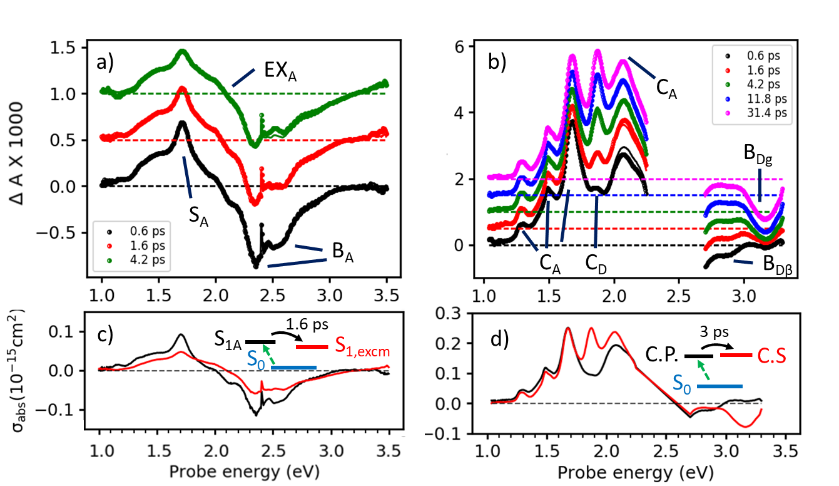
Figure 5. Transient absorption (TA) spectra after pumping at 520 nm with 150 fs pulses (main absorption of PDI) in pure PDI and the blend PDI: PFO (symbols in panel A and B, respectively). Solid lines in panels a) and b) are global fits according to a target analysis using the model given in panel c) and d), respectively. Panels c) and d) show the characteristic spectra, as resulting from the target analysis, in the same color as the corresponding states in the target model. “C.P.” means charge pair in the PDI phase while “C.S.” denotes charge-separated state in the intercalated PDI:PFO phase.
In Figure 5, the TA spectra are shown for pristine PDI and the blend after selectively exciting the PDI phase at 520 nm (symbols in Fig. 5a and b, respectively). In pure PDI (Fig. 5a), the initial photoexcitation is described by the S_{A} band at 1.7 eV, residing on top of a broad background. Apart from an overall loss of 50% of the signal within a few ps, there is very little spectral evolution on the femtosecond and picosecond time domain. The target analysis (Fig. 5c, for details see ESI, part F) shows that there is a first order process with 1.6 ps lifetime, resulting in a significant reduction of the S_{A} band and a displacement of the broad PA background towards higher probe energies. Both spectral shapes and evolution are very similar to the results obtained on a symmetric dyad of PDI.⁵⁴ The S_{A} band was assigned to excited state absorption for a monomeric singlet state in PDI, while the broad PA around 2.1 eV was assigned to formation of a PDI excimer, here labelled EX_{A}.^{55,56}
From the fact that about half of the oscillator strength in both PA and PB regions is lost in the final state (compare black and red curves in Fig. 5c), we can conclude that the excimer wavefunction must be significantly more localized than the excitonic one; otherwise the PB features would be retained during exciton formation. By comparing the PB cross-section to the one from GSA of the same transition, we find a strong delocalization of the exciton wavefunction over about 25 PDI molecules (see ESI, part B). It can thus be concluded that about half of the initially delocalized excitons localize into excimers within 1.6 ps. A small tail in the experimental TA dynamics (see ESI, part B), not rendered by the one step target model in Fig. 5c, might be caused by diffusive motion of further excitons towards pre-dimer sites.⁵⁷
If the same experiment is performed on the PDI:PFO blends, radically different TA spectra are obtained even in the femtosecond time domain (compare Fig. 5b and 5a, respectively). Optical probes for PDI anions (C_{A}) dominate the TA spectra at time scales as early as 600 fs after the excitation pulse. The relatively sharp PA band at 2.05 eV, shown in Fig. 5b,d, does not arise from excimers but is also a feature of charge separated states on PDI.⁴² This shows the formation of charged states in the PDI:PFO blends on a femtosecond time scale. However, the corresponding optical probe for the PFO cations is hardly visible after 600 fs; a target analysis shows that it builds up from zero with a 3 ps rate constant with first order kinetics (compare red and black curves in Fig. 5d around 1.85 eV). Concomitantly, a build-up of the B_{Dg} band is observed with the same kinetics. Although one cannot observe the PDI cation bands located at 2.3 eV, due to scattering of the pump pulse, the delayed build-up of PFO specific probes for charged states provides sufficient evidence to ascribe the first characteristic spectrum in Fig. 5d to a charge pair in the PDI phase. In a second step, holes are transferred from the PDI to the PFO within the intercalated PDI:PFO phase in a first order reaction of 3 ps lifetime. An alternative mechanism, namely dissociation of excimer states, was excluded due to the following reasons: excimer dissociation would lead to an increase of the PDI anion bands at 1.3 and 1.5 eV. However, when comparing the black and the red spectra in Fig. 5d, we find only a slight reduction of the background underneath the C_{A} bands, while these bands themselves do not change their strength during the process. Therefore, the process under discussion is creating charges in the PFO phase, while not changing the density of anions in the PDI phase, leaving a hole transfer to PFO as the only consistent explanation. Finally, the observed one-step kinetics and the exclusive encounter of optical probes from charged states allows us to exclude singlet fission as a possible competing pathway after resonant excitation of PDI, in agreement with literature results.⁴⁷
Why does the presence of PFO induce such a two-step mechanism involving the intermediate formation of charge pairs in the PDI phase, rather than causing exciton dissociation at the D-A interface? To address this question, the first few hundred femtoseconds of photoexcitation dynamics were resolved. As shown in the ESI, part G, there is evidence for a delayed process with about 400 fs delay time in both the pristine PDI film and the blends. In pristine PDI, this delayed process produces a symmetric charge transfer state that later evolves into an excimer. In the blends however, the delayed process is described by the build-up of the anion specific features C_{A}. The presence of the PFO therefore causes the formation of a symmetry breaking CT-state inside the PDI phase. It is known that in PDI in the gas phase, the lowest CT state has an energy which is only slightly larger than the lowest neutral state.⁵⁸ Based on this notion, Bellinger et al have studied theoretically the influence of a polarizing medium on the energetic ordering of CT versus neutral states in PDI dimers, finding a geometric symmetry breaking (molecules adopting an M⁺M⁻ geometry) to be a prerequisite for bringing the CT state below the neutral state.⁵⁹ Such symmetry breaking might be induced in the vicinity of a strong donor like PFO, inducing a partial ground state charge transfer $D^{δ+}A^{δ-}A^{δδ-}$, breaking the symmetry between an interfacial acceptor molecule and one in the next outer shell. While this scenario seems plausible, Bellinger et al highlight that their study disregards anisotropy in the polarization, which might have significant effects in the solid state. Recently, a symmetry breaking charge transfer has been observed in a PDI foldamer, whereby a polar solvent was able to stabilize the symmetry breaking state better than the symmetric CT state.⁴² Here, for the first time the stabilization of a symmetry breaking state is observed in a condensed phase by interaction with a PFO moiety in close proximity in the intercalated PDI:PFO phase.
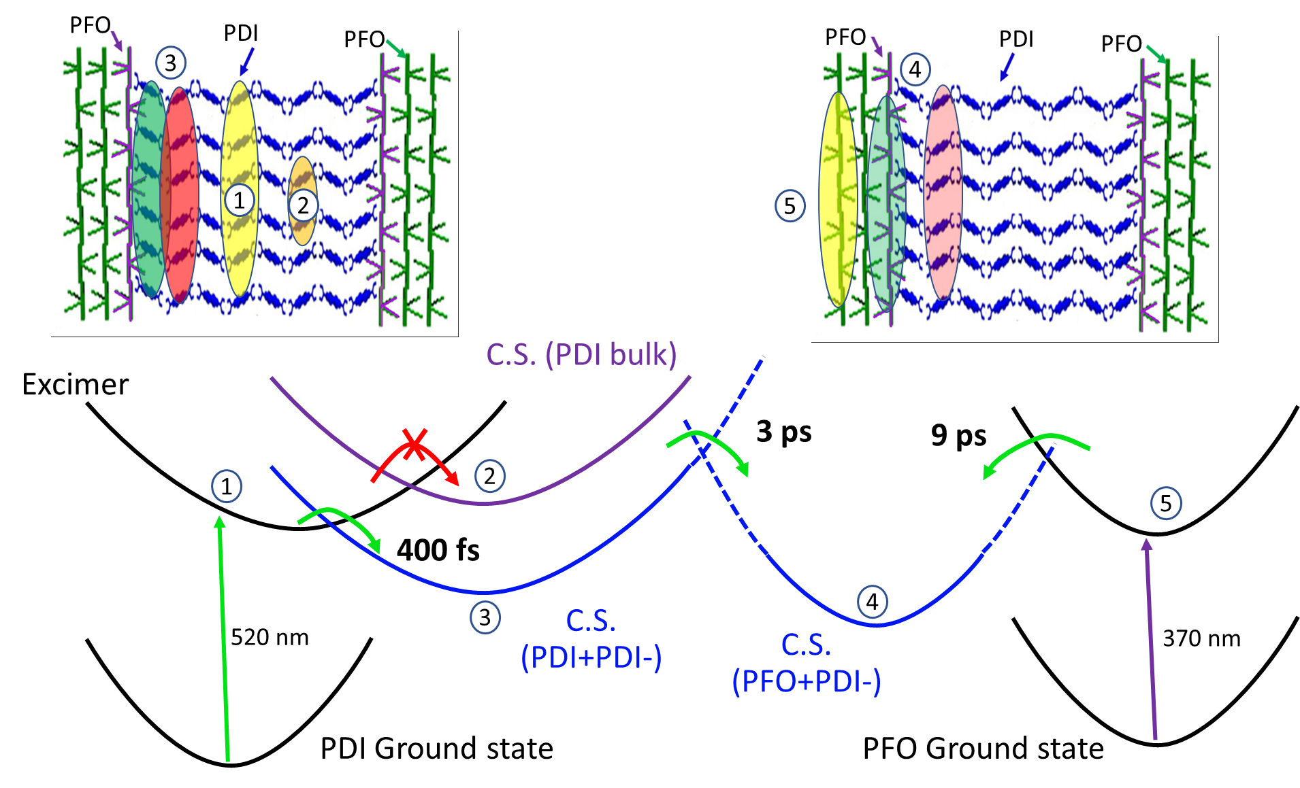
Scheme 1: Proposed photophysical model for ultrafast symmetry breaking charge transfer in PDI within the intercalated PDI:PFO phase. Dashed lines: weak coupling between the respective potential surfaces. In the top part, graphical representations are given for various points along the trajectory (blue: PDI; green: PFO and purple: PFO at the phase interface, respectively). Potential energy surfaces: (1) delocalized neutral excited PDI, excimer in minimum; (2) Symmetry breaking C.S state in bulk PDI, not accessible at room temperature; (3) Symmetry breaking C.S. state close to PFO interface; (4) C.S state across interface, microsecond lifetime, (5) PFO exciton.
Our results highlight the critical importance of polarizability effects between donor and acceptor systems. They are always present and control equilibria and transfer rates to a large extent, but very rarely can they be observed specifically as in our example. To our knowledge, this is the first direct demonstration of the formation of a symmetry breaking CT state close to the D-A interface, prior to the formation of the charge-separated state across the interface. As highlighted by Bellinger et al, such symmetry breaking is facilitated by the fact that in PDI, the CT state is energetically close to the neutral state.
Importantly, in the PDI:PFO blend, this symmetry breaking charge transfer occurs in a few hundred femtoseconds, outcompeting the formation of excimers. Excimer formation is a known process, competing with charge separation in many PDI derivatives used as non-fullerene acceptors.^{13, 21} Excimer formation can be suppressed by bulky substituents inhibiting co-facial alignment. This approach, however, conflicts with the need for high charge mobilities for efficient extraction. In our work, we show that even a PDI derivative that shows excimer formation in the pristine case, can show efficient charge separation through symmetry breaking charge transfer close to the D-A interface. These results suggest that PDI derivatives, when used as non-fullerene acceptors, don’t have to be designed to avoid excimer formation (as this approach tends to reduce charge mobility) but instead be optimized in conjunction with the electron donor material to produce the symmetry breaking charge transfer that we describe. On a more general level, the charge transfer mechanisms shown in this work – starting from excitons in both the PDI and PFO phase - lead to weakly bound charge separated states with potentially higher charge extraction yields. Our studies therefore encourage investigating this mechanism in a broader range of materials that are featured for D-A systems. Symmetry breaking charge transfer states in the phase that is mostly responsible for light absorption, might be used as a targeted strategy to overcome V_{OC} losses in organic photovoltaics, being the most important drawback compared to perovskite solar cells.^{60–65}

Conclusions
In this study, PDI:PFO intercalating blends exhibited unique specific optical probes for charge separated states, studied by TA. The crucial transfer processes occurring at the D-A interface include a long-range exciton dissociation mechanism, as observed from the experimental determination of the exciton wavefunction extension, approaching 20 monomer units in ordered PFO in the phase space filling picture. Further, a sub-picosecond branching of PDI excitons into excimers and symmetry-breaking charge transfer states occur, which is extremely sensitive to the local environment. In the presence of PFO, exclusively charge pairs are formed, which transfer subsequently the hole to the PFO phase. Both, long-range transfer and symmetry-breaking charge transfer result in non-nearest neighbour charge transfer states with reduced Coulomb coupling and therefore increased separation rates. This study confirms that donor-acceptor systems employing symmetry-breaking charge transfer have a potential to overcome existing charge separation limitations to achieve high charge yields in BHJ OPVs.
Conflicts of interest
No conflicts of interest to declare.
Acknowledgments
AI thanks the EC for a Marie Curie fellowship of the FP7 ITN “POCAONTAS”, Project No. 316633; International Engagement Fund of SuperSolar Hub and Diamond Light Source for providing beam time (SI16697-1). DTWT acknowledges support from the EPSRC IAA Early Career Research scheme. LL acknowledges support from the 'Severo Ochoa' Programme for Centres of Excellence in R&D (MINECO, Grant SEV-2016-0686), from the MINECO-FEDER project MultiCrom, CTQ2014-58801 and the MINECO-FEDER project OptoCT, CTQ2017-87054. The research reported in this publication was supported by funding from King Abdullah University of Science and Technology (KAUST).

References
1 P. Kumar and S. Chand, Prog. Photovoltaics Res. Appl., 2012, 20, 377–415.
2 S. a. Gevorgyan, M. V. Madsen, H. F. Dam, M. Jørgensen, C. J. Fell, K. F. Anderson, B. C. Duck, A. Mescheloff, E. a. Katz, A. Elschner, R. Roesch, H. Hoppe, M. Hermenau, M. Riede and F. C. Krebs, Sol. Energy Mater. Sol. Cells, 2013, 116, 187–196.
3 C. Lungenschmied, G. Dennler, H. Neugebauer, S. N. Sariciftci, M. Glatthaar, T. Meyer and A. Meyer, Sol. Energy Mater. Sol. Cells, 2007, 91, 379–384.
4 P. P. Boix, K. Nonomura, N. Mathews and S. G. Mhaisalkar, Mater. Today, 2014, 17, 16–23.
5 T. Goh, J. Huang, K. G. Yager, M. Y. Sfeir, C. Nam, X. Tong, L. M. Guard, P. R. Melvin, F. Antonio and B. G. Bartolome, Adv. Energy Mater.
6 N. Gasparini, L. Lucera, M. Salvador, M. Prosa, G. D. Spyropoulos, P. Kubis, H.-J. Egelhaaf, C. J. Brabec and T. Ameri, Energy Environ. Sci., 2017, 10, 885–892.
7 K. Lee, J. Y. Kim, S. H. Park, S. H. Kim, S. Cho and A. J. Heeger, Adv. Mater., 2007, 19, 2445–2449.
8 P. Cheng and X. Zhan, Mater. Horiz., 2015, 2, 462–485.
9 R. Alex Marsh, J. M. Hodgkiss, S. Albert-Seifried and R. H. Friend, Nano Lett., 2010, 10, 923–930.
10 F. Dou, E. Buchaca-Domingo, M. Sakowicz, E. Rezasoltani, T. McCarthy-Ward, M. Heeney, X. Zhang, N. Stingelin and C. Silva, J. Mater. Chem. C, 2015, 3, 3722–3729.
11 Y. Liu, J. Zhao, Z. Li, C. Mu, W. Ma, H. Hu, K. Jiang, H. Lin, H. Ade and H. Yan, Nat. Commun., 2014, 5, 5293.
12 I. Fraga Domínguez, A. Distler and L. Lüer, Adv. Energy Mater., 2017, 7, 1601320.
13 W. Chen, Q. Zhang, Y. Z. Lin, W. B. Wang, M. L. Gao, L. L. Li, J. Zhang, X. W. Zhan, T. H. Lee, M. J. Huang, H. S. Choi, J. Y. Kim, W. C. H. Choy, Y. M. Sun, H. Yan, Y. L. Loo, F. Ng, X. Y. Zhu and C. Nuckolls, J. Mater. Chem. C, 2017, 5, 1275–1302.
14 N. Bauer, Q. Zhang, J. Zhao, L. Ye, J.-H. Kim, I. Constantinou, L. Yan, F. So, H. Ade and H. Yan, J. Mater. Chem. A, 2017, 5, 4886–4893.
15 N. Liang, W. Jiang, J. Hou and Z. Wang, Mater. Chem. Front., 2017, 1, 1291–1303.
16 S. Few, J. M. Frost and J. Nelson, Phys. Chem. Chem. Phys., 2015, 17, 2311–2325.
17 D. L. Cheung and A. Troisi, J. Phys. Chem. C, 2010, 114, 20479–20488.
18 S. M. Falke, C. A. Rozzi, D. Brida, M. Maiuri, M. Amato, E. Sommer, A. De Sio, A. Rubio, G. Cerullo and E. Molinari, Science (80-. )., 2014, 344, 1001–1005.
19 D. Caruso and A. Troisi, Proc. Natl. Acad. Sci., 2012, 109, 13498–13502.
20 F. Provencher, N. Bérubé, A. W. Parker, G. M. Greetham, M. Towrie, C. Hellmann, M. Côté, N. Stingelin, C. Silva and S. C. Hayes, Nat. Commun., 2014, 5, 4288.
21 A. Sharenko, D. Gehrig, F. Laquai and T.-Q. Nguyen, Chem. Mater., 2014, 26, 4109–4118.
22 I. a Howard, F. Laquai, P. E. Keivanidis, R. H. Friend and N. C. Greenham, J. Phys. Chem. C, 2009, 113, 21225–21232.
23 A. Rademacher, S. Märkle and H. Langhals, Chem. Ber., 1982, 115, 2927–2934.
24 C. Nicklin, T. Arnold, J. Rawle and A. Warne, J. Synchrotron Radiat., 2016, 23, 1245–1253.
25 J. Peet, E. Brocker, Y. Xu and G. C. Bazan, Adv. Mater., 2008, 20, 1882–1885.
26 A. J. Cadby, P. A. Lane, H. Mellor, S. J. Martin, M. Grell, C. Giebeler, D. D. C. Bradley, M. Wohlgenannt, C. An and Z. V. Vardeny, Phys. Rev. B - Condens. Matter Mater. Phys., 2000, 62, 15604–15609.
27 M. Grell, D. D. C. Bradley, G. Ungar, J. Hill and K. S. Whitehead, Macromolecules, 1999, 32, 5810–5817.
28 J. Clark, C. Silva, R. Friend and F. Spano, Phys. Rev. Lett., 2007, 98, 206406.
29 A. Perevedentsev, N. Chander, J. Kim and D. D. C. Bradley, J. Polym. Sci. Part B Polym. Phys., 2016, 54, 1995–2006.
30 A. Nowak-Król, B. Fimmel, M. Son, D. Kim and F. Würthner, Faraday Discuss., 2015, 1–21.
31 W. Maniukiewicz, J. Bojarska, A. Olczak, E. Dobruchowska and M. Wiatrowski, Acta Crystallogr. Sect. E Struct. Reports Online, 2010, 66, o2570–o2571.
32 M. Misaki, Y. Ueda, S. Nagamatsu, Y. Yoshida, N. Tanigaki and K. Yase, Macromolecules, 2004, 37, 6926–6931.
33 M. Brinkmann, N. Charoenthai, R. Traiphol, P. Piyakulawat, J. Wlosnewski and U. Asawapirom, Macromolecules, 2009, 42, 8298–8306.
34 R.-J. Roe, Methods of X-ray and neutron scattering in polymer science, Oxford University Press on Demand, 2000, vol. 739.
35 J. Cabanillas-Gonzalez, T. Virgili, G. Lanzani, S. Yeates, M. Ariu, J. Nelson and D. D. C. Bradley, Phys. Rev. B, 2005, 71, 14211.
36 T. Virgili, D. Marinotto, C. Manzoni, G. Cerullo and G. Lanzani, Phys. Rev. Lett., 2005, 94, 117402.
37 O. J. Korovyanko and Z. V Vardeny, Chem. Phys. Lett., 2002, 356, 361–367.
38 M. Ariu, M. Sims, M. D. Rahn, J. Hill, A. M. Fox, D. G. Lidzey, M. Oda, J. Cabanillas-Gonzalez and D. D. C. Bradley, Phys. Rev. B, 2003, 67, 195333.
39 J. D. A. Lin, O. V Mikhnenko, J. Chen, Z. Masri, A. Ruseckas, A. Mikhailovsky, R. P. Raab, J. Liu, P. W. M. Blom and M. A. Loi, Mater. Horizons, 2014, 1, 280–285.
40 V. I. Arkhipov, E. V Emelianova and H. Baessler, Phys. Rev. B, 2004, 70, 205205.
41 C. Hippius, I. H. M. van Stokkum, E. Zangrando, R. M. Williams and F. Würthner, J. Phys. Chem. C, 2007, 111, 13988–13996.
42 J. Sung, A. Nowak-Król, F. Schlosser, B. Fimmel, W. Kim, D. Kim and F. Würthner, J. Am. Chem. Soc., 2016, 138, 9029–9032.
43 K. E. Brown, W. A. Salamant, L. E. Shoer, R. M. Young and M. R. Wasielewski, J. Phys. Chem. Lett., 2014, 5, 2588–2593.
44 N. Vân Anh, F. Schlosser, M. M. Groeneveld, I. H. M. Van Stokkum, F. Würthner and R. M. Williams, J. Phys. Chem. C, 2009, 113, 18358–18368.
45 J. M. Giaimo, J. V Lockard, L. E. Sinks, A. M. Scott, T. M. Wilson and M. R. Wasielewski, J. Phys. Chem. A, 2008, 112, 2322–2330.
46 L. Lüer, V. Moulisová, S. Henry, D. Polli, T. H. P. Brotosudarmo, S. Hoseinkhani, D. Brida, G. Lanzani, G. Cerullo and R. J. Cogdell, Proc. Natl. Acad. Sci., 2012, 109, 1473–1478.
47 C. Ramanan, A. L. Smeigh, J. E. Anthony, T. J. Marks and M. R. Wasielewski, J. Am. Chem. Soc., 2012, 134, 386–397.
48 P. E. Shaw, A. Ruseckas, J. Peet, G. C. Bazan and I. D. W. Samuel, Adv. Funct. Mater., 2010, 20, 155–161.
49 A. Melianas, V. Pranculis, D. Spoltore, J. Benduhn, O. Inganäs, V. Gulbinas, K. Vandewal and M. Kemerink, Adv. Energy Mater.
50 C. H. B. Cruz, J. P. Gordon, P. C. Becker, R. L. Fork and C. V Shank, IEEE J. Quantum Electron., 1988, 24, 261–269.
51 M. van Burgel, D. A. Wiersma and K. Duppen, J. Chem. Phys., 1995, 102, 20–33.
52 S. Mukamel, S. Tretiak, T. Wagersreiter and V. Chernyak, Science (80-. )., 1997, 277, 781–787.
53 J. Guo, H. Ohkita, H. Benten and S. Ito, J. Am. Chem. Soc., 2009, 131, 16869–16880.
54 B. Fimmel, M. Son, Y. M. Sung, M. Grüne, B. Engels, D. Kim and F. Würthner, Chem. Eur. J., 2015, 21, 615–630.
55 A. Schubert, V. Settels, W. Liu, F. Würthner, C. Meier, R. F. Fink, S. Schindlbeck, S. Lochbrunner, B. Engels and V. Engel, J. Phys. Chem. Lett., 2013, 4, 792–796.
56 H. Yoo, J. Yang, A. Yousef, M. R. Wasielewski and D. Kim, J. Am. Chem. Soc., 2010, 132, 3939–3944.
57 J. Gierschner, L. Lüer, B. Milián-Medina, D. Oelkrug and H.-J. Egelhaaf, J. Phys. Chem. Lett., 2013, 4, 2686–2697.
58 D. Veldman, S. M. A. Chopin, S. C. J. Meskers and R. A. J. Janssen, J. Phys. Chem. A, 2008, 112, 8617–8632.
59 D. Bellinger, V. Settels, W. Liu, R. F. Fink and B. Engels, J. Comput. Chem., 2016, 37, 1601–1610.
60 T. Heumueller, T. M. Burke, W. R. Mateker, I. T. Sachs-Quintana, K. Vandewal, C. J. Brabec and M. D. McGehee, Adv. Energy Mater., 2015, n/a-n/a.
61 S. M. Tuladhar, M. Azzouzi, F. Delval, J. Yao, A. A. Y. Guilbert, T. Kirchartz, N. F. Montcada, R. Dominguez, F. Langa and E. Palomares, ACS Energy Lett., 2016, 1, 302–308.
62 N. K. Elumalai and A. Uddin, Energy Environ. Sci., 2016, 9, 391–410.
63 D. Baran, T. Kirchartz, S. Wheeler, S. Dimitrov, M. Abdelsamie, J. Gorman, R. S. Ashraf, S. Holliday, A. Wadsworth and N. Gasparini, Energy Environ. Sci., 2016, 9, 3783–3793.
64 Z. Hu, A. P. Willard, R. J. Ono, C. W. Bielawski, P. J. Rossky and D. A. Vanden Bout, Nat. Commun.
65 D. Raithel, S. Baderschneider, T. B. de Queiroz, R. Lohwasser, J. Köhler, M. Thelakkat, S. Kümmel and R. Hildner, Macromolecules.

