Appendix A
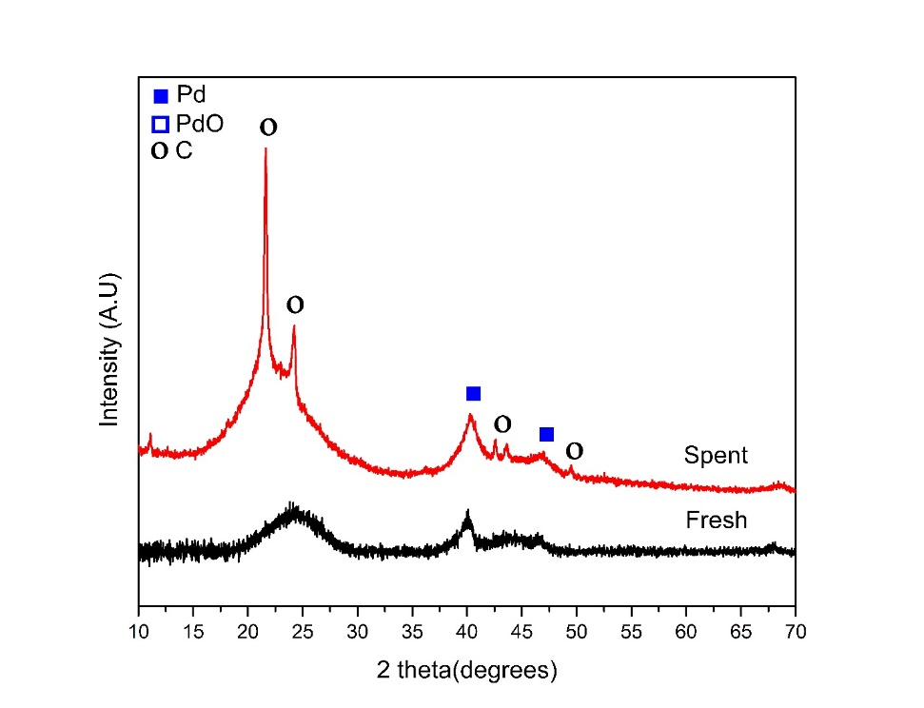
Figure A.1 XRD diffraction pattern of fresh 5 wt.% Pd/C (black line) and spent 5 w.t% Pd/C from reaction run without 1,2,3,4-tetrahydronaphthalene as co-reactant (red line),
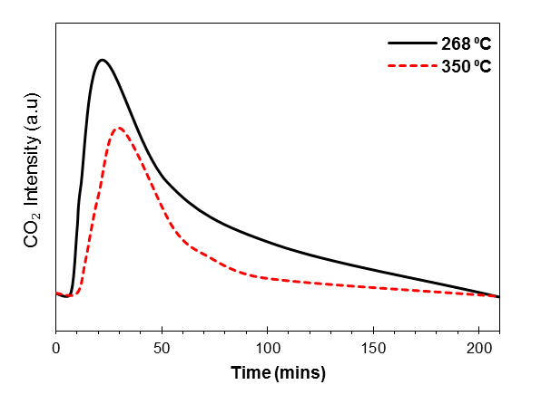
Figure A.2 The evolutionary behavior of CO₂ as a function of time for thermal oxidative treatment of spent 5 w.t% Pd/C collected from reaction run with 1,2,3,4-tetrahydronaphthalene as co-reactant at 330 ºC.

