Storm the Castle
Project Book

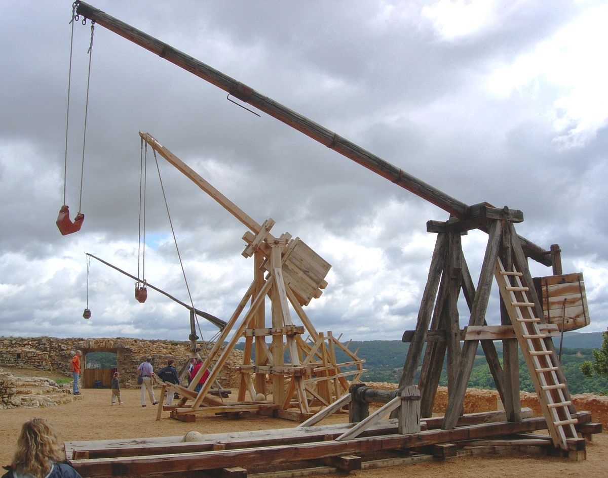

Name:

A brief history of trebuchets.
The Trebuchet was a weapon used during siege warfare in Medieval times for hurling heavy stones to smash castle or city walls. The word 'Medieval Trebuchet' is derived from the Old French word 'Trebucher' meaning to throw over. In England siege weapons, including the Medieval Trebuchet, was also known as the Ingenium from the Latin word ingenium meaning ingenious device! (the name engineer also comes from ingenium).
The Medieval Trebuchet was an invaluable siege attack weapon, similar to a catapult. Medieval engineers of the Middle Ages worked hard on the design of the trebuchet to ensure that this siege weapon and the aim of this type of catapult, or sling, would have the greatest effect. The force of the Medieval Trebuchet was capable of reducing castles, fortresses and cities to rubble.
Medieval Trebuchet history dates back to antiquity. The traction Medieval Trebuchet is believed to be an ancient war engine which was invented in China in 300BC. It is thought that the Medieval Trebuchet may have developed from the stave sling. In the traction Medieval Trebuchet a large troop of men pulled down on ropes to propel the missile. The Medieval Trebuchet reached Europe during the early Middle Ages, or Dark Ages, in 500 AD and was used extensively by the French. The Medieval Trebuchet (Trebucket) was introduced to England in 1216 during the Siege of Dover - as were many other types of siege engine. Louis the Dauphin of France crossed the Channel with a large force and laid siege to Dover Castle making a violent and incessant attack on the walls. He used the Medieval Trebuchet against the walls of Dover Castle. The constable of Dover castle was Hugh de Burgh - he refused to surrender. King Edward I ordered his chief engineer, Master James of St. George, to begin work on a new, more massive engine called Warwolf, a version of the Medieval Trebuchet. The Warwolf is generally thought of as the most powerful and most famous of the trebuchets in history.
The Medieval Trebuchet was a highly accurate siege engine requiring expert building and design skills. The Medieval Trebuchet was a scaled-up stave sling used to reduce fortresses and is a counterweight siege engine. The initial design of the Medieval Trebuchet was revised so that the troop of men used to pull down the ropes were replaced with a large fixed, or pivoting, counterbalance weight. The Traction Medieval Trebuchet used people to power the device. The Counterpoise Medieval Trebuchet replaced the people power with a weight on the short end.
- The Medieval Trebuchet consisted of a lever and a sling
- A very large force was applied to the shorter end of the arm, the load is on the other longer end of the arm with the fulcrum in the middle
- The siege engine's arm could measure up to 60 feet in length
- Heavy lead weights or a pivoting ballast box (filled with earth, sand or stones) were fixed to the short end of the Medieval Trebuchet arm
- A heavy stone, or other missile, was placed in a leather pouch that was attached by two ropes to the other, long, end
- When the arm was released, the force created by the falling weight propelled the long end upward and caused the missile to be flung in the air towards the target
- The Medieval Trebuchet was capable of hurling stones weighing about 100kg with a range of up to about 300 metres.
- After maximum range was achieved, the Medieval Trebuchet was moved toward or away from the target
Missiles thrown from the Medieval Trebuchet catapults were deadly. The Medieval Trebuchet is generally associated with throwing stones. A Medieval Trebuchet could release up to 2000 stones in one day! Should the supply diminish sharp wooden poles and darts would be used. Fire caused havoc in a besieged castle or city and a variety of fire missiles, including firebrands were thrown. Terrifying Greek Fire was also used as a missile from the Medieval Trebuchet. Attackers were ingenious in their ideas for launching Medieval Trebuchet missiles which would cause as much distress and discomfort inside the castle or town walls. Medieval Trebuchet missiles included the following objects:
- Stones
- Sharp wooden poles and darts
- Fire
- Casks of Burning Tar
- Burning Sand ( this became trapped inside armour )
- Pots of Greek Fire
- Dung
- Dead, sometime mutilated, bodies
- Disease ridden bodies
- Body parts
- Dead animals
- Any rotting matter
- Quicklime
In the late Medieval times of the Middle Ages the men who operated the Medieval Trebuchet were called ' Gynours '. The Medieval Trebuchet was a massive war engine and its size required that the machine would be built at the site of the siege. The Gynours were under constant bombardment from the arrows and missiles of the enemy. The enemy would also attempt to burn the Medieval Trebuchet during any daring reconnaissance trips. Catapults would also be built by the enemy within the castle or city walls to attack any of the attackers’ siege engines. Warning cries were often made when a fire missile had been launched by a Medieval Trebuchet.
Siege weapons, such as the Medieval Trebuchet, were made to order. They were far too cumbersome to move from one place to another. In a siege situation the commander would assess the situation and the siege weapons design requirements to break a siege. Engineers would instruct soldiers as to the construction and building of siege weapons such as the Medieval Trebuchet.

How a trebuchet works.
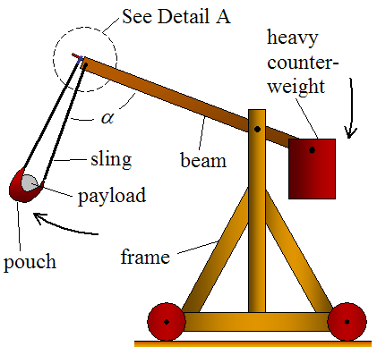
The counterweight pivots around a much shorter distance than the payload end. The advantage of this is that the payload end of the beam reaches a much higher linear velocity than the counterweight end of the beam. This is the principle of mechanical advantage, and is what allows the payload to reach a high launch velocity. However, because the counterweight pivots around a much shorter distance, its weight must be much greater than the weight of the payload, to get a high launch velocity. However, increasing the mass of the counterweight beyond a certain point will not help, since the limiting speed of the falling counterweight is free-fall speed.
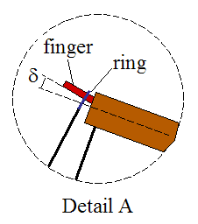
The sling releases when a certain angle α is reached. At this point the ring (which is connected to the sling and loops around the finger for support) slips off and the payload is launched. The release angle α can be adjusted by changing the finger angle δ. For a greater δ the release angle α increases. For a smaller δ the release angle α decreases.
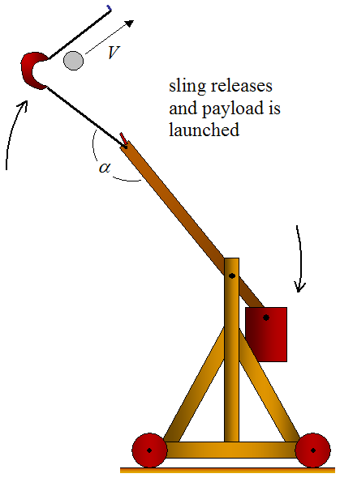
As the beam rotates clockwise (due to the falling counterweight), the payload experiences centripetal acceleration which causes it to move outwards (since it is unrestrained). This results in a large increase in linear velocity of the payload which far exceeds that of the end of the beam to which the sling is attached. This is the heart of trebuchet physics and is the reason a trebuchet has such great launching power.
The optimal release position and design:
- The initial release position is such that the beam on the counterweight side makes an angle of 45° with the vertical.
- The length of the long arm of the beam (on the payload side) is 3.75 times the length of the short arm of the beam (on the counterweight side).
- The length of the sling is equal to the length of the long arm of the beam (on the payload side).
- A counterweight that has a mass 100 times greater than the mass of the payload.

How far could a projectile go?
The mathematics used to analyse a trebuchet is quite challenging. To simplify matters we will look at the theoretical distance a trebuchet could throw a missile once it has left the sling.
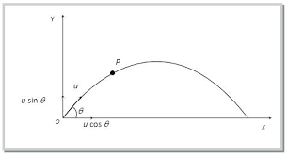
The graph above shows how a projectile (a missile) would move once it has been fired. The shape of the graph is known as a parabolic curve and to get this shape air resistance is ignored. In engineering speak, we say this is an ideal model and doesn’t really show how a projectile would travel in a real situation.
The point O on the graph is the origin and we will use this as our reference point.
Our first step is find equations that will describe the different aspects of the projectile’s flight.
We can calculate the distance the projectile will travel in the $x$ direction by using this equation since there isn’t any horizontal acceleration.
$$x=\left(ucosϑ\right)t$$
In this equation $x$ is the horizontal distance, $u$ is the initial velocity of the missile and $t$ is the time of flight.
The vertical direction is a little different since we have to take into account gravity, which causes an acceleration of $9.81m/s^{2}$.
The equation we can use to account for this is:
$$y=\left(usinϑ\right)t-\frac{1}{2}gt^{2}$$
Where $g$ represents the acceleration due to gravity.
We can now do a bit of rearranging of our equations to find out such things as the vertical height of the projectile at a certain time, the horizontal distance the projectile will travel and the maximum range of the projectile.
The vertical height $y$ can be calculated by rearranging our first equation to find one for$t$.
$$x=\left(ucosϑ\right)t$$
By dividing both sides of our equation by $ucosϑ$, we get:
$$t=\frac{x}{\left(ucosϑ\right) }$$
To find the time of flight of the projectile we use the fact that we start with the time at 0, $t=0$ and the vertical distance, $y$ is also equal to 0.
At the start, $t=0$ and $y=0$ so we end up with $0=0$ which isn’t very interesting!
What we need to know is next time $y$ has a value of zero. To find this we can look at our equation
$$y=\left(usinϑ\right)t-\frac{1}{2}gt^{2}$$
Give $y$ a value of 0 and rearrange it to get:
$$\left(usinϑ\right)t=\frac{1}{2}gt^{2}$$
Divide both sides by $t$ to get:
$$\left(usinϑ\right)=\frac{1}{2}gt$$
$$t=\frac{2usinϑ}{g}$$
The horizontal range can be found by using $x=\left(ucosϑ\right)t$ and replacing $t$ with $\frac{x}{\left(ucosϑ\right) }$.
Our first equation therefore becomes:
$$x=\left(ucosϑ\right)\frac{2usinϑ}{g}$$
If we multiple these together, we get:
$$x=\frac{2v^{2}sinϑcosϑ}{g}$$
As per usual in mathematics, we need to do a bit of rearranging. So using the fact that $sin2ϑ≡2sinϑcosϑ$ (one of the trig identities), we get:
The horizontal range $=\frac{u^{2}sin2ϑ}{g}$
If we know the speed of our projectile, we can find the maximum range. This means we need to find the maximum value of $\frac{u^{2}sin2ϑ}{g}$. Hopefully, you remember that the maximum value of the sine function is 1. The question now becomes, when does$sin2ϑ=1$? The answer is when $ϑ={45}^{0}$.
Challenge – Design and Build a Trebuchet.
Task 1:
In the box below, write down which factors you think will have the greatest effect on how far a trebuchet can hurl a missile.

To make life easier and not have to calculate the range of our trebuchets, we will use a simulation programme (this is what engineers do a lot of).
The programme we are going to use is called TrebStar (you can download it at home from http://www.algobeautytreb.com/ )
Symbol | Description
l1 | length of the short arm of the beam
l2 | length of the long arm of the beam
l3 | length of the sling
l4 | length of the counter weight hanger
l5 | height of the pivot
m1 | mass of the counter weight
m2 | Mass of the projectile
mb | mass of the beam

The diagram above shows the first screen of the programme. At the top left hand corner you can see a number of input variables (l1, l2 etc). In the boxes beneath the variables you can enter different values. The table below gives a brief explanation of each of the input variables.
Task 2.
Find the maximum distance your trebuchet can throw a missile. I would suggest you only change one input variable at a time. So, for example, you could start by changing the value of l1, the length of the short arm of the beam and see the effect this has. Once you have changed an input variable, click on ‘throw it’. You will see an animation of your trebuchet throwing a missile. The simulation will also give you lots of data about the throw beneath the animation. The range is given by the output variable ‘R’ (see Appendix 1 for information on the other variables).
Variable name | Variable value | Variable description | Range
l1
l2
l4
m1
m2

Task 3.
Build a trebuchet from the components given to you. You can now test your trebuchet.
Record the results in the table below.
Variable name | Variable value | Variable description | Range
l1
l2
l4
m1
m2
Task 4.
Think about the results you obtained from using the simulator and the results you got from testing your trebuchet. In the box below, write about why they are different. You might like to consider for example friction, accuracy in the length of the sling etc.

Ultimate Task
Your trebuchet needs to be able to fire a missile fast enough and far enough to destroy the castle!
Good luck and may the best trebuchet win.
What I have learned from designing, building and operating a trebuchet.

Trebuchet Simulator help
Inputs
Appendix 1
Symbol | Description
l1 | length of the short arm of the beam
l2 | length of the long arm of the beam
l3 | length of the sling
l4 | length of the counter weight hanger
l5 | height of the pivot
m1 | mass of the counter weight
m2 | Mass of the projectile
mb | mass of the beam

Outputs
Symbol | Description | Comment
h | maximum height
phiz | angle between the counter weight hanger and the beam at the start of the throw | in degrees
Reff | range efficiency | assumes all of the energy to throw the projectile comes from the counter weight
Rgeff | range efficiency | assumes the energy also comes from the beam
thgo | the angle with respect to the horizontal at which the projectile must leave the sling to achieve the maximum range.
rg | radius of gyration | non-uniform beams require the calculation of the centre of mass and the radius of gyration
rc | Centre of mass

More information about Medieval life can be found at http://www.medieval-life-and-times.info/medieval-weapons/trebuchet.htm
A more detailed analysis can be found at https://www.real-world-physics-problems.com/trebuchet-physics.html

