DESIGNING AND BUILDING A BRIDGE
PROJECT BOOK

NAME:

SCHOOL:

The challenge you face as an apprentice engineering wizard is to think about how people can get to the other side of a river.

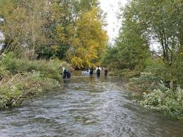

You might consider walking across.

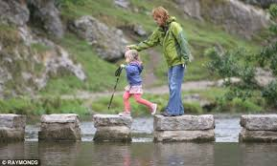

You could think about using stepping stones.

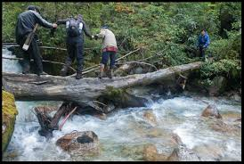

How about just chopping down a tree?

Things you need to think about:
How safe will your bridge be? You don’t want people, especially children, falling into the river.
How difficult will it be to design?
How difficult will it be to make?
Will it be very expensive?

After thinking about the problem you have decided that a simple bridge is probably the best option.
Being an engineer, you also decide that before you design and build the actual bridge, you will make a model so you can try out your ideas without spending a lot of money or spending a lot of time designing your bridge.
Task 1.
What will my bridge need so that people can walk safely across it?

In school you have learned about different shapes, such as circles, rectangles, triangles etc. You want your bridge to be very strong so that lots of people can walk across it.
Task 2.
Which of the shapes that you know about do you think will support the most weight without collapsing?
100Kg
100Kg
100Kg

My answer:
I think the ______________________ will support the most weight without collapsing.
Task 3.
Which of the shapes is the easiest to make?
My answer:
I think the ___________________ will be the easiest to make.

Task 4.
How can I use this shape to build my bridge?
My answer:

You now have an idea of what you need to design and build your bridge. In the space below sketch some of your ideas.

Building your model
Using the straws, pipe cleaners, wood and sellotape, make your model bridge. You need to think about the best way to build a strong bridge with the least number of straws. The structure of the bridge must support, what is known as, the deck (the bit of wood).
You can use as many straws and pipe cleaners as you like to build the bridge but it must not collapse when weights are put on it. So, you may decide to join the straws end-to-end and see how much weight your bridge will support. If it works, great. If not, then you need to think of a different way of using the straws.

Task 5:
Start to play. Try making different shapes with the straws and see how hard you can press before the shape collapses.
When you are happy your bridge will support some weight, begin to test it to find out the maximum weight it will support before it collapses.
My answer:
My bridge will support a maximum weight of:

Remember: Apprentice engineers are not afraid to experiment. Very rarely do things work as expected the first time and say to yourself:

‘It’s great to be stuck. It gives me the chance to think’.

From designing and building a model bridge, I have learned that:

