Title: Soft Toric Contact Lens Wear Improves Digital Performance and Vision - a Randomised Clinical Trial
Running title: Soft Toric Contact Lens and Digital Performance

Authors: Cecilia Chao¹, Kelsea Skidmore¹, Erin S. Tomiyama¹, James S. Wolffsohn², Kathryn Richdale¹

Institutions: 1. University of Houston, College of Optometry, Houston, Texas. USA
2. School of Optometry, Aston University, Birmingham, UK

Corresponding author
Kathryn Richdale
Email: Kathryn.richdale@gmail.com

Financial disclosures/acknowledgement: This study is supported by an Alcon unrestricted investigator-initiated research grant.

Abstract
PURPOSE
To compare objective and subjective digital near visual performance and comfort in low to moderate astigmatic participants fitted with toric versus spherical equivalent silicone hydrogel daily disposable contact lenses.

METHODS
This was a double-masked, randomised, crossover study. Participants aged 18 to 39 years with astigmatism of -0.75 to -1.50 D were recruited and fitted with toric and spherical contact lenses, in random order. Outcomes were measured at baseline and after one week of wear with each contact lens type after the follow-up visits. High- and low-contrast near logMAR visual acuity, automated visual acuity, zoom (%), contrast (%), reading distance (cm), critical print size (logMAR) and reading speed were assessed. Participants also completed the validated Near Activity Visual Questionnaire (NAVQ) and Contact Lens Dry Eye Questionnaire 8 (CLDEQ-8) for each correction type.

RESULTS
Twenty-three participants completed the study (74% female, average age 24.4±4.2 years). When participants wore toric contact lenses, near high- and low-contrast visual acuity, automated visual acuity improved by 3-4 letters (all P<0.03) and participants were able to read faster on an iPad (P=0.02). Participants were also able to read with 8% less contrast on the iPad with toric lenses (P=0.01). Participants reported better subjective vision on the overall NAVQ (P=0.001) and better comfort on CLDEQ-8 (P=0.02) with toric lenses. Fewer participants reported difficulty with maintaining focus at near, reading small print, reading labels/instructions, reading the computer display/keyboard and reading post/mail with toric correction.

CONCLUSIONS
Toric contact lenses improve comfort, subjective and objective visual performance with digital devices and other near tasks compared to the spherical equivalent correction in participants with low to moderate astigmatism.

Keywords: Digital performance; Silicone hydrogel; Toric contact lenses; Visual comfort; Visual performance.

Key Points:
- Toric contact lenses provided better high- and low-contrast visual acuity at near compared with spherical contact lenses for low to moderate astigmatic patients.
- Low to moderate astigmatic patients who wore toric contact lenses were able to read faster on an iPad compared with usingspherical contact lenses.
- Toric contact lenses provided better subjective vision and comfort compared with spherical contact lenses.

Introduction
Adults in the USA spend over 10 hours a day consuming media on digital devices, including smartphones, tablets and home computers.¹ The Coronavirus 19 (COVID-19) pandemic has further increased digital device use, with up to 76% of US adults reporting increased screen time due to working from home and relying on digital platforms for communication.² Sustained clear near and intermediate vision is required to meet these digital visual demands.^{3,4} Unfortunately, standard examination room high-contrast, high-luminance distance acuity testing may not be helpful in demonstrating performance in real-world activities in this digital era.

Approximately 47% of patients have at least 0.75 dioptres (D) of astigmatism in one eye.⁵ However, due to the perceived complexity, potential for longer chair time and higher cost of toric lenses, eye care providers often fit astigmatic patients with spherical lenses.^{6,7} Only 25-30% of astigmatic patients have historically been fitted with toric contact lenses.^{8,9} Due to improved technology, better comfort and easier fitting can be achieved,¹⁰ even for those who have failed a fitting with toric lenses previously.^{6,7} In addition, better visual acuity (VA), particularly in low contrast or lighting situations, can be achieved for low astigmatic patients wearing toric soft contact lenses compared to aspheric or spherical contact lenses.^{7,11}

Wolffsohn’s laboratory developed iPad based applications to quantify reading performance on digital devices which allows for a more comprehensive real-world vision assessment beyond standard clinical measures.¹² Using these applications, our previous study found that toric lens correction improved near high-and low-contrast VA by 0.5 to 1 full lines on a laptop computer, and enabled individuals to read one line smaller text on the iPad tablet computer(Apple, apple.com) compared with spherical contact lenses.¹³ In addition, improved near visual performance was reported when participants wore toric lenses compared with the spherical equivalent correction¹³ based on the validated Near Activity Visual Questionnaire (NAVQ),¹⁴ which is specifically designed for quantification of subjective near visual function. Automated VA assessment has been developed to allow more vigorous assessment of the acuity endpoint.¹⁵ Wolffsohn’s laboratory recently developed another iPad-based application to assess automated VA, which is likely to be more robust than traditional VA measures in being a time-limited detection task rather than simply a recognition task, such as reading subtitles. This automated VA test demonstrated good repeatability, as the differences (bias) between repeated testing were less than one letter (<0.02 logMAR) with a within-subject standard deviation of less than 6 letters (±0.12 logMAR) (unpublished data).

Contact lens discomfort can affect wearing time and potentially lead to dropout.^{16,17} According to the Tear Film and Ocular Surface (TFOS) Contact Lens Discomfort report, lens design, material and the interaction between the contact lens and ocular surface are all potential factors associated with contact lens discomfort.¹⁷ Toric lenses have been reported to be less comfortable than spherical lenses; however, previous studies mainly explored older lens materials and designs.¹⁷ It is thought that contact lens discomfort may also be related to subjective visual quality (Questions 3a and 3b in Contact Lens Dry Eye Questionaire-8; CLDEQ-8).¹⁸ However, the effect of modern toric and spherical daily disposable contact lenses on the association between contact lens discomfort, subjective visual quality and visual function has not been investigated. Recently, it was reported that contact lens discomfort was associated with upregulation of tear eicosanoid biomarkers; Masoudi et al found a higher concentration of Leukotriene B4 (LTB₄) at the end of the day in symptomatic soft contact lens wearers compared to asymptomatic contact lens wearers.¹⁹

Therefore, the aims of this study were to quantify objective and subjective digital visual performance and comfort in low to moderate astigmatic participants fitted with toric correction compared to spherical equivalent correction, using the latest digital and patient reported outcome tools. It was hypothesised that toric contact lenses will provide better visual performance and comfort compared to spherical equivalent correction in low to moderate astigmatic participants.

Methods
This was a 3-week prospective, single-site, randomised, doubled-masked, two period, two contact lens crossover study design conducted at the University of Houston College of Optometry between June and October 2021 (duration of the clinical trial was five months). Institutional Review Board approval was obtained through the University of Houston, in accordance with the Declaration of Helsinki, and the study was registered on ClinicalTrials.gov (NCT#04772560). Participants were recruited from the patients, students, staff, faculty and surrounding community of the University via flyers and emails. All participants provided informed consent prior to enrolment in the study. Participants were required to present to the first visit following at least 24 hours without their habitual contact lenses, as well as use of artificial tears or other ocular solutions. All outcome visits were performed after a week of final assigned contact lens wear, with two hours of contact lens wear to provide stable contact lens fits between participants and lens types for the assessment of the primary outcomes.

A sample size of 23 participants was required to detect a difference of six letters in high contrast near VA between toric and spherical hydrogel contact lens wear¹³ with P=0.05 and 80% power. This also powered the study to detect the difference in low contrast near VA (11 letters)¹³ between lens types. The automated VA test is novel and had not been used previously to allow sample size estimates. A total of 30 participants were enrolled to allow for approximately 20-25% dropout, screen-failure or missing data and have 23 participants complete the study.

Participants were recruited if they were established, full time (>6 days week, >8 hours/day), soft lens wearers, aged between 18 and 39 years, had a vertex-corrected sphere power between plano and -6.00 D and vertexed refractive cylinder power between -0.75 to -1.50 D in each eye with a self-report of at least four hours per day using digital devices. Participants were required to speak and read English at a high school level or equivalent (by self-report) in order to perform the reading tests. Other inclusion criteria included best corrected VA of 6/7.5 or better in each eye; no gas permeable contact lens wear for at least three months, no binocular vision disorder and/or history of ocular pathology or surgery. Participants were screened at visit 1 for contact lens discomfort using the CLDEQ-8;¹⁸ based on published cut-offs for contact lens related dry eye, a score of less than 12 was required prior to randomisation.

The first visit included a pre-fitting evaluation, baseline outcome measures, randomisation to begin with either toric [Precision 1® for Astigmatism (verofilcon A, base curve:8.5mm and diameter: 14.5mm) or spherical lenses [Precision1® Sphere contact lenses (verofilcon A, 8.3/14.2mm)] (Alcon, alcon.com)]. The type of lens worn first, whether spherical or toric, was determined via a randomisation table. The fitting of the second type of lenses was performed at the end of visit 3 (Figure 1). Visits 2 and 4 were contact lens follow up visits performed approximately three days after the lenses were dispensed, and any lens power changes were made at this time if the distance VA was 6/7.5 or worse. This procedure was performed by an unmasked experienced licensed optometrist. Visits 3 and 5 were contact lens outcome visits performed approximately one week after the follow up visits. (Figure 1). All participants were asked to wear the assigned lenses on a daily-wear daily disposable basis and for at least eight hours each day.

Figure 1. Flow diagram of the study design

Contact lens fitting and follow-up
Auto-refraction and auto-keratometry (WAM-5500, grandseiko.com) and manifest refraction were performed by an unmasked examiner at the first visit. Accommodation (negative and positive relative accommodation) and binocular vision (heterophoria testing using the Modified Thorington technique) were assessed at the same visit. The fitting procedure was conducted as previously described, following standard clinical procedures¹³ by an experienced licensed optometrist. An anterior segment slit lamp examination, including quantification of fluorescein staining, was carried out using the Cornea and Contact Lens Research Unit (CCLRU) grading scale²⁰ before the first pair of contact lenses were assigned. Adverse events were queried and assessed at all five study visits.

Study outcomes
The unmasked examiner provided the subjects with the CLDEQ-8 to complete and recorded the average wear time. The CLDEQ-8 ^{4,16} was used to assess contact lens related discomfort. All study outcome measures listed below were conducted by a masked examiner at visits 1, 3 and 5.

Binocular near high luminance high and low contrast logMAR VA was measured electronically using M&S Clinical Trial Suite (M&S Technologies, mstech-eyes.com) at 40cm, starting from 0.5 logMAR and progressing until three or more letters were missed on a line. High luminance, high contrast (HLHC) VA and high luminance, low contrast (HLLC) VA were measured. For automated VA, the subject was instructed to hold the iPad at 40 cm and was presented with a Landolt C surrounded by crowding bars for 0.3s each, starting from 0.5 LogMAR and progressing to smaller sizes using a staircase threshold method. Participants tapped the screen to identify which of the four possible directions the letter was oriented. Automated VA was repeated five times and the average was used for analysis.

The NAVQ ¹⁴ is a 10-item questionnaire that was used to assesses patient acceptance of the correction for near tasks in addition to overall satisfaction with near vision. The individual items were reported and the percent difference in endorsement between lens designs were examined. A lower total score indicates less difficulty.

Reading performance, speed and functionality were examined using two custom-made iPad based near reading programs, as previously described.¹². Participants read an assigned article (a different one at each visit) with the text contrast set to 10% and zoom at 50% to start. Participants were then asked to adjust the contrast and zoom to the minimum level where they could read the text comfortably, as quickly as possible but to also understand the content. The reading speed (in words per minute, WPM), mean distance the subject held the iPad, mean zoom and mean contrast in %, as well as the total number of blinks during the testing were recorded. Subjective responses related to reading task were requested and recorded. Digital reading speed ¹² was based on the Radner reading test, which contains a standardised structure from a text size of 0.9 logMAR to -0.10 logMAR with each sentence containing 14 words. Participants were instructed to read the sentences aloud as quickly and accurately as possible. Optimal reading speed (ORS) was calculated as the average reading speed above the critical print size (CPS) and was reported in WPM.

Up to 22μl of basal tears were collected from the lateral canthus using disposable glass capillaries (Blaubrand intraMARK, sigmaaldrich.com) from both eyes as described previously²¹ and stored at -80°C until analysis. LTB₄ ELISA kit (sensitivity of 5.63pg/ml, Cat# ADI-900-068, enzolifesciences.com) was used to determine the LTB₄ concentration in tears based on the manufacturers’ protocol using a dilution factor of 1:10.¹⁹
At visit five, participants were asked their preferred contact lens correction (pair one or pair two), and the unmasked examiner recorded the preference for toric versus spherical equivalent correction.

Statistical Analysis
The data were analysed using SPSS version 26 (SPSS for Microsoft, ibm.com) and significance was defined as P<0.05. Outcome measures for the two contact lens designs were first analysed using the Grizzle model.²² Data were tested for the presence of a carryover effect by examining the average of outcomes in the two periods within participants between the two sequences of randomisation, that is, sphere then toric or toric then sphere. An independent paired T-test or Mann-Whitney test, as appropriate, was carried out to ensure there were no carryover or period effects at the alpha level of 0.10 or greater according to the Grizzle standard protocol.²² If carryover and period effects were found with P<0.10, only the first period was reported.²² The differences in outcome measures between lens designs were examined using a linear mixed model, with fixed factors of sequence and contact lens design to obtain unbiased effect sizes. Estimated means, standard errors and medians and interquartile ranges were reported for each lens design. Estimated means, standard errors and 95% confidence intervals of the differences between lens designs were also reported. In the presence of any carry-over effects, hypothesis tests were conducted on period one only. CLDEQ-8 and overall NAVQ were also analysed using paired T-test or Wilcoxon Rank test, as appropriate. Subjective reading performance was examined using the Fisher’s Exact test. Final lens preference was analysed using a one-sample binomial test in all participants. Also, the preference was reported based on cylinder power (-0.75D vs >-0.75D). Partial correlation tests, controlling for lens designs, were carried out to examine associations between eye comfort, visual performance, subjective visual quality and LTB₄ concentration.
Results
Demographic
Thirty participants were screened, and twenty-three participants were eligible and completed the study (Figure 2). The mean age of the participants was 24.4±4.2 years and 74% (n=17) were female. The majority of the participants were White/Caucasian (48%), followed by Asian (35%); 13% were Black and 4% were American Indian. Sixty percent of the participants self-reported non-Hispanic ethnicity.
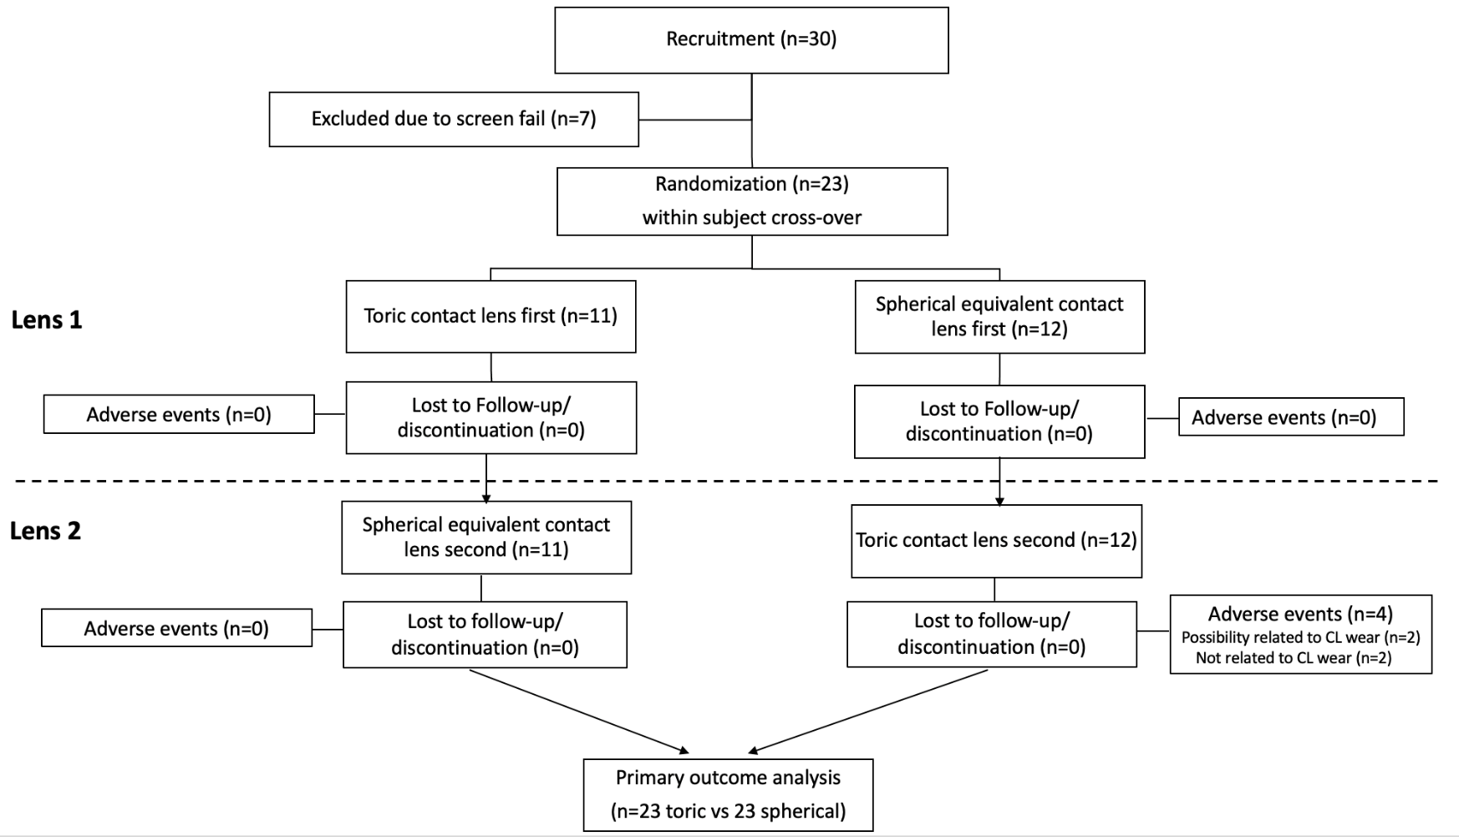 Figure 2. Flow diagram of study enrollment and completion

More than 90% of the participants (n=21) were habitual toric soft contact lens wearers; 10% wore spherical lenses. The same number of participants reported that they wore their contact lenses during the daytime while two participants reported extended wear. The majority of the participants wore daily disposable lenses (48%), 39% wore monthly and 13% wore biweekly reusable soft contact lenses. Refractive error and binocular function findings are listed in Table 1. All baseline parameters were as expected and typical for a low to moderately astigmatic population, and there were no apparent differences in baseline characteristics between randomisation sequences (Table 1). The median refractive sphere was about -3.00D with -1.25 D of cylinder, as expected based on the enrollment criteria.
Table 1. Median and interquartile range baseline refractive and binocular function parameters
 | OD | OS
Subjective spherical refraction (D) | -3.00 (-2.25 − -4.25) | -3.25 (-2.00 − -4.25)
Subjective cylinder refraction (D) | -1.25 (-1.00 − -1.25) | -1.25 (-1.00 − -1.50)
Flat K (D) | 43.08 (41.68 − 43.81) | 42.90 (42.00 − 43.97)
Steep K (D) | 44.32 (43.44 − 45.58) | 44.65 (43.50 − 45.64)
Binocular function
Negative relative accommodation (D) | +2.50 (+2.50 – +2.75)
Positive relative accommodation (D) | -4.00 (-3.00 − -5.50)
Distance heterophoria (0: ortho, +: eso, - exo) | 0 (-2.5 − +0.5)
Near heterophoria (0: ortho, +: eso, - exo) | 0 (-6.0 − +1.0)

Contact lens fitting and adverse events
All contact lenses were deemed to have a clinically acceptable fit (100%) by the unmasked optometrist, with adequate movement, centration and coverage, as well as minimal and stable rotation in the case of a toric lens. Only one subject presented with acceptable but bilaterally decentred lenses with toric contact lens wear. There was only one eye with greater than 10° of rotation with a toric contact lens at any visit. The lens parameters were not modified because the acuity met the pre-specified criteria. There was no difference in average wearing time between toric [11 hours (9-13 hours)] and spherical lenses [12 hours (9-14 hours), P=0.41].

There was no significant difference in the presence of ocular surface staining between contact lens designs (spherical: 30% vs. toric: 35% of eyes, P>0.20). Four adverse events were observed during the study. Two participants had epithelial defects (corneal staining > grade 2) and one subject presented with a hordeolum at the last visit. These three adverse events were observed when the subject wore toric contact lenses and resolved after discontinuation of lenses. One additional non-ocular adverse event was reported but assessed as not likely to be related to the treatment. The data for the adverse event visits were retained for primary outcomes but samples not used for tear analysis.

Outcome measures
Carryover and period effects were examined, and no significant effects were found (all P>0.13) except for HLHC VA (P=0.04) (Table 4). The near HLHC VA was only reported for the first sequence due to the crossover effect (P=0.04). Near VA was better with toric contact lens correction, with an improvement of 3-4 letters of acuity under high (P=0.03) and low contrast conditions (P=0.01) (Table 2). Automated VA also improved by 3-4 letters with the toric correction compared to spherical contact lenses (P=0.01, Table 2). There was a wider range of acuities with the automated test as compared to the standard manual logMAR chart.

Overall, participants reported greater difficulty (higher score) when using spherical contact lenses compared with toric contact lenses (P=0.001, Table 2). For individual items of the questionnaire, 8.7%-43.5% of the participants reported at least a score of 1 or greater difficulty when they wore spherical compared to toric contact lenses (Supplementary Table 1). The greatest difference (>25%) in difficulty with the spherical correction compared to toric was reported for maintaining focus at near, reading small print, reading labels/instructions, reading the display/keyboard on the computer and reading post/mail (Supplementary Table 1).

Table 2. Near visual acuities (VA) and Near Visual Acuity Questionnaire (NAVQ) score with toric and spherical contact lenses (CL).
 | Carryover effect | Toric CL | Spherical CL | df | Difference | 95% CI for difference | P value
HLHC VA (logMAR)* | P=0.04 | -0.10±0.02  -0.08  (-0.13 − -0.03) | -0.03 ± 0.21  0.00  (-0.06 − 0.01) | 22 | 0.07±0.03 | 0.01 − 0.13 | P=0.03
HLLC VA (logMAR) | P=0.96 | 0.22±0.02  0.22  (0.18 − 0.30) | 0.30 ± 0.02  0.30  (0.22 − 0.36) | 42 | 0.08±0.03 | 0.02 − 0.14 | P=0.01
Automated VA (logMAR) | P=0.67 | 0.04±0.02  0.01  (-0.0 − 0.13) | 0.11±0.02  0.12  (0.00 − 0.20) | 42 | 0.07±0.03 | -0.00 − 0.14 | P=0.01
NAVQ overall score | P=0.45 | 0.3±0.2  0.0  (0.0-1.0) | 1.2±0.2  1.0  (0.0-2.0) | 42 | 1.0±0.3 | 0.4-1.5 | P=0.001
Estimated mean±standard error, median (interquartile range, IQR), P value: the comparison between toric and spherical contact lens wear using linear mixed model. * Presence of carryover and period effects (P<0.10) thus only the first period was reported. HLHC: high luminance high contrast; HLLC: high luminance low contrast; NAVQ: near acuity visual questionnaire; VA: visual acuity; df: degrees of freedom; CI: confidence interval. Bold: P<0.05 for comparison between contact lens types

There was a significant association between worse higher overall NAVQ score and HLHC VA (r=0.48, P<0.001, Figure 3A), HLLC VA (r=0.47, P<0.001, Figure 3B), automated VA (r=0.48, P<0.001, Figure 3C) and CPS (r=0.48, P<0.001, Figure 3D). The exclusion of the three outliers (far right) did not affect the associations.

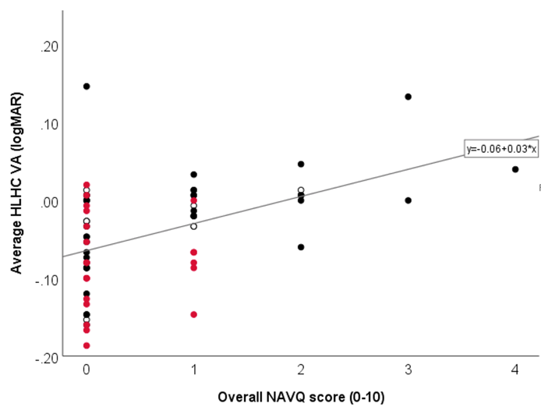 A  r=0.48, P<0.001 | 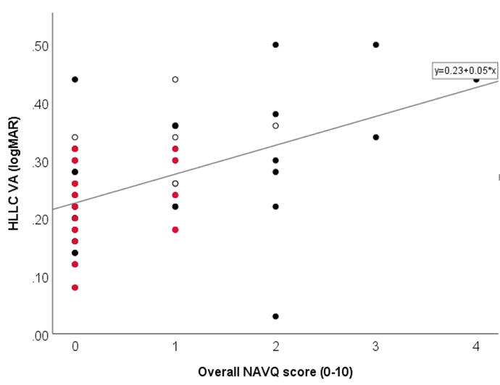 B
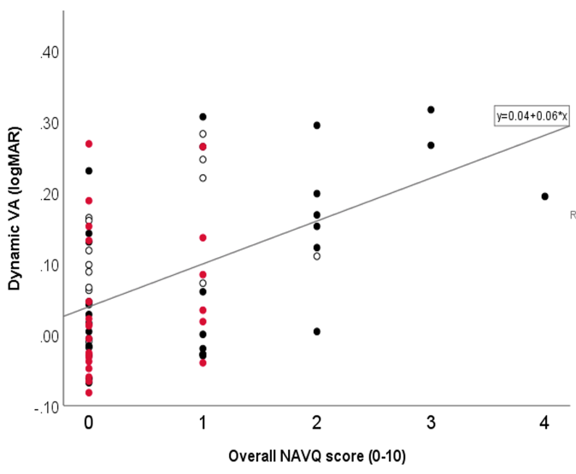C  r=0.48, P<0.001 | 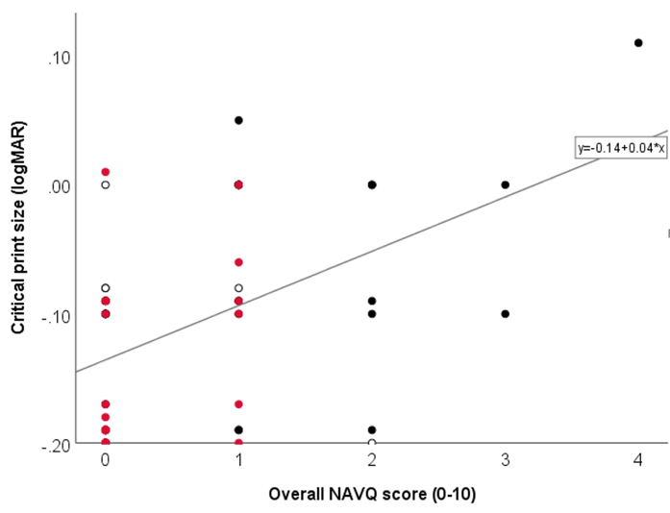D  r=0.48, P<0.001
Figure 3. The association between overall NAVQ score and high luminance high contrast VA (A), high luminance low contrast VA (A), automated visual acuity (C) and critical print size for reading sentence test (D) using partial correlation test. White: baseline, red: toric, black: spherical.
r=0.47, P<0.001

Participants increased contrast by 8% to read when the spherical correction was worn (P=0.01, Table 3). Participants could read smaller text at a faster rate (smaller CPS) when using toric contact lenses compared to spherical contact lenses (P=0.02). Reading speed, blink rate, reading distance and zoom in the reading speed test, and subjective responses to reading on the iPad did not differ significantly with contact lens type (P>0.06).

Table 3. Reading speed and reading sentence test outcomes with toric and spherical contact lens wear.
 | Carryover effect | Toric CL | Spherical CL | df | Difference | 95% CI for difference | P value
Contrast (%) | P=0.27 | 44±5  37 (27 − 57) | 52±5  46 (33 − 69) | 42 | 8±7 | -6 − 23 | P=0.01
Reading sentence  CPS (LogMAR) | P=0.13 | -0.14±0.02  -0.17  (-0.20 − -0.09) | -0.08±0.02  -0.10  (0.17 − 0.00) | 42 | 0.05±0.02 | 0.01 − 0.10 | P=0.02
Reading speed (wpm) | P=0.19 | 238±17  217 (176 − 267) | 214±17  198 (179 − 236) | 42 | 24±24 | 25 − 73 | P=0.33
Blink Rate (blinks/min) | P=0.27 | 11±2  10 (4 − 16) | 14±2  14 (7 − 18) | 42 | 3±2 | -3 − 7 | P=0.12
Reading distance (cm) | P=0.30 | 35.2±0.9  34.9 (32.1 − 36.5) | 34.0±0.9  33.8 (30.8 − 37.7) | 42 | 1.2±1.3 | -1.4 − 3.8 | P=0.37
Zoom (%) | P=0.50 | 64±2  61 (59 − 68) | 69±2  65 (59 − 79) | 42 | 6±3 | -1.3 − 12.5 | P=0.06
CL: contact lens Estimated mean±standard error and median and inter-quartile range (IQR), P value: the comparison between toric and spherical contact lens wear using linear mixed model. When presence of carryover and period effects (P<0.10) was found, only the first period was reported. CPS: critical print size; wpm: words per minutes; df: degrees of freedom; CI: confidence interval. Bold: P<0.05 for comparison between contact lens types

Participants reported greater comfort when they wore toric compared to spherical contact lenses [6 (2-9) vs 8 (4-12), P=0.02]. However, more participants reported changeable, blurry vision with toric lenses (P<0.02, Supplementary Table 1). Participants who wore toric lenses with a greater amount of astigmatism (1.25 vs 0.75D) reported lower scores on the CLDEQ-8, but this subset was not powered for statistical analysis. There was no difference in wearing time between contact lens type (P=0.20) nor cylinder power in toric contact lens wear (P=0.86).

Tear LTB₄ concentration was analysed in 18 participants; 5 participants were excluded due to either insufficient tear volume at any visit or adverse events during contact lens wear. No significant differences in LTB₄ concentration were found between tears collected at baseline [38.2 (29.2 – 71.8pg/ml)], or after toric [31.5 (19-8 – 48.6pg/ml)] or spherical contact lens wear [40.6 (18.8 – 65.4pg/ml; P=0.46, Figure 4A]. LTB₄ concentration was not associated with the CLDEQ-8 score or individual subjective comfort questions (P>0.30). However, higher LTB₄ concentration was associated with higher HLLC VA (logMAR) (r=0.30, P=0.04, Figure 4B) and higher contrast used for the reading test (r=0.36, P=0.009, Figure 4C) based on partial correlation tests. The exclusion of the three outliers (top) did not affect the associations.

There were 17 participants (74%) who preferred toric contact lenses, while six participants preferred spherical contact lenses (P=0.02). Of those who preferred spherical contact lenses, all had astigmatism of -0.75D in both eyes.
Figure 4. LTB₄ tear concentration by contact lens type (A) and associations between LTB4 concentration and high luminance low contrast VA (HLLC logMAR) (B) and reading contrast (%) (C). White: baseline, red: toric, black: spherical.

Discussion
This study aimed to examine the potential benefits of a toric contact lens correction in participants with low to moderate astigmatism fitted with daily disposable silicone hydrogel contact lenses. Objective outcome measures were near VA (both high and low contrast) and visual function, including reading preference, acuity and automated VA using digital devices. Subjective visual function and comfort were also assessed. Similar to our previous research and that of others,^{6,13} the majority of participants preferred toric contact lenses over a spherical equivalent correction. This was especially true for moderate astigmatic patients (cylinder power of 1.25D). Even though toric contact lens wear showed greater comfort and subjective near visual performance compared to spherical lens wear, participants reported more changeable vision with these lenses. Previous studies reported that vision and eye discomfort may be connected, particularly when using digital devices.²³

Consistent with our previous findings with early generation daily disposable and reusable lenses,^{7,13} participants had better VA under high luminance, high contrast and low contrast conditions, when wearing toric compared to a spherical equivalent correction. Daily disposable hydrogel soft contact lens wearers showed an improvement of three letters to one line with a toric correction for high contrast and low contrast VA.¹³ Reusable contact lenses showed potential VA improvements of up to 12-13 letters, but this study included participants with up to 2.00D of astigmatism.⁷ The slightly smaller difference (3-4 letters) in the present study compared to our previous daily disposable investigation could be due to the repeated measures of HCHL VA at each visit, which may have shown a learning curve.

This study also introduced a new tool to examine automated VA. This novel test allows assessment of a more demanding interactive visual task. Although our unpublished data showed that the automated VA test (CoR of ±0.21-0.24 logMAR) is not as repeatable as a standard VA assessment (CoR of ±0.10-0.11 logMAR), this may be expected since the automated VA is more difficult due to a rapid presentation time of 0.3 seconds compared to the static display of a standard test. When participants wore toric contact lenses, the range of automated VA was much larger than with standard acuity tests and correlated with subjective reports of vision. Further studies are needed to assess if this test may be a useful clinical measure of visual performance with different types of correction.

In order to assess reading performance and functionality, a modified Radner reading test and reading articles were used. In general, participants were able to read smaller text at a faster rate with toric lenses compared to the spherical equivalent contact lens correction. The reading CPS in this study was about one line better than our previous study for both toric and spherical designs (0.0 in toric and 0.1 in spherical design).¹³ This could be due to the improved material (silicone hydrogel vs hydrogel) or optical designs compared to the older generation lenses used in the previous study.¹³ However, a direct comparison between materials and designs is required to confirm this hypothesis. When required to read an article online, participants increased the contrast more when the spherical equivalent lens correction was worn. Our previous report showed that both contrast and zoom were affected by correction type.¹³ There was no significant difference for zoom for this study, likely due to a power issue. Based on a post-hoc sample size calculation, a sample size of 27 would be sufficient to detect the difference in zoom between groups with the effect size of 0.58, P=0.05 and 80% power. Other examined parameters, such as blink rate, reading distance and speed, and subjective responses were not different between the two lens types, which is consistent with our previous findings between lens types.¹³

Although both contact lens types were composed of the same material in this study, the diameter, base curve as well as other optic profiles between toric and spherical lenses could impact vision and comfort outcomes. Based on the overall NAVQ score, participants reported better near visual quality with toric lenses, demonstrating that participants with low to moderate astigmatism perceived clear benefits with the use of toric contact lenses compared to the spherical equivalent soft contact lens correction. Based on the difference in the percentage endorsement of difficulty with each item from the NAVQ, participants reported greater challenges with maintaining focus, reading small print and reading a computer display with spherical equivalent correction. GIven a better CPS using the mobile app than the traditional paper test,¹² further investigation is required to compare digital and paper visual performance to confirm the findings in the NAVQ score.

Previous literature found that tear LTB₄ is a potential biomarker for contact lens discomfort.^{19,24} Even though a significant difference in CLDEQ-8 was found by lens type in this study, a difference in LTB₄ was not observed. This could be due to the recruitment of asymptomatic contact lens participants. In addition, the association between LTB₄ concentration and subjective ocular or visual discomfort was not found, which is consistent with a previous study.²⁵ Interestingly, we found that the LTB₄ concentration was positively associated with LCVA and the contrast selected during reading performance. Since LTB₄ is a pro-inflammatory lipid mediator secreted from inflammatory and immune cells,^{26,27} the higher concentration of this protein may affect the clarity of vision. Therefore, it may indicate that not just the lens designs alone, but sub-clinical inflammation on the ocular surface may also affect the visual performance. However, further confirmation between visual function and other inflammatory mediators, such as cytokines and neurotransmitters, which may affect immune cell migration is required.

In summary, toric contact lenses improved high and low contrast and automated VA when compared with spherical equivalent contact lenses in participants with low to moderate astigmatism. In addition, the functionality of reading sentences on a digital device with smaller text size and better overall satisfaction and comfort based on NAVQ and CLDEQ-8 were found when participants wore toric lenses. More moderate astigmatic participants preferred toric contact lenses over the spherical equivalent, compared to low astigmatic participants; further research is warranted to understand differences in visual performance by level of astigmatism. This study utilised both standard clinical methods and novel digital tools to demonstrate an improved performance of participants with low to moderate astigmatism when fitted with toric soft lenses compared to spherical equivalent contact lenses, indicating the need for practitioners to fit toric lenses in astigmatic patients more often.
References
1 Howard J. Americans devote more than 10 hours a day to screen time, and growing. CNN 2016. https://www.cnn.com/2016/06/30/health/americans-screen-time-nielsen/index.html. Accessed 13 Oct 2021.
2 Johnson J. COVID-19 impact on digital communications in the U.S. 2020. Statista.com, 2021. https://www.statista.com/statistics/1108828/usa-coronavirus-digital-communications-usage/. Accessed 13 Oct 2021.
3 Hue JE, Rosenfield M, Saa G. Reading from electronic devices versus hardcopy text. Work. 2014; 47: 303-307.
4 Collier JD, Rosenfield M. Accommodation and convergence during sustained computer work. Optometry. 2011; 82: 434-440.
5 Young G, Sulley A, Hunt C. Prevalence of astigmatism in relation to soft contact lens fitting. Eye Contact Lens. 2011; 37: 20-25.
6 Cox SM, Berntsen DA, Bickle KM et al. Efficacy of Toric Contact Lenses in Fitting and Patient-Reported Outcomes in Contact Lens Wearers. Eye Contact Lens. 2018; 44 Suppl 1: S296-S299.
7 Richdale K, Berntsen DA, Mack CJ, Merchea MM, Barr JT. Visual acuity with spherical and toric soft contact lenses in low- to moderate-astigmatic eyes. Optom Vis Sci. 2007; 84: 969-975.
8 Efron N, Nichols JJ, Woods CA, Morgan PB. Trends in US contact lens prescribing 2002 to 2014. Optom Vis Sci. 2015; 92: 758-767.
9 Morgan PB, Efron N, Woods CA. International contact lens prescribing survey - an international survey of toric contact lens prescribing. Eye Contact Lens. 2013; 39: 132-137.
10 Perez-Gomez I, Valente R, Vonbun H. Survey of patient and ECP satisfaction with a new daily disposable toric contact lens. Optom Vis Sci. 2021; E-abstract: 215065.
11 Morgan PB, Efron SE, Efron N, Hill EA. Inefficacy of aspheric soft contact lenses for the correction of low levels of astigmatism. Optom Vis Sci. 2005; 82: 823-828.
12 Kingsnorth A, Wolffsohn JS. Mobile app reading speed test. Br J Ophthalmol. 2015; 99: 536-539.
13 Logan AM, Datta A, Skidmore K et al. Randomized clinical trial of near visual performance with digital devices using spherical and toric contact lenses. Optom Vis Sci. 2020; 97: 518-525.
14 Buckhurst PJ, Wolffsohn JS, Gupta N et al. Development of a questionnaire to assess the relative subjective benefits of presbyopia correction. J Cataract Refract Surg. 2012; 38: 74-79.
15 Skidmore K, Chao C, Tomiyama E, Wolffsohn J, Richdale K. Toric vs. spherical correction: looking further than traditional acuity. GSLS meeting. 2022 Las Vegas US.
16 Richdale K, Sinnott LT, Skadahl E, Nichols JJ. Frequency of and factors associated with contact lens dissatisfaction and discontinuation. Cornea. 2007; 26: 168-174.
17 Jones L, Brennan NA, Gonzalez-Meijome J et al. The TFOS International Workshop on Contact Lens Discomfort: report of the contact lens materials, design, and care subcommittee. Invest Ophthalmol Vis Sci. 2013; 54: TFOS37-70.
18 Chalmers RL, Begley CG, Moody K, Hickson-Curran SB. Contact Lens Dry Eye Questionnaire-8 (CLDEQ-8) and opinion of contact lens performance. Optom Vis Sci. 2012; 89: 1435-1442.
19 Masoudi S, Stapleton FJ, Willcox MD. Contact lens-induced discomfort and protein changes in tears. Optom Vis Sci. 2016; 93: 955-962.
20 Terry RL, Schnider CM, Holden BA et al. CCLRU standards for success of daily and extended wear contact lenses. Optom Vis Sci. 1993; 70: 234-243.
21 Chao C, Golebiowski B, Stapleton F, Richdale K. Changes in tear cytokine concentrations following discontinuation of soft contact lenses-a pilot study. Eye Contact Lens. 2016; 42: 237-243.
22 Grizzle JE. The two-period change-over design an its use in clinical trials. Biometrics. 1965; 21: 467-480.
23 Jaiswal S, Asper L, Long J et al. Ocular and visual discomfort associated with smartphones, tablets and computers: what we do and do not know. Clin Exp Optom. 2019; 102: 463-477.
24 Masoudi S, Stapleton FJ, Willcox MDP. Differences in tear film biochemistry of symptomatic and asymptomatic lens wearers. Optom Vis Sci. 2017; 94: 914-918.
25 Panthi S, Nichols JJ. Lipid mediators of inflammation in contact lens discomfort. Invest Ophthalmol Vis Sci. 2018; 59 E-abstract: 269166.
26 Kim N, Luster AD. Regulation of immune cells by eicosanoid receptors. ScientificWorldJournal. 2007; 7: 1307-1328.
27 Toda A, Yokomizo T, Shimizu T. Leukotriene B4 receptors. Prostaglandins Other Lipid Mediat. 2002; 68-69: 575-585.

Supplementary tables

Supplementary Table 1. Individual items of the Near Visual Acuity Questionnaire and Contact Lens Dry Eye Questionnaire – 8 with toric and spherical contact lenses (CL) based on differences in endorsement (score > 0).
Items | Carryover effect |  | Toric CL (T) |  | Spherical CL (S) |  | P value | Difference in endorsement (S-T)
 |  |  | Range | Endorsement n (%) | Range | Endorsement n (%)
Near Visual Acuity Questionnaire
Maintain focus at near | P=0.76 |  | 0-1 | 2(8.7%) | 0-2 | 12 (52.2%) | 0.003 | 43.5%
Small print | P=0.27 |  | 0-0 | 0 (0%) | 0-2 | 8 (34.7%) | 0.004 | 34.7%
Labels/instructions | P=0.49 |  | 0-0 | 0 (0%) | 0-2 | 7 (31.4%) | 0.009 | 31.4%
Display/keyboard on computer | P<0.99 |  | 0-1 | 1 (4.3%) | 0-2 | 7 (31.4%) | 0.047 | 27.1%
Post/mail | P=0.26 |  | 0-0 | 0 (0%) | 0-2 | 6 (26.0%) | 0.02 | 26.0%
Conducting near work | P=0.53 |  | 0-1 | 1 (4.3%) | 0-2 | 8 (34.8%) | 0.02 | 27.1%
Own writing | P=0.46 |  | 0-0 | 0 (0%) | 0-2 | 3 (13.0%) | 0.23 | 13.0%
Display/keyboard on phone | P=0.26 |  | 0-1 | 2 (8.7%) | 0-1 | 5 (21.7%) | 0.41 | 13.0%
Seeing closer | P=0.56 |  | 0-1 | 1 (4.3%) | 0-1 | 3 (13.0%) | 0.61 | 8.7%
Seeing closer in dim lighting | P=0.50 |  | 0-1 | 4 (17.4%) | 0-2 | 6 (26.0%) | 0.72 | 8.6%
Contact Lens Dry Eye Questionnaire – 8
Discomfort - F | P=0.98 | 0 - 3 |  | 14 (60.9%) | 0 - 2 | 12 (52.2%) | 0.17 | -8.7%
Discomfort - I | P=0.78 | 0 - 3 |  | 15 (54.2%) | 0 - 2 | 15 (54.2%) | 0.44 | 0%
Dryness - F | P=0.68 | 0 - 3 |  | 15 (54.2%) | 0 - 2 | 15 (54.2%) | 0.37 | 0%
Dryness - I | P=0.85 | 0 - 3 |  | 15 (54.2%) | 0 - 3 | 14 (60.9%) | 0.62 | 6.7%
Vision - F | P=0.39 | 0 - 4 |  | 15 (54.2%) | 0 - 2 | 10 (43.2%) | 0.004 | -11.0%
Vision - I | P=0.53 | 0 - 5 |  | 15 (54.2%) | 0 - 3 | 9 (39.1%) | 0.02 | -15.1%
Eye closure | P=0.95 | 0 - 2 |  | 10 (43.2%) | 0 - 1 | 7 (30.4%) | 0.08 | -12.8
Lens removal | P=0.48 | 1 - 4 |  | 7 (30.4%) | 1 - 2 | 4 (17.4%) | 0.21 | -13.0%
F: frequency; I: intensity, Bold: P<0.05

