Performance analysis of a Vertical Axis Wind Turbine Using Computational Fluid Dynamics
Tabbi Wilberforce, Abed Alaswad
College of Engineering and Physical Sciences, Department of Mechanical, Biomedical and Design Engineering, Aston University, Birmingham, B4 7ET, UK.
Abstract
Vertical axis wind turbines (VAWTs) have gained popularity in the last few decades due to their numerous advantages when deployed in urban areas. Despite this, Vertical axis wind turbines have complex aerodynamics, dynamic stall, hence lower performance. Low/zero starting torque, noise, visual impact, as well as blade safeness are further hurdles when they are fitted into the physical environment. Due to these pertinent issues that comes to play in a vertical axis wind turbine, the current investigation explores an augmented vertical axis wind turbine (AVAWT) having a rotor as well as a stator. The outcome of the study highlighted the effect of mesh density as well as the type of turbulence model selected in the determination of the forces being exerted on the blade using computational fluid dynamics. Investigation into the effect of time steps showed lesser effect of this parameter on the performance of the blade computationally. The newly developed augmented turbine blades improved the output power by nearly 1.35 times in comparison to an open rotor. The shape for the conical surface as well as the stator blade impacted the performance as well. Furthermore, it was deduced that there was higher dynamic stall for scenarios where the tip speed ratios were lower. The study showed the importance of the stator in a vertical axis wind turbine in ensuring that the incoming wind attains some acceleration as well as creating a lower pressure outlet but overall aids in the improvement of the power and torque coefficients by more than 36%.
Keywords: Vertical axis wind turbine, Computational Fluid Dynamics, Aerodynamics,
Introduction
With the world currently exploring diverse medium of energy generation, renewable energy sources are considered to be one of the primary sources that is capable of bringing this transition to fusion. This paradigm shift has become necessary due to the harmful effect of fossil commodities on the environment [1]. A proactive approach capable of reducing the high dependency on fossil commodities is the evolution of a net zero energy community (NZEC). Within such communities, harnessing energy for electrical as well as thermal purposes originates from sustainable energy sources [2]. The development of wind turbines can be traced to the late 1930’s. Over the years, there has been significant improvement leading to the two common types of turbines namely, horizontal and vertical axis wind turbines. Vertical axis is predominantly preferred in urban areas because of the merits associated with them [3]. Some of the notable merits are less material needed in relation to the size of the rotor, production cost as well as the shape of the blades being uniform. Others include the stability of the structure due to its proximity to the ground. Vertical axis wind turbines are also able to generate some power at the least wind speed [4]. The development of wind turbine has lately evolved from being sited in remote communities as well as open locations to the built environment. The advantage of institutionalising this approach is the huge reduction in the cost of cables as well as transmission losses unlike the onshore and offshore horizontal axis wind turbine [5]. Despite the significant advancement on the horizontal axis wind turbine being best suited for the built environment, others have argued that the vertical axis wind turbine will be the most ideal for urban communities [6]. The absence of a yaw mechanism making the system omni – directional coupled with their higher efficiency even under turbulent conditions are notable reasons for their high recommendation for the built environment [7]. The main setback for the commercialization of vertical axis wind turbines for the build environment is largely due to their lower starting torque, fluctuations in the torque as well as complex flow. The evolution of augmented devices is mainly to mitigate some of these notable challenges [8]. This design has been in existence since 1960 but majority of them were unidirectional as well as expensive [9]. The concept of augmented wind turbines has been necessary for the built environment in order to be able to accommodate lower wind speeds as well as higher turbulence. An omnidirectional augmented wind turbine popularly called Zephyr vertical axis wind turbine has also been investigated [10]. The augmented wind turbine studied came with a stator as well as rotor design. Power coefficient for the Zephyr turbine was deduced as 0.12. For the fact that the power coefficient was lower, these turbines were not ideal for commercial purposes. Other authors explored the development of power augmentation guide vane design for vertical axis wind turbine [11]. The unit was investigated to enhance the speed of wind prior to their entry into the turbine. The outcome of the study via the application of computational fluid dynamics presented a conclusion that the presence of the augmented guide vane ensured an increment of power by over 1.2 in comparison to the open vertical axis wind turbine of the same capacity. A directed guide vane row to also enhance the efficiency of a straight bladed vertical axis wind turbine have also been presented [12]. The primary goal was to evaluate the correlation between the guide vane geometry for varying set of angles as well as the gap between the rotor and the guide vane row. The authors argued that the peak coefficient was high compare to wind turbine not having a guide vane. A power coefficient being more than 1.8 greater compared to an open rotor was equally presented for an angle of 45º. Several investigations have also been championed experimentally to comprehend the efficiency of varying hydrokinetic turbines in the absence of a diffuser or with a diffuser [13]. Due to the fact that the presence of the diffuser did not make a significant in terms of the power coefficient, it was not recommended according to the authors. Yingyi and Shigeo [14] equally investigated the extension of the generalised actuator disc theory for aerodynamic analysis of the diffuser – augmented wind turbines. A linear as well as quadratic approximation were given for the Glauert correction of the DAWT in the turbulent wake state. An empirical model was hence proposed for predicting the axial velocity profile at the rotor plane.
The present study explores a newly developed vertical axis augmented wind turbine. The operationalization of this novel concept will best be suited for the built environment, and they are simply made up of a stator, rotor and the tunnel. The stator comes as eight vertical blades whiles the rotor is made up of 5 blades fixed to a shaft.
2. Computational dynamics for the augmented wind turbine
Computational fluid dynamics (CFD) has been utilised to tackle various fluid flow problems and predict fluid flow in and around varying geometries in recent years. CFD is a numerical code that solves governing equations in space and time for a given fluid flow scenario. The simulations for this project were performed using CFX 2020R2. The development of the geometry was carried out using solid works 2020. To reduce computational time but maintain the accuracy of the simulation process, the investigation was further explored in 2D.
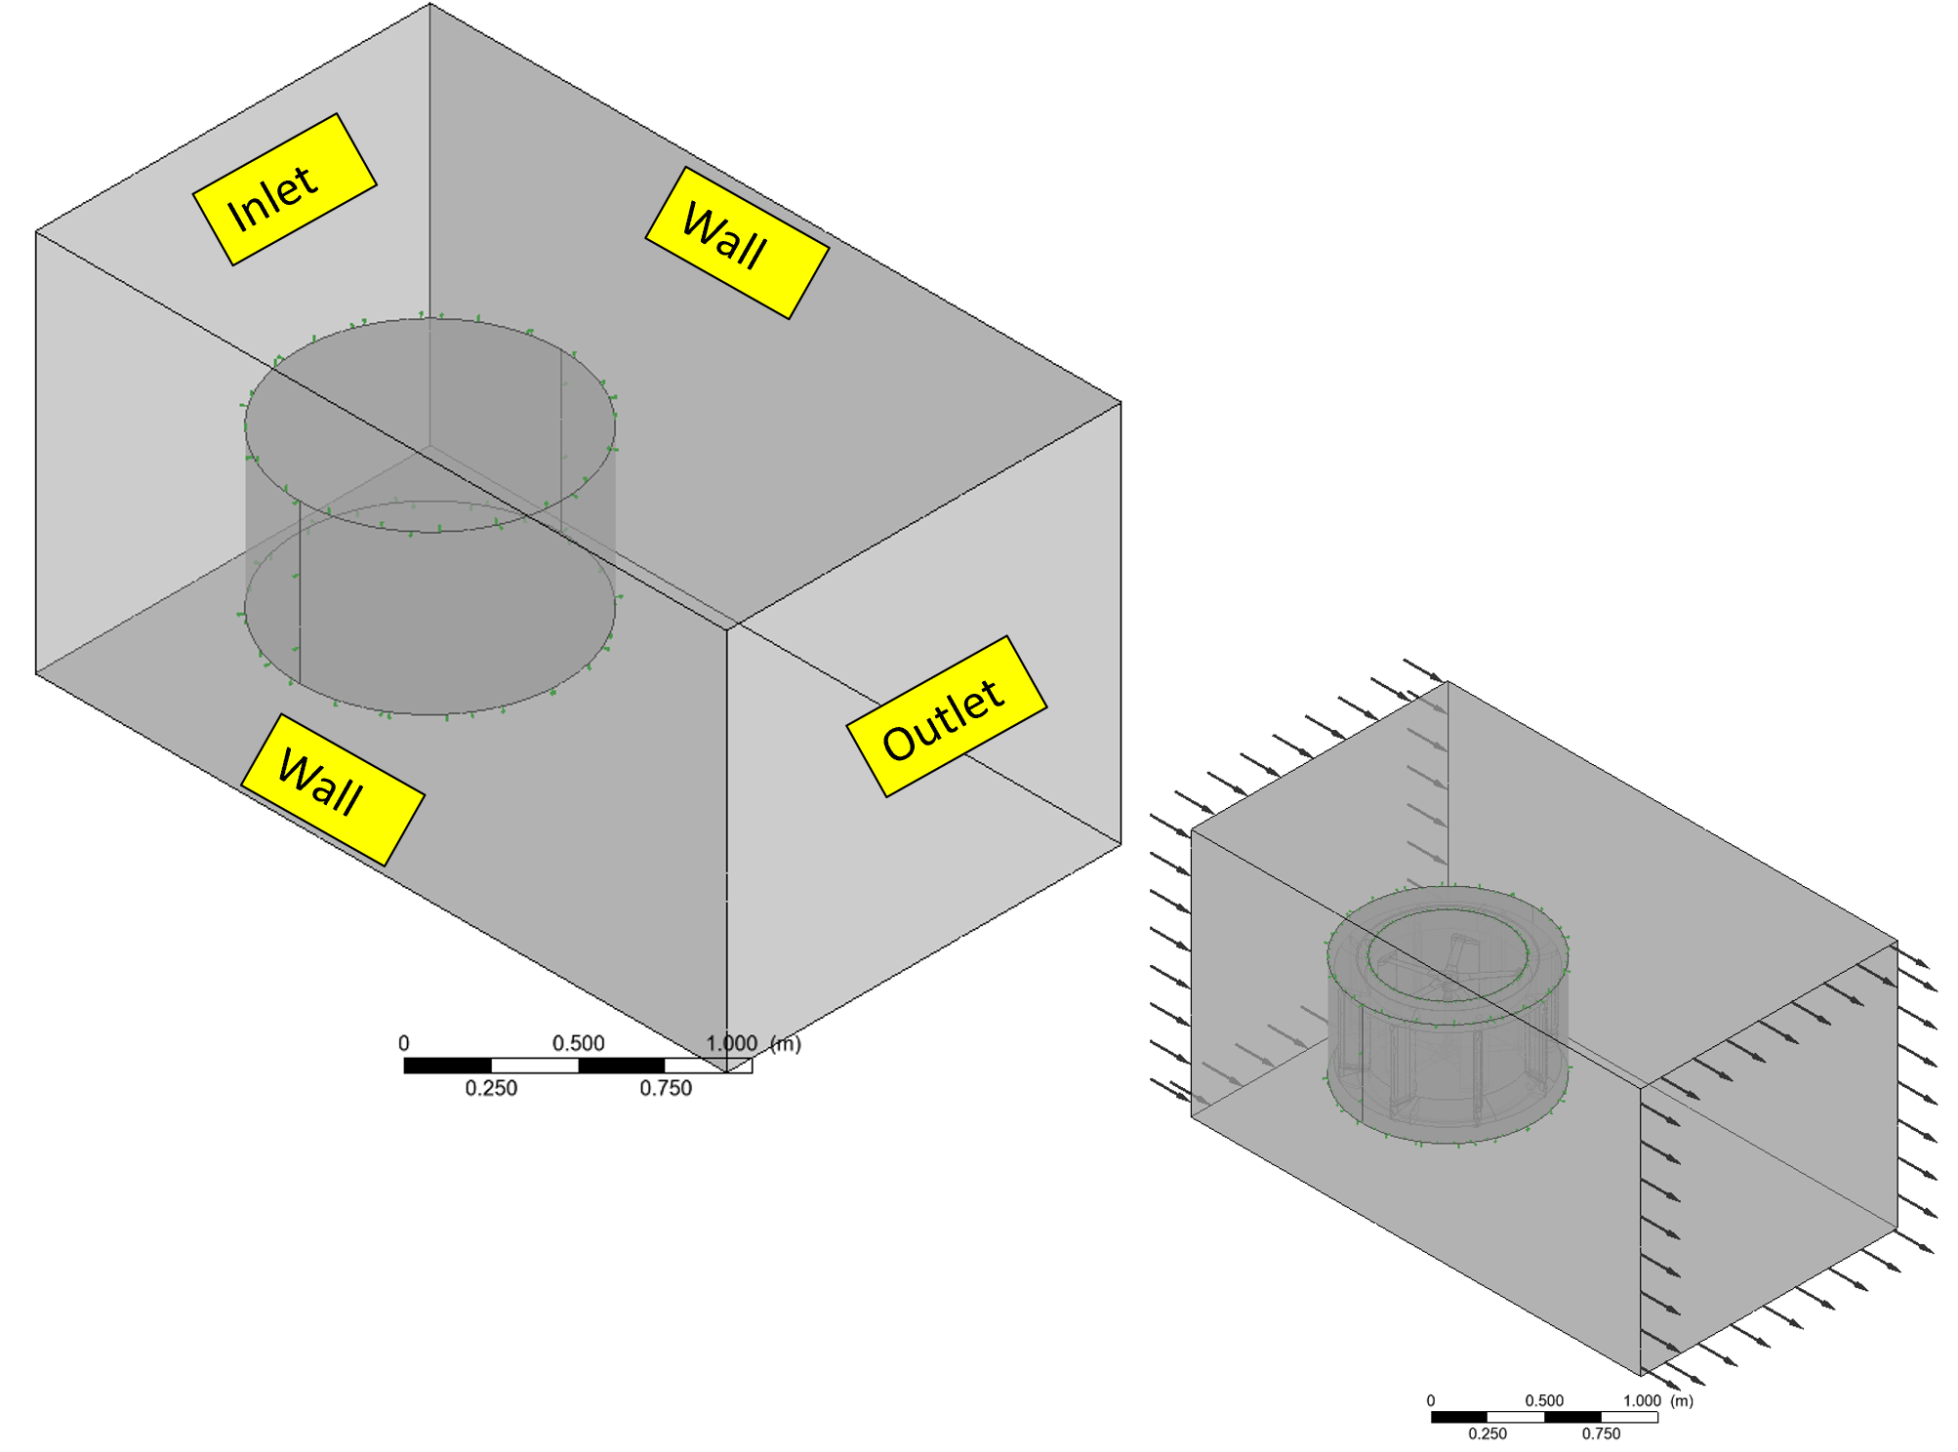
Fig. 1: Sketch of the imported geometry in ANSYS.
2.1 The rotor
The rotor (Fig. 2) utilised for this study is a straight bladed Darrieus rotor having a diameter of 140mm. The rotor is designed to have 5 blades connected by a shaft. There are apparently 8 supporting arms and these arms are all linked together by the centralised shaft. NACA 0018 was the aerofoil utilised for this study. The solidity for the rotor was kept at 0.73 whiles the pitch angle for the vertical as well as the horizontal blades was maintained to 0º. Using the blade chord(c), the pressure centre was kept at 0.25c
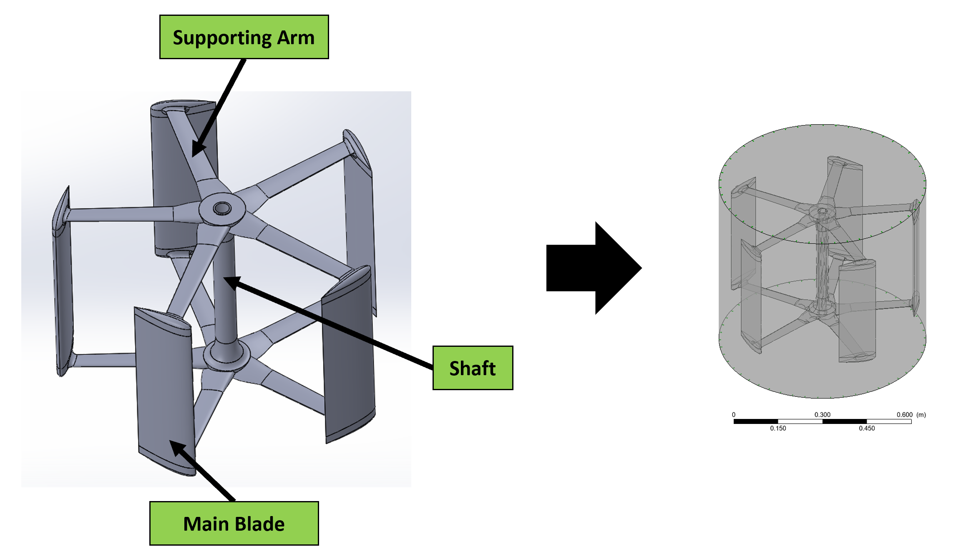
Fig. 2: Rotor blade design
2.2 Stator
The stator is made up of 8 straight vertical blades as well as two circular bases. The stator blades form eight similar and converging inlet surfaces to focus the mass flow rate adjacent to the rotor, while the cylindrical bases outer edges induce turbulent mixing above and below to lower back pressure inside the stator and boost the wind turbine's power output. The stator blades' aerofoil was designed as NACA0018 profile. The gap δ between stator and rotor, also called stator-rotor clearance, was set to 0.2m with a stator-rotor turbine diameter ratio (Ds(out)/Dr) of 1.6. The stator blades are set at a 0 degrees angle from the radius, while the top and bottom conical surfaces are set at a +30 and -30 degrees angle from the horizontal.

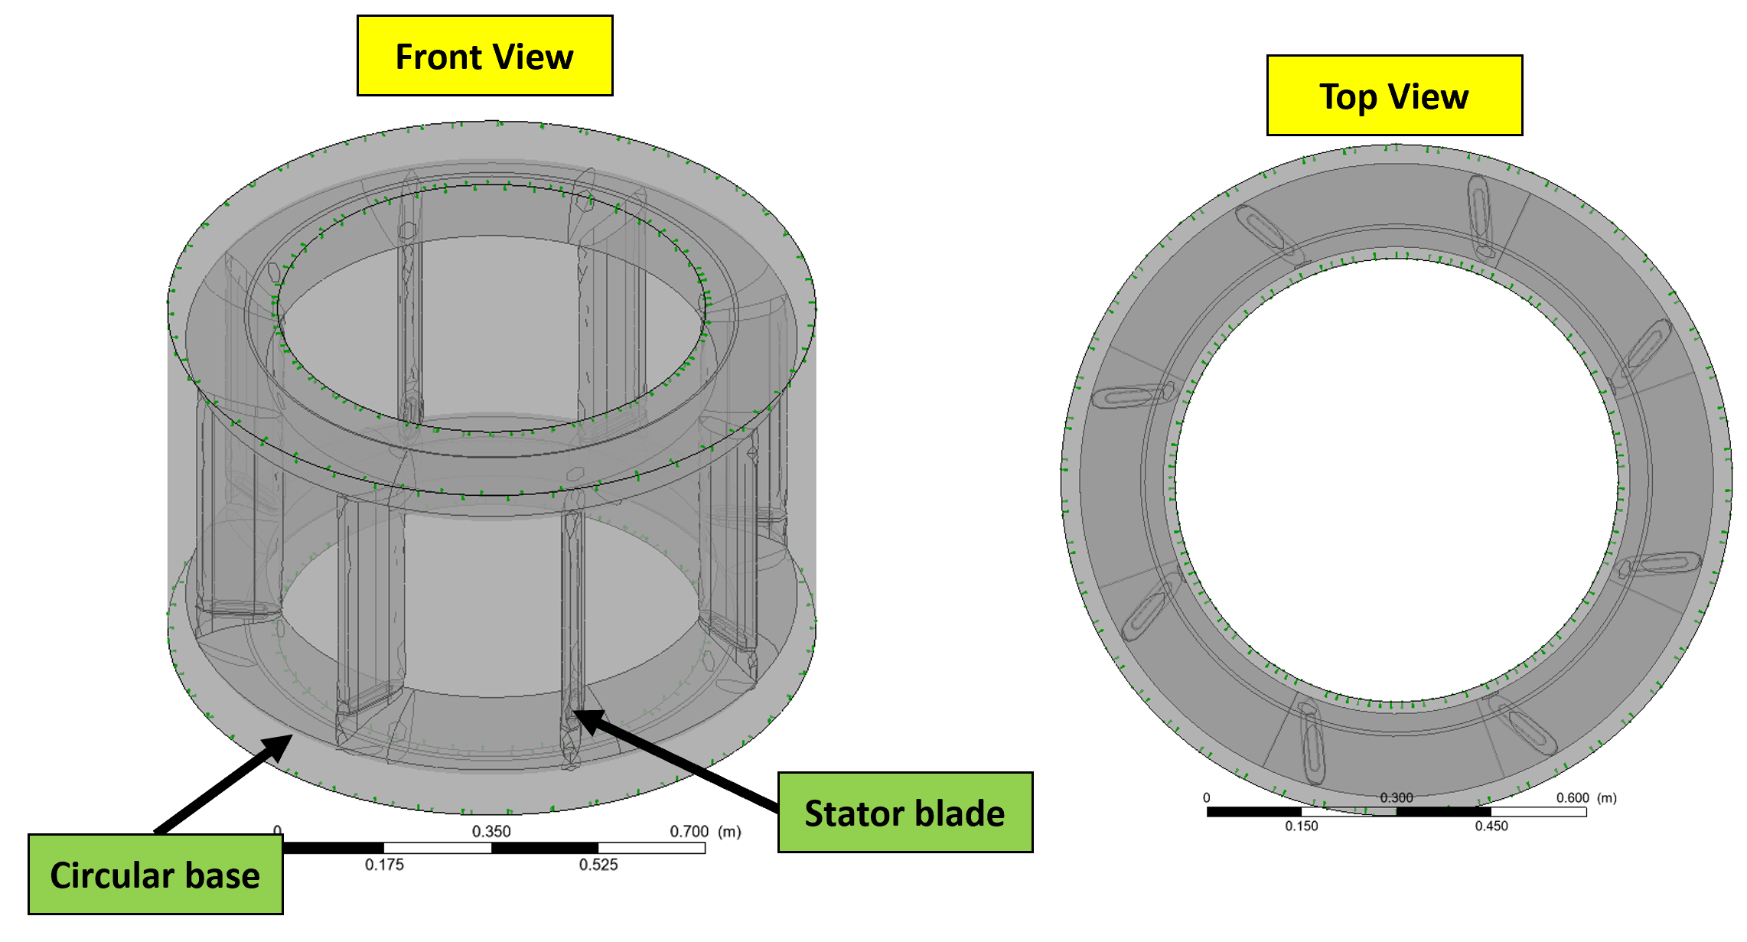
a)
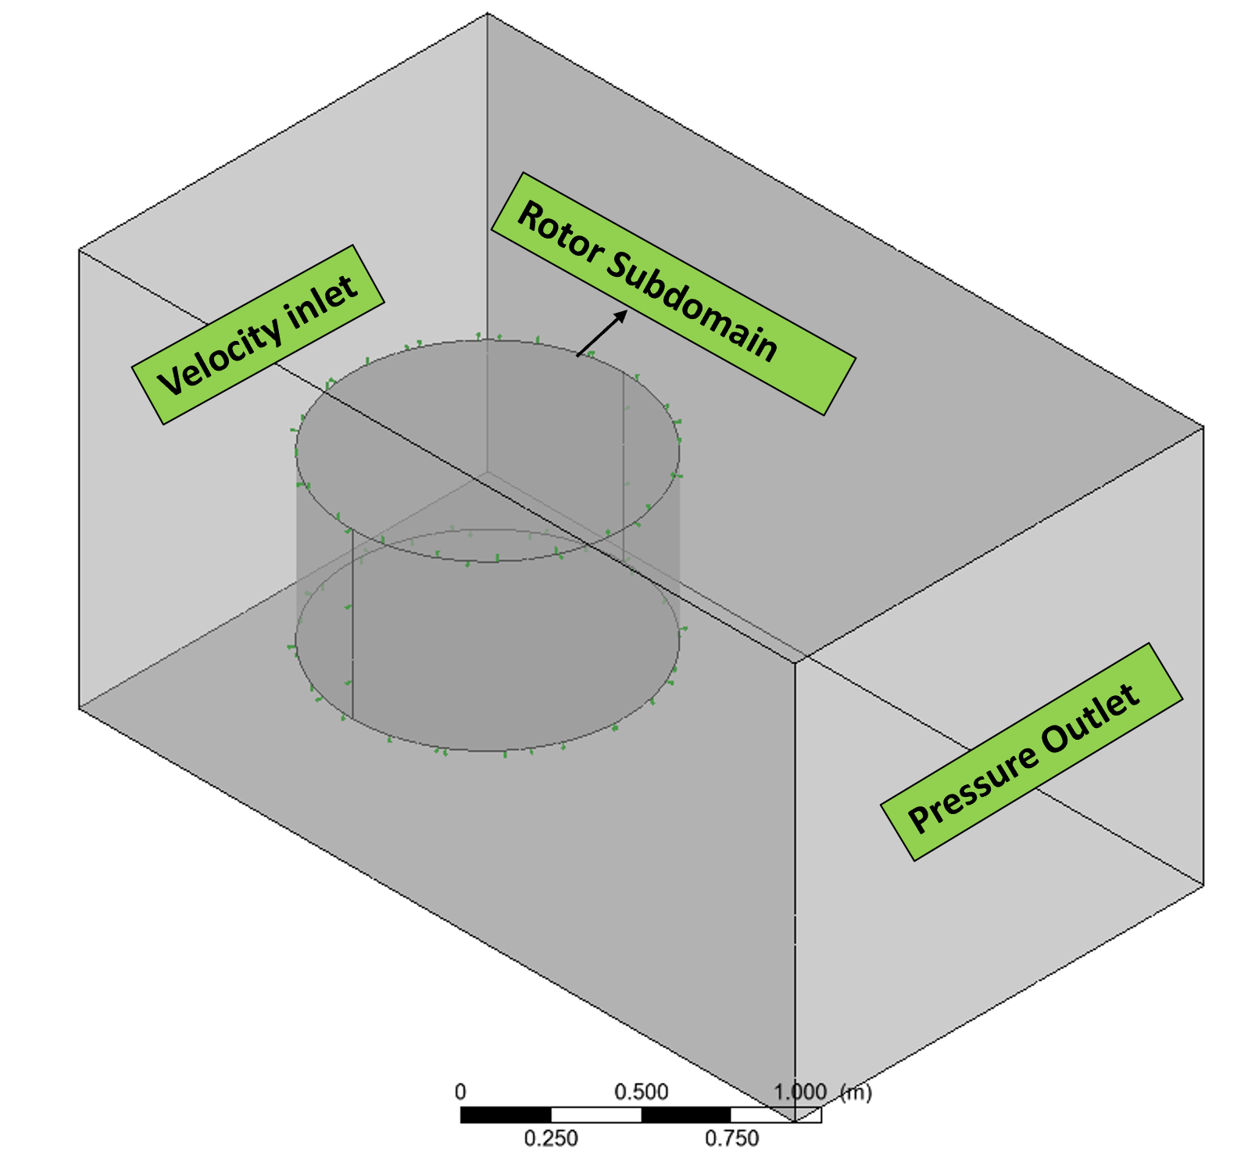
b)
Fig. 3: a) 3D stator for the augmented wind turbine b) Proposed wind tunnel
2.3 Computational domain
With the present study exploring the operational characteristics of a 4 bladed rotor for a vertical axis wind turbine, the usage of both fixed as well as rotating domains has become very necessary. As captured in Fig. 3b the fluid domain is made up of 2 separate domains namely a rectangular outer domain having a circular aperture as well as an inner circular domain that fit perfectly into the opening. The wind tunnel is basically the rectangular domain whiles the rotor domain is represented as the circular section.
The wind tunnel is designed to capture air flow around the augmented rotor. The dimensions for the rotor diameter was six times lower than that of the wind tunnel domain. The hole within the tunnel is also designed as explained earlier to accommodate the stator – rotor domain. For consistency, the boundary parameters for the inlet was designed as 10 rotor diameters upwind due to the fact that the boundary conditions closer to the rotor will present an inaccurate solution. The outlet boundary condition on the other hand was also designed to be 14 rotor diameters downwind mainly for monitoring the formation of wake when the turbine is in operation. With a turbulence intensity kept at 5% mainly for simulating the operation of the wind turbine in an urban area, the inlet of the model was placed on the left region of the tunnel. The right section accommodated the outlet and a relative pressure of 0 Pa assigned. The outer rectangular domain had a structured mesh mainly to speed up the computational calculations and reduce simulation time. The side walls were subjected to 2 wall boundary circumstances. As the 2D model was generated from the 3D complete model's midsection, two symmetry boundary criteria were evaluated for the top and bottom halves of the tunnel. In order to assure fluid continuity and quicker result convergence, an interface boundary condition was used. The rotor is divided into 2 varying subdomains ie the circular subdomain near the rotor blades as well as a circular domain within the rotor having a central shaft. An angular velocity was introduced for each of these domains. These domains were then fixed into the circular hole within the wind tunnel domain. The domains were initially meshed with irregular mesh densities because these types of meshes were best suited for aerofoils. This approach of clearly separating the domains was necessary in order to create some leverage in the creation of the quality of mesh around the rotor. To ensure the continuity of fluid through the domains, interface boundary conditions was equally adopted. To reduce computational time, mesh size in between the two domains was maintained throughout the simulation. To further reduce the computational time a symmetry boundary condition was utilised in order to conduct the simulation in 2D. The stator on the other hand had 8 NACA0018 symmetrical blades positioned around the rotor within the circular section in the proposed wind tunnel. Similarly, interface boundary condition was also kept in between the wind tunnel and the stator. The stator blades were also maintained as wall boundary conditions. The top as well as bottom sections of the stator were also halved using symmetry boundary condition. The presence of the stationary ring positioned closer to the stator blades was to have some room in controlling the quality of mesh within this region. The stator domain also had an unstructured mesh. Fig. 5 shows the type of mesh used for the investigation.
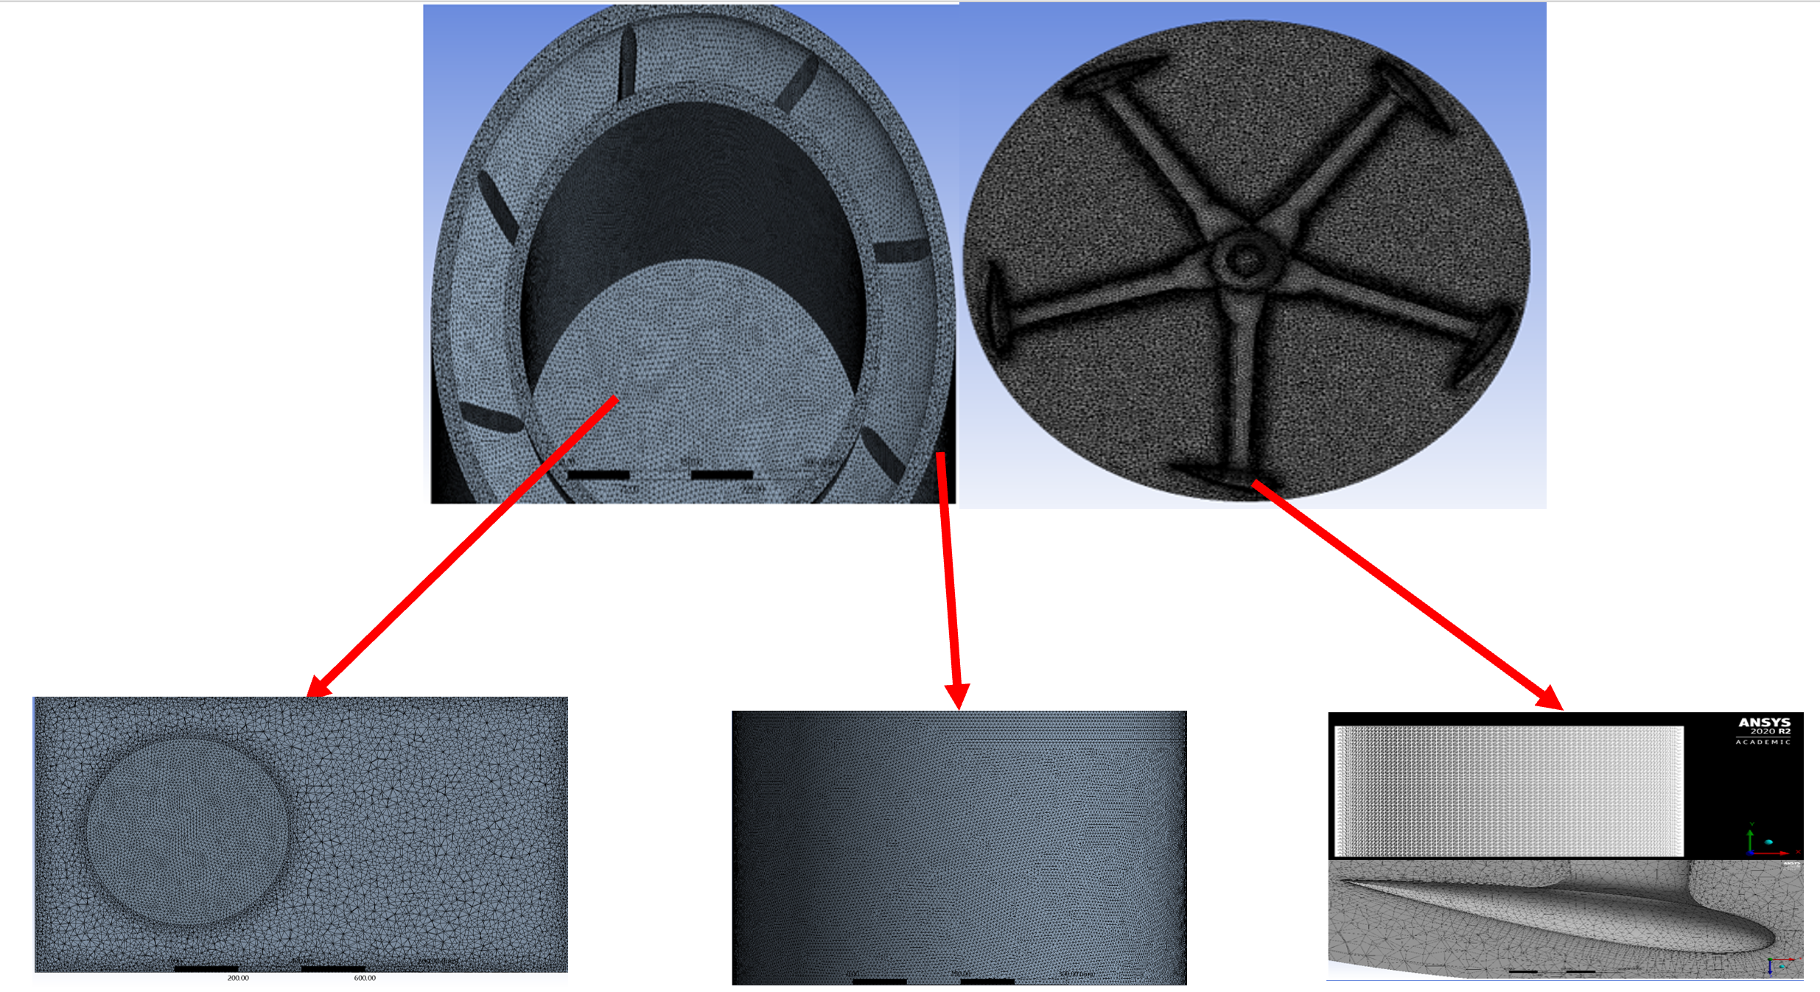
Fig. 4: Mesh developed during simulation for the various domains.
From Fig. 4 it can be observed that these subdomains were necessary in order to enhance the quality of the mesh closer to the stator as well as rotor blades. This was necessary to clearly deduced and appreciate the development of wakes closer to the blades. A CFD Ansys cfx 2020R2 was used for the simulation. The Reynolds Averaged Navier Stokes equations was used via the application of the finite volume method. Equation 1 and 2 highlights the equation used.
$\text{Continuity equation: }\text{∇}\text{.} \vec{\text{v}}\text{=0}$ (1)
$\text{Momentum equation: }\text{ρ}\left[\frac{\text{∂}\vec{\text{V}}}{\text{∂t}}\text{+}\left(\text{V.}\text{∇}\right)\text{V}\right]\text{= -}\text{∇}\text{P+ρg+μ}{\text{∇}}^{\text{2}}\vec{\text{V}}$ (2)
Where; $\text{ρ}$ is density, change in velocity with respect to time is $\frac{\text{∂}\vec{\text{V}}}{\text{∂t}}$ and convective acceleration $\left(\text{V.}\text{∇}\right)\text{V}$. Pressure gradient is $\text{-}\text{∇}\text{P}$, body force term $\text{ρg}$ and viscous term ${\text{∇}}^{\text{2}}$.
The selection of the best turbulence model for any CFD related project often comes with some bit of challenge because this is subject to the nature of the type of flow under investigation. This has a direct correlation to the computational power, time as well as the accuracy of the results to be generated. The Direct Numerical Simulation (DNS), Large Eddy simulation (LES) and RANS are some often used type of turbulence model for CFD simulations. The DNS on the other hand will require more resources unlike the LES and RANS.
2.4 Mesh sensitivity study
Several studies were explored in order to evaluate the correlation between the quality of mesh being used for the investigation and the outcome deduced. Computational time as well as the accuracy of the results to be gathered is sine qua non to the type of mesh being used in the simulation. Table 1 presents a summary of the time for the various simulation and time for each results gathered. It can be argued that the number of elements/mesh determined the computational cost for this simulation.
Table 1: Computational time for the fine, coarse and medium mesh under investigation
Types of mesh | Coarse | Finer | Medium
Elements | 35,000 | 3,160,000 | 468,000
Time taken for simulation (minutes) | 145 | 340 | 180
The study was performed for the 4-blade rotor with the wind speed ($U_{∞})$maintained at 7m/s and tip speed ratio ($λ)$of 2.5. This was due to the fact that the optimum turbine performance was more likely to occur with a tip speed ratio of 2.5. Fig. 5 presents the instantaneous torque per unit blade length against the azimuth angle which is basically the complete rotation of a rotor blade. The investigation was examined for a finer, Coarse as well as medium mesh. It can be observed from Fig. 5 that at the initial start i.e., in the range of angle (0 – 30º), there is a perfect agreement between the 3 meshing under study. As the investigation transcends between azimuth angle of 30 – 180º there is huge deviation between the coarse mesh and the fine mesh but after azimuth angle of 180º, the results for the medium and coarse mesh are closely related hence to accelerate the computational time but maintain the accuracy of the data being gathered, the medium mesh will be the most ideal option. It can also be seen that the torque is positive for the medium and fine mesh with the only negative values being recorded at azimuth angles 345º and 24º. Higher amount of energy is also gathered in the upward region in particular at angle 90º but around 220º lesser amount of energy is deduced.
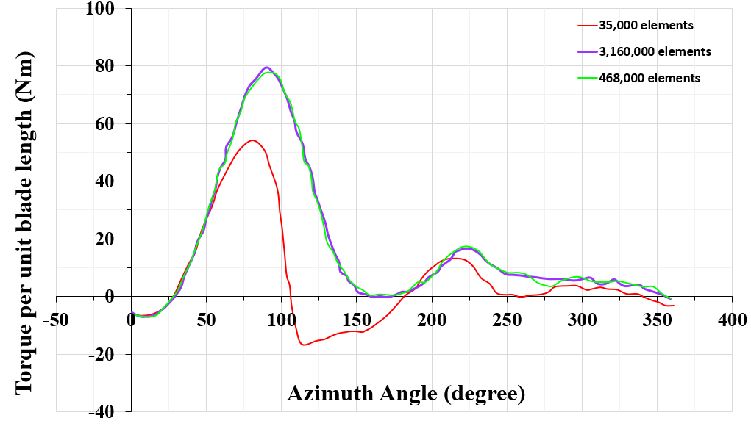
Fig. 5: Effect of element size on the accuracy of the simulation
2.5 Time correlation investigation
The next stage of the study was executed to appreciate the effect of time step on the outcome of the study being conducted. A new variable (Time) was introduced into the simulation mainly to capture the unsteady flow caused by the rotation of the vertical axis wind turbine. It has been reported in literature that in order for the simulation to converge, it is largely dependent on the selection of a good time step [15,16]. The time steps considered for this study were 0.001, 0.002 and 0.003. Fig. 6 highlights the outcome of the various times steps on the simulation. The results capture the torque per unit blade length for a rotor blade via a 360º revolution. It can be observed that there is literally no difference between the time steps considered hence 0.002 was selected as the ideal time step for the rest of the simulation.
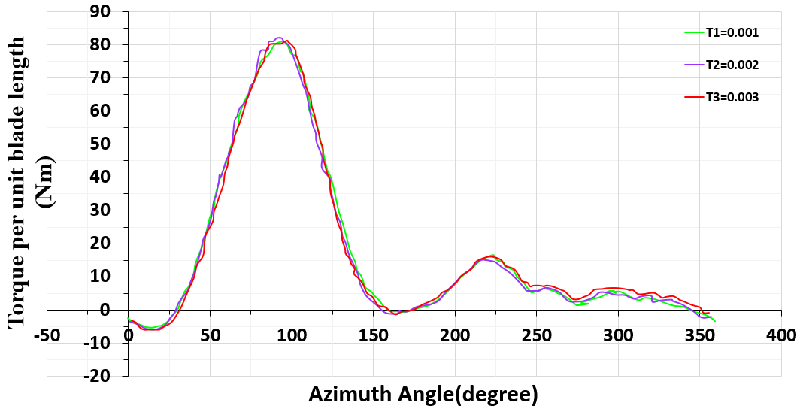
Fig. 6: Time dependence investigation on the simulation
2.6 Turbulence model
The study considered 3 varying RANS turbulence models namely standard K – $ε$ model, standard k – $ω$ and SST model. These 3 simulations were conducted using 468,000 elements and 0,002 seconds time step. Fig. 7 captures the torque forces for each of the model being investigated. It can be deduced that the standard K – $ε$ model led to a low torque being produced compared to that of the standard k – $ω$ as well as SST model. There is also a good correlation between the standard k – $ω$ and SST model for the upstream flow but deviation in the downstream. The SST model is often recommended for unfavourable pressure gradients as well as a separation in flow which is often predominant when the turbine is in operation. The functionality of the SST model comprises of two varying turbulence models namely k – $ω$ for the inner parts as well as k - $ε$ for the free – stream. It has been reported that the SST model has the tenacity of simulating in detail vortices in the event of a dynamic stall for lower tip speed ratio’s compared to k – $ω$ as well as K – $ε$ model [12].
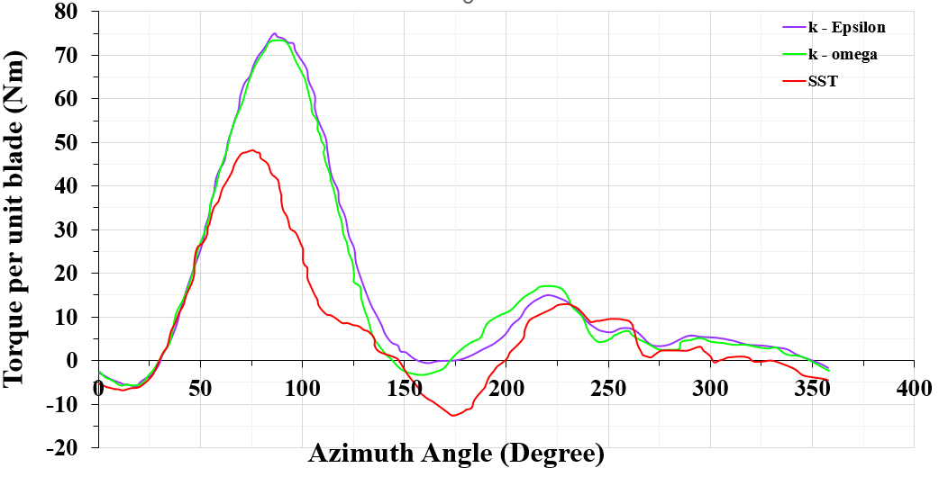
Fig. 7: Various types of turbulence model considered in study
Fig. 8 highlights the fact that the k- ε simulated model did not reveal a significant difference in terms of velocity near the stator blades. There are also some approximations in the bottom half for the rotor but the SST model presented a significant variation in terms of velocity near the rotor blades. It captures some stagnation in terms of the flow surrounding the stator. There is also a reduction of velocity near the supporting arms when the SST model was investigated. The SST turbulence model on the other hand is capable of predicting the dynamic stall for the turbine having higher accuracy. This model was recommended for running the transient simulations.
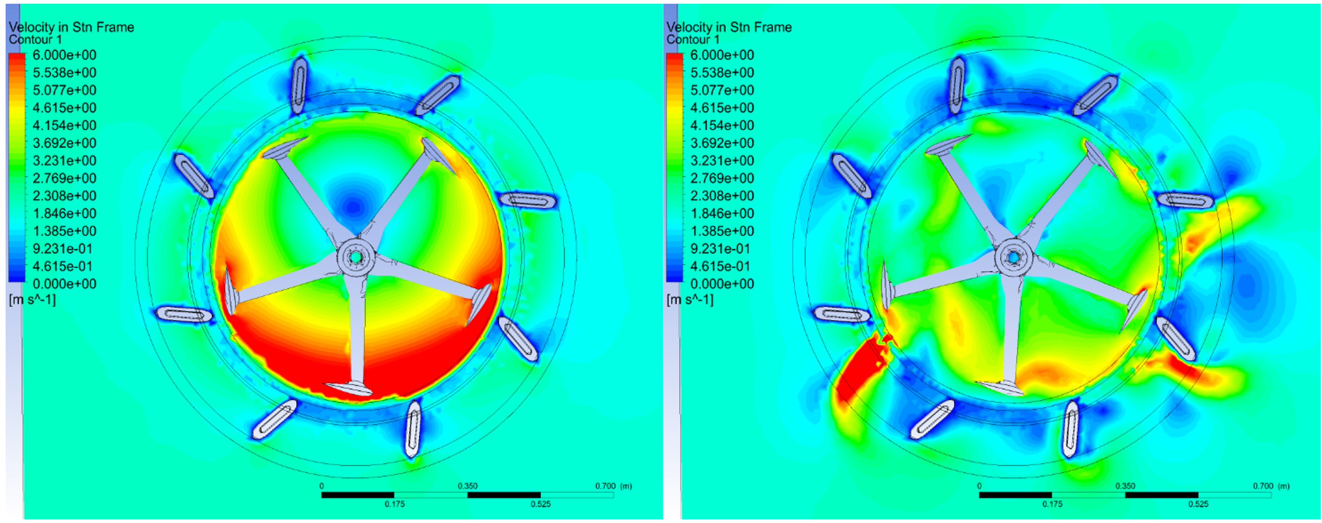  a) | b)
Fig. 8: a) k- ε model b) SST model
This investigation observed the torque as well as the tip speed ratio against power coefficient. $C_{t,average}$and $C_{p,average}$ denotes the torque coefficient as well as power coefficient respectively. Equation 3 and 4 present mathematical equations utilised in the determination of these parameters. Equation for calculating the tip speed ratio is also indicated in Eqn. 5.
$C_{t,average}= {T_{average}}/{0.5 * ρ* A_{r}R_{r}U_{∞}^{2}}$ (3)
$C_{P,average}= {P_{average}}/{0.5* ρ* A_{r}U_{∞}^{3}}$ (4)
$TSR= {ωR_{r}}/{U_{∞}}$ (5)
The wind speed taken into account for the study is $U_{∞}$ whiles the symbol $ω$ is the angular velocity. Radius for the rotor is equally denoted as $R_{r}$. $P_{average}$ is the average power and the density of air captured as $ρ$whiles average toque is $T_{average}$. Swept area is also depicted as $A_{r}$.
2.7. Model Validation
An investigation was carried out primarily to explore the correlation between an experimental data and the 2D open rotor under investigation. This was imminent in order to deduce the accuracy of the numerical computations. The intention was to explore the disparity between the experimental and numerical data gathered. The comparison was carried out using the outcome of work by Castelli et al [17]. The investigation was presented using a Darrieus rotor having symmetrical NACA series as well as exact solidity. The rotor was examined using 8 varying rotational speeds but maintained speed at 8m/s. Fig. 9 captures the experimental and numerical data as reported by Castelli et al [17] in tandem to the present study. Both numerical studies were carried out in wind tunnel while the experiment was performed at a low wind speed. The average power coefficient Cp against tip speed ratio is presented. The first observation is the shape of both curves being similar. For the study conducted by Castelli, the highest power coefficients for the experimental as well as the wind tunnel test was within a tip speed ratio of 2.50 with the power coefficient being 0.55 for the 2D and that of the wind tunnel recording 0.3. The authors clarified that the disparity between the numerical coupled with experimental work was due to the finite blade length as well as the drag omission in their study. They further presented that CFD could serve as alternative for future investigations on wind tunnels. Despite the geometrical difference between the present study and that of Castelli, the shape of the curve deduced is closely related to that of Castelli [17]. However, there is a 13% difference in terms of the average power coefficient which is due to the changes in solidity which is 0.7 in this study against 0.5 in Castelli [17], hence buttresses the argument by Paraschivious [18] that as the solidity increases the power coefficient increases as well [19]. In terms of the tip speed ratio, at which the maximum power coefficient occurs, there is a difference between 2.5 in Castelli et al [17] and 2.8 in this present study. This disparity is due to the variation in blade profiles for the various studies being conducted. It is very established that the performance of any wind turbine is largely influenced by the Reynolds number Re as denoted in Eqn. 4.
$R_{em}= {cU_{∞}}/ν$ (4)
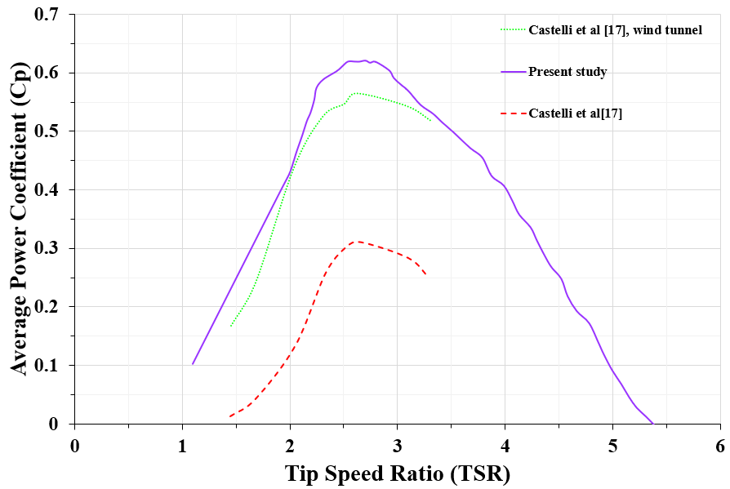
Fig. 9: Comparative study between Castelli et [16] and present open augmented wind tunnel
3. Results
The following simulations conducted considered a medium mesh as well as the application of the SST model based on the findings from previous sections. The time step for the study was also kept at 0.002 seconds. The criteria for convergence were equally maintained as 10⁻⁴. The first study was to explore the performance of the turbine subject to the speed of rotation. To better appreciate the outcome of the study, a graph for the velocity contours coupled with the power coefficient is presented. This is carried out at a tip speed ratio of 0.8.
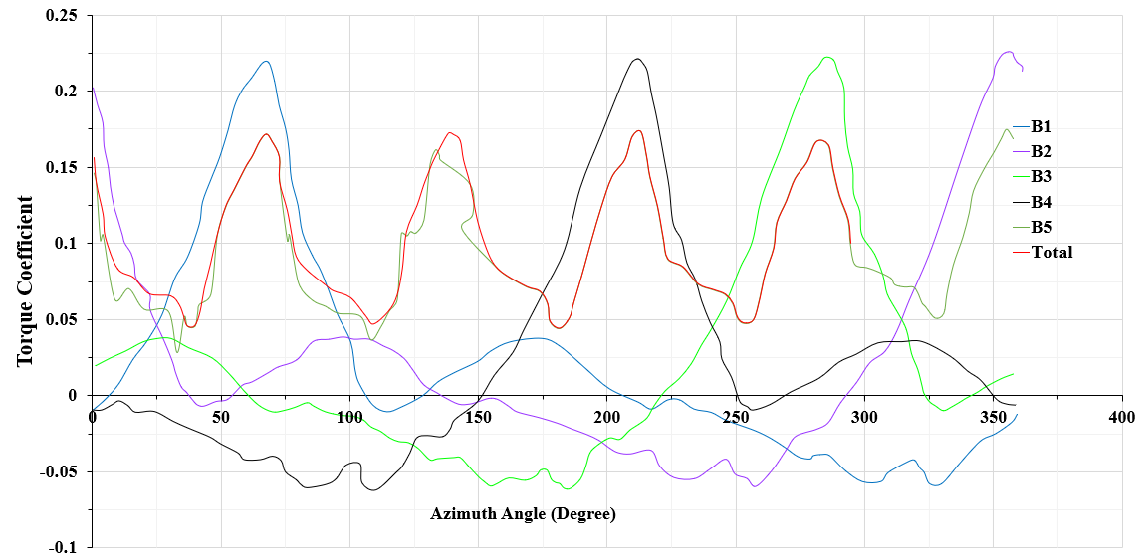
Fig. 10: The torque coefficient against azimuth angle on all blades
From Fig. 10, it can be evident that the higher torque for the blade occurs at azimuth angle more than 65º. there is an increment in drag because the blade attains a dynamic stall beyond this point hence the drag tends to dominate till 113º as well as 202º. There is the development of a negative torque beyond this point. The entire torque deduced for all blades for the open rotor is equally presented in Fig. 10. The changes in torque coefficient for one of the blades (B1) at varying tip speed ratio is also depicted in Fig. 11. It can be observed that beyond an azimuth angle of 200º, there is the development of a negative torque coefficient. It is seen that the highest negative torque coefficient was observable at tip speed ratio of 3. Due to the wake effect, there is high complexity in terms of the unsteady flow field.
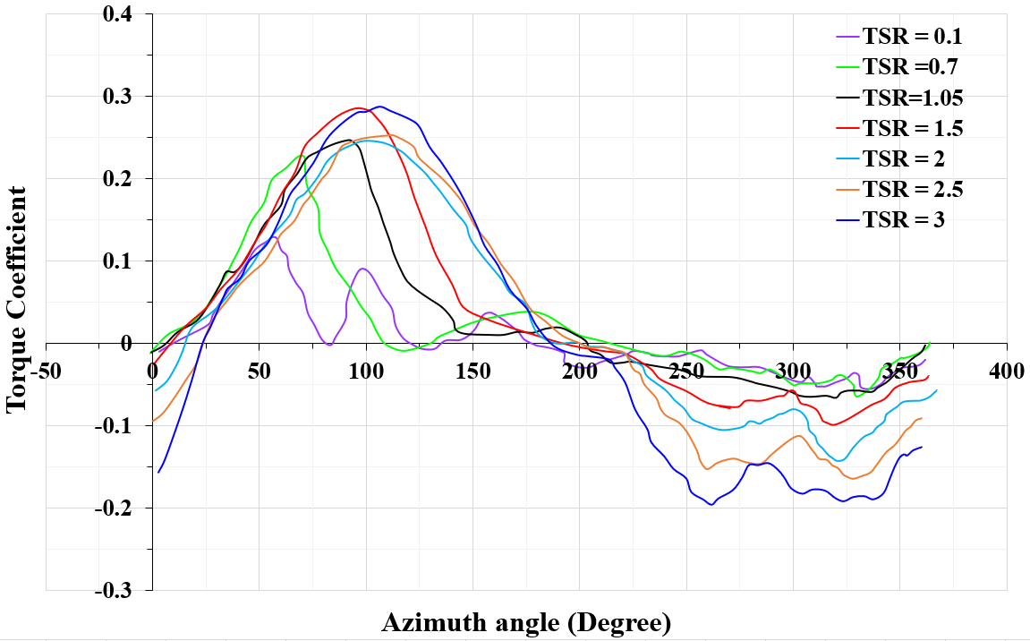
Fig. 11: Correlation between Azimuth angle and torque coefficient for varying tip speed ratio
Fig. 12 presents the velocity plots deduced for the turbine simulation at tip speed ratio of 3. It can be observed that there is a decline in wind speed closer to the stator blades inclined at an angle in tandem to the incoming wind. In the case of the upstream section of the turbine, the wind speed tends to increase at some regions closer to the blades of the rotor. There is a decrease in the rotor supporting arms. The wind speed equally slows down in the downstream region of the rotor. It is equally observable that the upper as well as lower stator blades causes a deviation in terms of the slower moving wind mainly to reduce turbulence around the rotor blades. There is appreciable increase from 2m/s to 9.34m/s due to the movement of the blade downstream. Other regions around the stator blades records an increment in windspeed from 0.7 – 2.9m/s. The stator blades cause the development of drag next to the rotor.
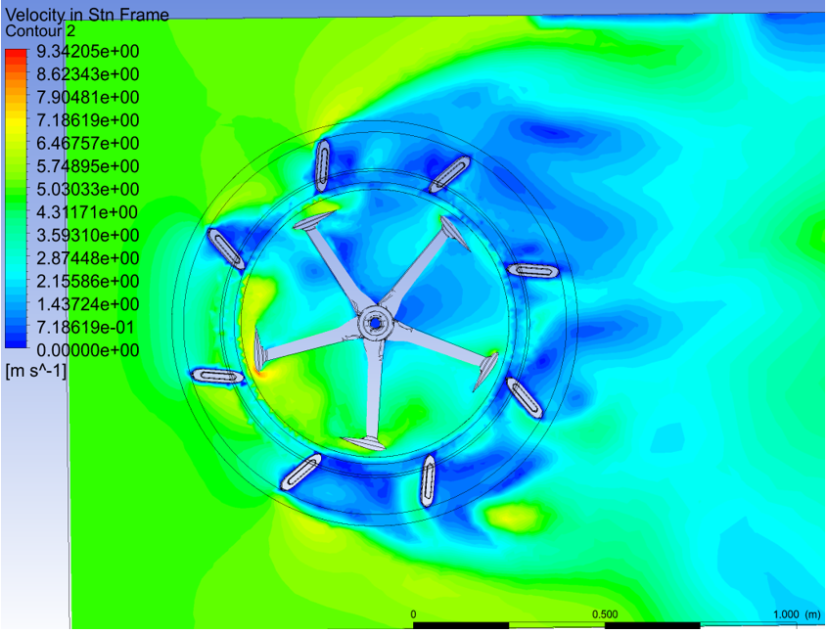
Fig. 12: Velocity profile at tip speed ratio of 3.
From Fig. 13, it can be observed that there is an increase in pressure when the wind meets the stator blades. This leads to a decrement in windspeed closer to the upstream stator blades. From the plot, it is seen that there is normalization of pressure when the air meets the rotor. Furthermore, the pressure dips slightly on the underside for the aerofoil particularly for the upstream region. It gives an indication of the blade causing a lift due to the difference in pressure. There is also an increment in pressure next to the central shaft as well as the short section of the supporting arm. Pressure difference from the entrance to the exit of the turbine can be deduced. The velocity streamlines for the simulation is depicted in Fig. 14. From Fig. 14, the stator blades serve as the passage for the airflow once it approaches the rotor.
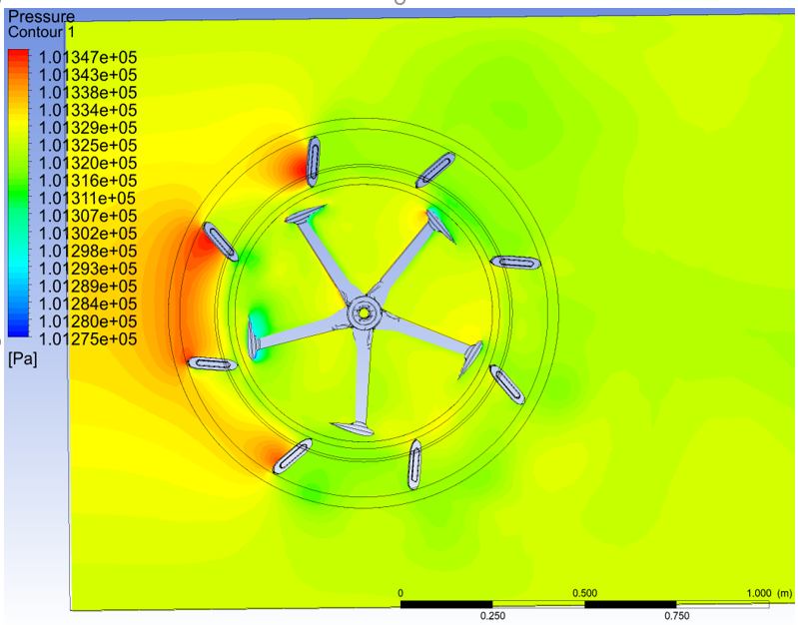
Fig. 13: Pressure profile at tip speed ratio of 3.
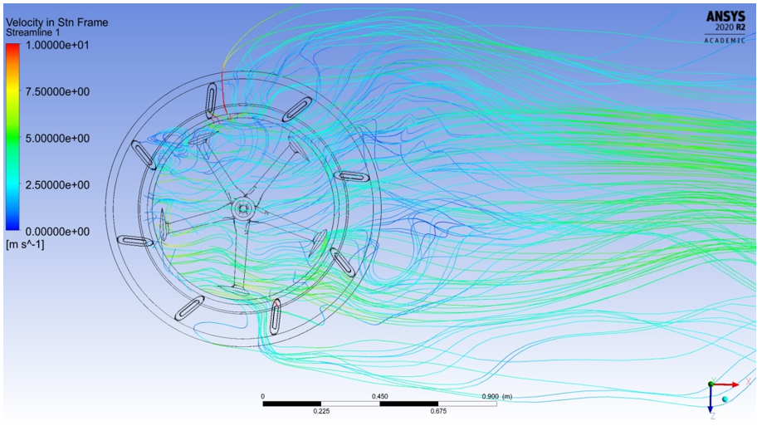
Fig. 14: Streamlines of air flow around the stator blade
Similarly, the tip speed ratio coupled with the torque coefficient is highlighted in Fig. 15. It can be observed that there is a direct correlation between the two parameters (torque coefficient and tip speed ratio) when the tip speed ratio was between 0.3 and 1.55 but beyond these tip speed ratios, the variations between the parameters are inversely proportional. In the case of the open rotor the highest torque coefficient is attained at tip speed ratio of 1.55.
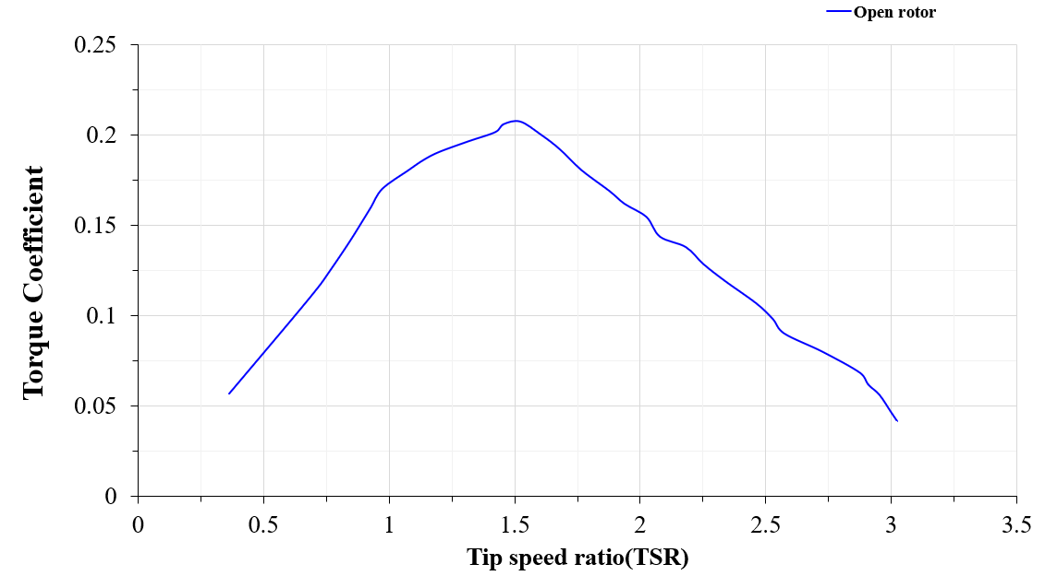
Fig. 15: Average torque coefficient against tip speed ratio
The power that can be harnessed from the augmented rotor in comparison to an open rotor is the next investigation conducted. To further appreciate the study in detail, eight varying tip speed ratio for the open rotor as well as the augmented rotor was explored. The convergence criteria for the study were maintained at 10⁻⁴ just as was carried out in order investigations explained earlier. The variation between the torque coefficient and the azimuth angle for both open and augmented rotor is highlighted in Fig. 16. The highest torque coefficient occurred at 0.26 for the augmented rotor whiles that of the open rotor was 0.225. This was slightly over 13% increment compared to that of the rotor.
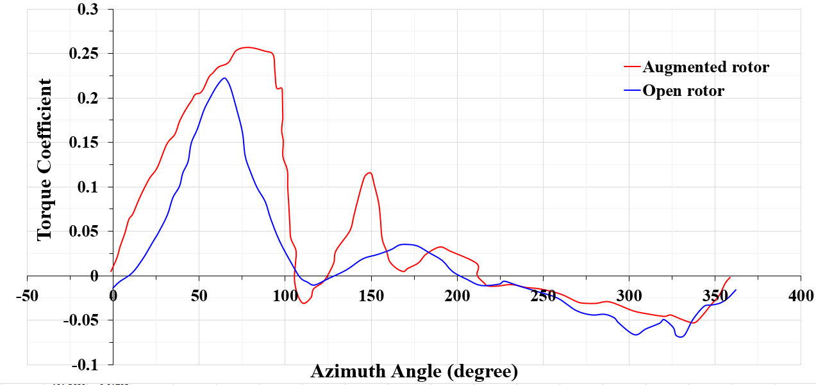
Fig. 16: Azimuth angle against Torque coefficient for the open as well as augmented rotor
The result for the augmented rotor is captured as the solid line whiles the open rotor is the dashed line. It is obvious that the augmented rotor performed better compared to the open rotor concept. This is more predominant between azimuth angle of 0 – 150º. The maximum torque coefficient is attained at an azimuth angle of 87º but that of the open rotor was recorded at 65º. In all, there were 3 peaks for the augmented rotor. The next observable peak was after 155º whiles the last one was around 205º. Fig. 17 depicts the power coefficient for the open as well as the augmented rotor. It is observable that the open rotor achieved a maximum power coefficient at tip speed ratio of 2.8 but at the same tip speed ratio the augmented rotor achieved a power coefficient which was higher than that of the open rotor by 1.38 times.
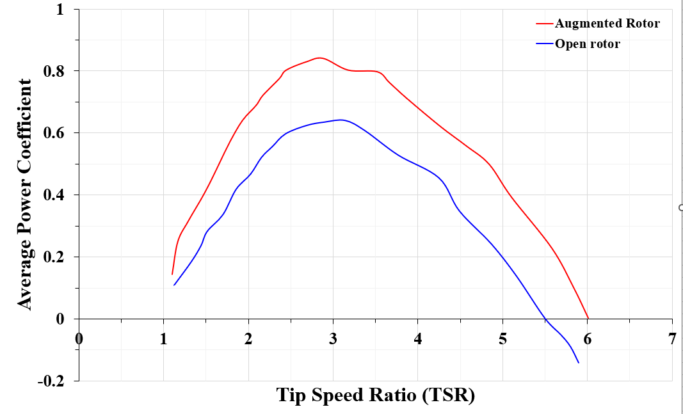
Fig. 17: Power coefficient against tip speed ratio for the open as well as augmented rotor.
To further appreciate the output power derived from a turbine in tandem to the speed of wind, varying wind speed were equally investigated. The goal was to ascertain the torque and power deduced by varying the speed of wind as well as the tip speed ratio. This was to better appreciate the augmented rotor operating at lower as well as optimum values. For varying wind intensity, the torque per unit blade as seen in Fig. 18 increase with the speed of wind at the highest tip speed ratio of 2.50. The torque per blade length is also nearly 5 times higher at 12 m/s compared to the values obtained at 6m/s.
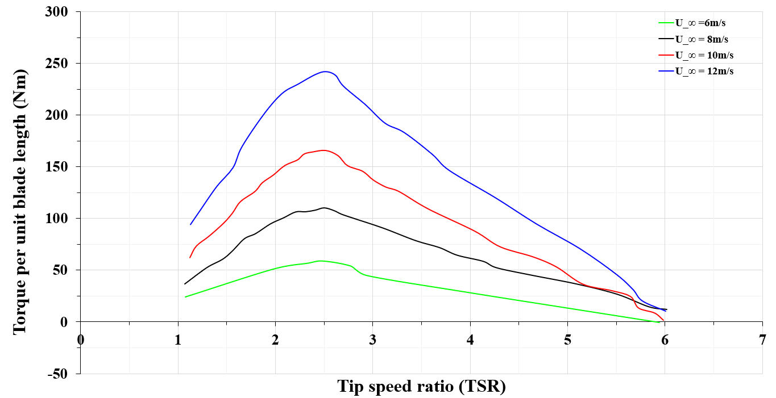
Fig. 18: Effect of varying wind intensity on torque per unit blade length against tip speed ratio
Fig. 19 captures the variation for the blade stator orientation and how it impacted the rotor torque. To execute this task, the rotor blade pitch is maintained at 0º whiles that of the stator pitch was varied from -30º,0º,30º at tip speed ratio of 2.8 because the highest average power coefficient was attained at this tip speed ratio. The wind velocity for the study was kept at 12m/s. Fig. 19a captures the torque per unit length vrs the azimuthal angle. The instantaneous torque coupled with the total torque for the stator blades angle at -30º is equally captured. It can be deduced that there is a drift to the right in terms of the highest value for the instantaneous as well as the total torque forces as against the results for the open rotor depicted in Fig. 5, 6 and 7. The highest torque using blade one (B1) as an example is attained at azimuth angle of 135º but that of the open rotor occurs at 90º. In terms of the torque area, the area encompassed by the augmented rotor having the stator blades at -30º is higher compared to only the rotor. From Fig. 19b, it can be observed that the average torque value at stator blade angle of 0º is higher compared to the average value of 60Nm obtained in the stator blade angle of -30º. Despite the torque values obtained in Fig. 19b being positive, there is a significant drop in torque at azimuth angle of 68º. It must be stated Fig. 19b moves more towards the right with several peaks as well as negative values when compared to that of the -30º in Fig. 19a. It equally shows that higher torque values are deduced upstream. For that of the stator blade being 30º, the average torque values are noted to being lower compared to that of Fig. 19a and 19b.

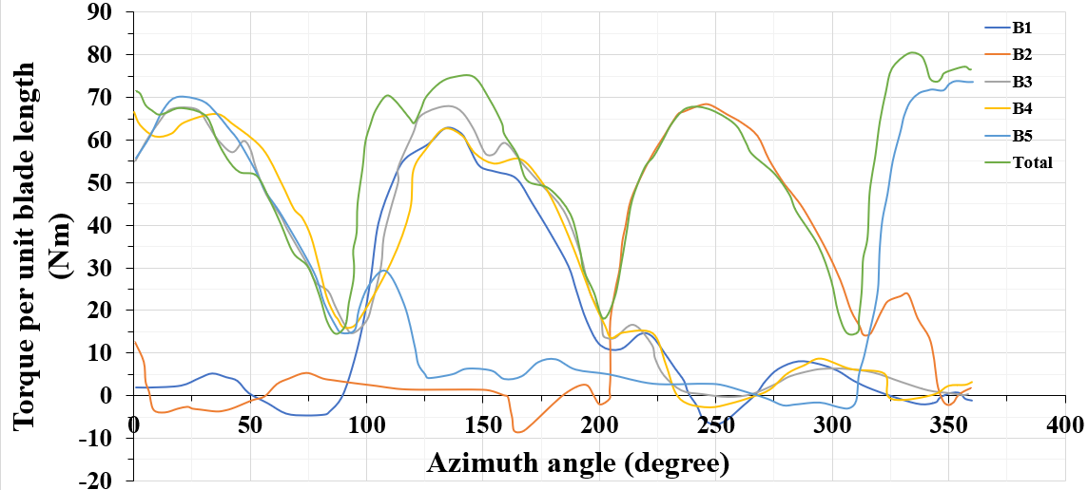
a)
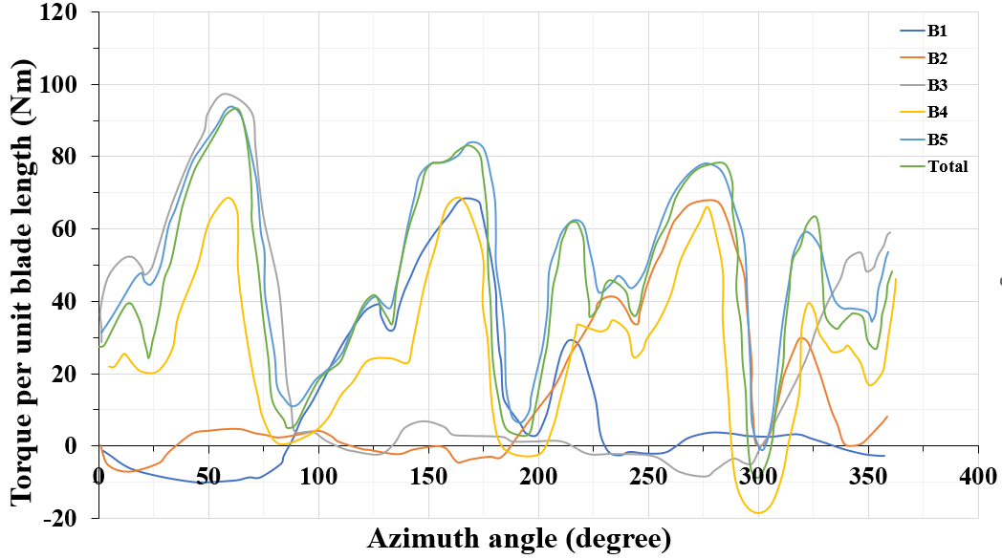
b)
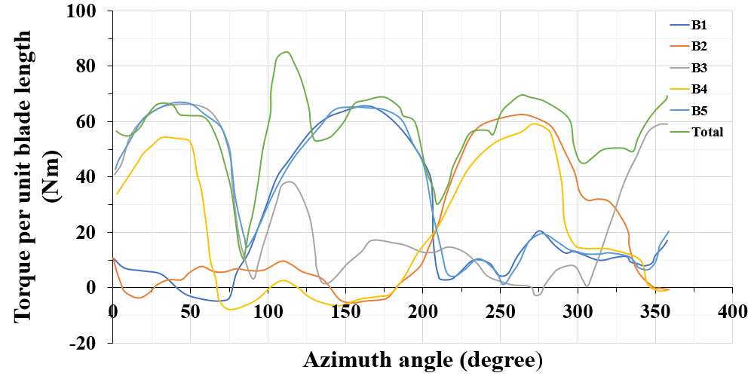
c)
Fig. 19: Effect of varying stator blade orientation a) (-30º) b) 0 c) 30 on torque for the AWT
Fig. 20 captures the outcome of the study where varying rotor blade orientation and their effect on power coefficient and torque coefficient was ascertained. A 0º degree angle was maintained for the stator blade whiles that of the rotor blades were analysed for 0º, 2º and 5º. The computational time for these simulation was nearly 2 days and 6 hours. There is some variation between the three rotor blade orientations being investigated though that is slightly insignificant. From Fig. 20a) it is observed that the average power coefficient improved slightly at 2º. This analogy is based on the fact that the area covered by the 2º rotor blade orientation was higher compared to that of the 0º and 5º.
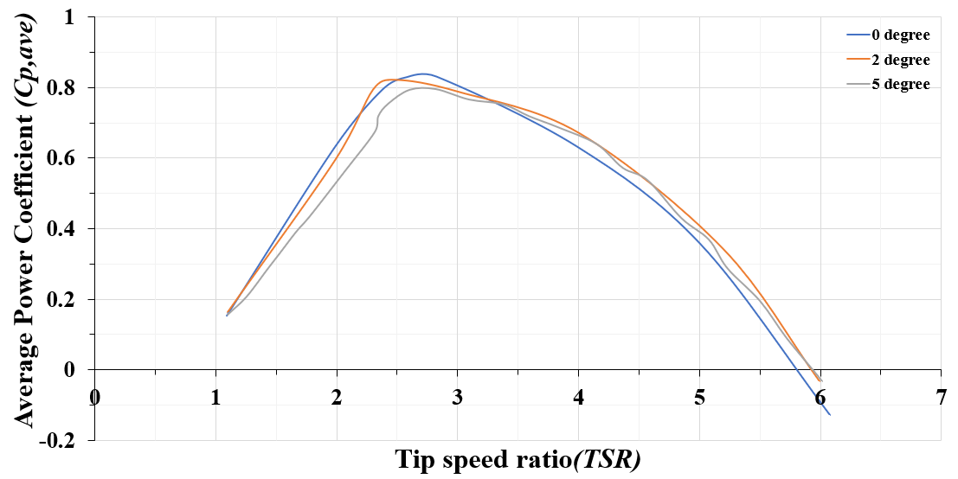
a)
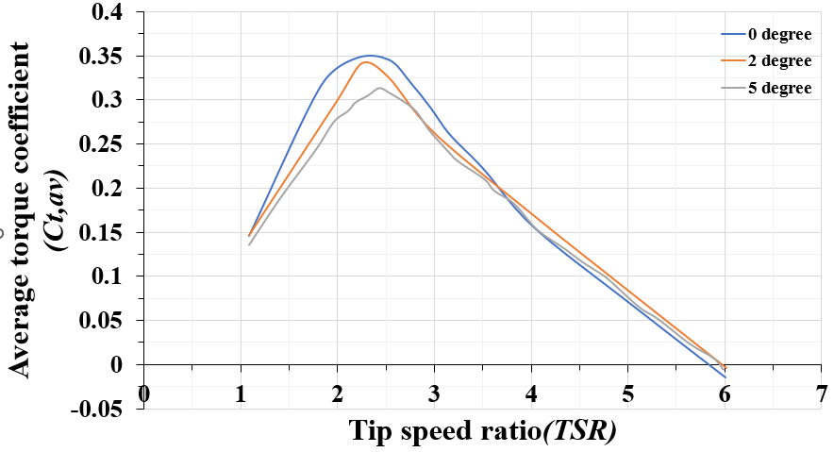
b)
Fig. 20: Varying rotor orientation for a) Average power coefficient (Cp,ave) vrs Tip speed ratio (TSR) b) Average torque coefficient (Ct,av) vrs Tip speed ratio (TSR)
The average torque coefficient is depicted in Fig. 20b. It can be observed that from 0º to 2º rotor blade orientation, there is an improvement in terms of the torque coefficient. It can be highlighted that the highest torque coefficient for a 0º rotor blade angle occurred at tip speed ratio of 2.36 whiles that of 2º rotor blade orientation occurred at 2.28 tip speed ratio. On the other hand, at 5º rotor blade orientation, the highest torque coefficient was attained at 2.48 tip speed ratio unlike the average power coefficient where the highest values occurred at 2.8 tip speed ratio at depicted in Fig. 20a)
4. Discussion
The present work explored the utilization of computational fluid dynamics in the development of augmented wind tunnel. It has been deduced that mesh sensitivity test coupled with the turbulence model is critical in the determination of an accurate numerical results as discussed earlier. To further ascertain the effect of time step on the accuracy as recommended in [15, 16], the present study varied three-time steps and 0.002 was settled on as the most ideal for the rest of the simulation. The work investigated the numerical results to that of an experimental data a from literature [17]. There is a good correlation between the two data sets. Similarly, the presence of a stator had significant impact on the amount of power being generated. From the study, the number of cells and nodes in order to capture the fluid dynamics at the boundary layer on the surfaces of the blades must be critically taken into account in the simulation. From fig. 6, harnessing of energy in the case of the open rotor occurs at the upstream at azimuth angle beyond 93º but when the study delved into the downstream, there was small amount of energy being harnessed particularly at peak of 225º. The outcome of the numerical data gathered for the complete rotation was in perfect agreement with other data published in literature [16]. Furthermore, the turbulence model selected can influence the flow developed, computational time as well as the accuracy of the data being gathered. The turbulence module considered in this study were the $k- ε$ model, $k- ω$ model as well as $SST$ model. The results deduced using the $k- ε$ turbulence model were inaccurate whiles the $k- ω$ as well as the SST model were in perfect agreement. Though the $k- ω$ was ideal for augmented wind turbine, the SST turbulence model was used for the entire simulation because it could predict dynamic stall at lower tip speed ratio. Study into time dependence was imminent to strike a balance between the accuracy of the results gathered coupled with computational time. The presence of a stator from the investigation equally helped improved the power being produced. To speed up the flow upstream as well as decrease the flow downstream, the presence of a surface that converges at the top but diverges at the bottom was recommended. In order to decrease drag, the shading sections developed by stator blades was seen to be a solution to mitigate this challenge. The rotor blades show that considering the upstream as well as downstream regions, the rotor blades was subjected to varying peaks with the torque averagely being higher in the case of the augmented rotor as against the open rotor. For suitable energy generating process, the stator ensures air is guided into the rotor plane. It has been deduced that intensity of the wind speed significantly affects the amount of energy being generated but this is directly proportional to how the stator blades are oriented.
5. Conclusion
As the world continue to strive for environmentally friendly medium of harnessing energy, the wind industry is considered by the research community as a solution to salvage the situation but there are concerns relating to suitable sites where the turbines required in harnessing energy from the wind could be installed. The cost of installation, decommissioning and maintenance has been primary point for discussion by both policy makers and engineers due to how some of these commercial wind turbines are designed. The present study focussed on vertical axis wind turbine design and development due to their application within communities and cities as well as their abilities to harness energy from low wind speed. This investigation explored the development of open as well as augmented Darrius vertical axis wind turbine. An open rotor was examined initially with the quest of establishing a suitable mesh strategy for the work. Other sections equally covered the type of turbulence model as well as time step that must be considered for the rest of the study. Validation of the data gathered from the open rotor was equally explored. A comparative study between the open and augmented rotor in terms of the power coefficient as well as torque coefficient and torque per unit blade length was also explored. The effect of wind intensity on the augmented rotor was also examined whiles various orientation for the stator blades were also simulated to determine their effect on the power coefficient. The study has revealed the forces being exerted on the blades in the case of the open rotor was subject to the type of element as well as the turbulence model used. The time step though had an effect on the simulated data, it was less significant compared to the other parameters (e.g mesh) discussed earlier. The upstream section was where the highest energy extraction occurred, but this was the case at an azimuth angle of 90º. In terms of validation, there is a perfect correlation between the experimental data and the numerical data harnessed from Ansys. There was significant increment in the power as well as torque coefficient by more than 36% with the introduction of the stator. It is also observed that the average power coefficient improved at 2º rotor blade orientation compared to that of the 0º and 5º at a constant stator blade orientation of 0º. In terms of the torque coefficient, the studies show an appreciable increase between 0º and 2º. Varying the stator blade orientation at fixed rotor blades also presented some interesting results in terms of the accuracy of the simulated data gathered. Future investigations should consider multiple wind direction and how they impact the stator aerodynamics using computational fluid dynamics. Information covered in this study is to present a robust case to both policy makers and the wind energy research community on how the design of the blades and stator could be varied effectively to harness more energy from a vertical axis wind turbine sited within a community or city.
Reference
1. Omid Atlaschian, M. Metzger, Numerical model of vertical axis wind turbine performance in realistic gusty wind conditions, Renewable Energy, Volume 165, Part 1, 2021, Pages 211-223, ISSN 0960-1481, https://doi.org/10.1016/j.renene.2020.10.147.
2. M. Maalouly, M. Souaiby, A. ElCheikh, J.S. Issa, M. Elkhoury, Transient analysis of H-type Vertical Axis Wind Turbines using CFD, Energy Reports, Volume 8, 2022, Pages 4570-4588, ISSN 2352-4847, https://doi.org/10.1016/j.egyr.2022.03.136.
3. D. Micallef, G. van Bussel. A review of urban wind energy research: Aerodynamics and other challenges. Energies, 11 (2018), p. 2204.
4. W. Tjiu, T. Marnoto, S. Mat, M.H. Ruslan, K. Sopian. Darrieus vertical axis wind turbine for power generation i: Assessment of darrieus vawt configurations. Renew. Energy, 75 (2015), pp. 50-67.
5. Mertens, S., 2006. Wind energy in the built environment: concentrator effects of buildings (TU Delft).
6. S. Stankovic, N. Campbell, A. Harries. Urban Wind Energy (2009).
7. Rezaeiha A., Montazeri H., Blocken B. On the accuracy of turbulence models for CFD simulations of vertical axis wind turbines. Energy, 180 (2019), pp. 838-857, 10.1016/j.energy.2019.05.053.
8. Abe et al., 2005. K. Abe, M. Nishida, A. Sakurai, Y. Ohya, H. Kihara, E. Wada, K. Sato. Experimental and numerical investigations of flow fields behind a small wind turbine with a flanged diffuser. J. Wind Eng. Ind. Aerodyn., 93 (2005), pp. 951-970.
9. Mewburn-Crook, A., 1990. The Design and development of an augmented vertical wind turbine.
10. K. Pope, V. Rodrigues, R. Doyle, A. Tsopelas, R. Gravelsins, G.F. Naterer, E. Tsang. Effects of stator vanes on power coefficients of a zephyr vertical axis wind turbine. Renew. Energy, 35 (2010), pp. 1043-1051.
11. C.W. Tong, M.Z. Zainon, P.S. Chew, S.C. Kui, W.S. Keong, P.K. Chen. Innovative power-augmentation-guide-vane design of wind-solar hybrid renewable energy harvester for urban high rise application AIP Conf. Proc., 1225 (2010), pp. 507-521
12. M. Takao, H. Kuma, T. Maeda, Y. Kamada, M. Oki, A. Minoda. A straight-bladed vertical axis wind turbine with a directed guide vane row—effect of guide vane geometry on the performance. J. Therm. Sci., 18 (2009), pp. 54-57.
13. B.K.Kirke. Tests on ducted and bare helical and straight blade Darrieus hydrokinetic turbines. Renew. Energy, 36 (2011), pp. 3013-3022.
14. Yingyi Liu, Shigeo Yoshida, An extension of the Generalized Actuator Disc Theory for aerodynamic analysis of the diffuser-augmented wind turbines, Energy, Volume 93, Part 2, 2015, Pages 1852-1859, ISSN 0360-5442, https://doi.org/10.1016/j.energy.2015.09.114.
15. Qin, N., Howell, R., Durrani, N., Hamada, K., Smith, T., 2011. Unsteady flow simulation and dynamic stall behaviour of vertical axis wind turbine blades. Wind Eng. 35, 511–528.
16. Nobile, R., Vahdati, M., Barlow, J.F., Mewburn-Crook, A., 2011. Dynamic stall for a Vertical Axis Wind Turbine in a Two-dimensional Study. Linköping, Sweden.
17. Raciti Castelli, M., Englaro, A., Benini, E., 2011. The Darrieus wind turbine: proposal for a new performance prediction model based on CFD. Energy 36, 4919–4934.
18. Paraschivoiu, I., 2002. Wind Turbine Design: With Emphasis on Darrieus Concept. Polytechnic International Press, Canada.
19. Altmimi, Amani I., Mustafa Alaskari, Oday Ibraheem Abdullah, Ahmed Alhamadani, and Jenan S. Sherza. 2021. "Design and Optimization of Vertical Axis Wind Turbines Using QBlade" Applied System Innovation 4, no. 4: 74. https://doi.org/10.3390/asi4040074.

