**In-Situ Hydrogen Generation from 1,2,3,4-Tetrahydronaphthalene for Catalytic Conversion of Oleic Acid to Diesel Fuel Hydrocarbons: Parametric Studies using Response Surface Methodology Approach**

Kin Wai Cheah,1a,b,c Suzana Yusup,2a* Georgios Kyriakou,3b,c Mariam Ameen,4a Martin J. Taylor,5b,c Daniel J. Nowakowski,6b,cAnthony V. Bridgwater7b,c and Yoshitmitsu Uemura8a

aBiomass Processing Centre, Centre of Biofuel and Biochemical, Mission Oriented Research, Chemical Engineering Department, Universiti Teknologi PETRONAS, Bandar Seri Iskandar, 32610 Tronoh, Perak, Malaysia.

bEuropean Bioenergy Research Institute, Aston University, Aston Triangle, B4 7ET, United Kingdom

cChemical Engineering and Applied Chemistry, Aston University, Aston Triangle, Birmingham B4 7ET, United Kingdom

1E-mail address: cheahkinwai@hotmail.com

2*E-mail address (corresponding author): drsuzana_yusuf@utp.edu.my; Tel: +6053687642; Fax: +6053688204

3E-mail address: [g.kyriakou@aston.ac.uk](mailto:g.kyriakou@aston.ac.uk)

4E-mail address: mariam.ameenkk@gmail.com

5E-mail address: martintaylorphd@gmail.com

6E-mail address: [d.j.nowakowski@aston.ac.uk](mailto:d.j.nowakowski@aston.ac.uk)

7E-mail address: a.v.bridgwater@aston.ac.uk

8E-mail address: yoshimitsu_uemura@utp.edu.my

**Abstract**

This work reported a new strategy in producing synthetic diesel hydrocarbons from a mono-unsaturated fatty acid model compound, oleic acid and replacing high pressure molecular hydrogen with a hydrogen-rich donor solvent, 1,2,3,4–tetrahydronaphthalene for the first time. Under the absence of an external H2 supply, oleic acid was dispersed in 1,2,3,4-tetrahydronaphthalene and hydrotreated over commercially available 5 wt% Pd/C in a fed-batch reactor to obtain diesel range fuel products. A maximum oleic acid conversion of 92.4% and highest diesel hydrocarbon selectivity of 67.4 % were achieved at 330 oC with a solvent to fatty acid mass ratio of 1 for 3 h under autogenous pressure. In-situ H2 produced from 1,2,3,4-tetrahydronaphthalene operated as an effective hydrogen donor vehicle that continuously transported active hydrogen species from gas phase to reactant acid molecules and radical fragments. It minimized polymerization of reaction intermediate and suppressed coke formation, which subsequently improved catalyst resistance toward deactivation.

**Keywords**

Diesel Hydrocarbons; Oleic Acid; 1,2,3,4-Tetrahydronaphthalene; In-Situ Hydrogen; Catalytic Deoxygenation;

1. **Introduction**

Hydrogenated Derived Renewable Diesel (HDRD) is a new breed of biomass derived liquid fuel made from vegetable oils and animal fat via a catalytic hydrodeoxygenation (HDO) process. It mainly consists of linear paraffinic hydrocarbons that are structurally and chemically similar to those found in petroleum distillate. This carbon neutral biofuel has a higher heating value, higher energy density and better cold point properties than that produced from the transesterification of lipids. This emerging synthetic biofuel can be served directly as a drop-in replacement for petroleum diesel fuel. However, to convert natural oils and fats into synthetic diesel range hydrocarbons, HDO usually requires a continuous supply of high pressure molecular hydrogen for a series of hydrogen dependent reactions such as the saturation of olefins, removal of heteroatoms and hydrocracking of carbon chains [1]. Moreover, many on-site hydrogen production facilities around the world are fossil fuel-energy based, either from Steam Methane Reforming (SMR) using natural gas as a feedstock, or electrolysis using electricity generated from coal, natural gas, petroleum, or nuclear fission reactors [2]. It adversely impacts the process sustainability and inhibits hydro processed renewable distillate fuels production from becoming fossil fuel independent.

In addition, HDO processes are well-known for their very high molecular hydrogen demands due to the removal of oxygenated lipid functional groups via catalytic reductions. For example, the molecular hydrogen consumption by hydrodeoxygenating a lipid rich feedstock can reach up to as high as 400 Nm3 / m3 of liquid feed, even by co-processing at the lowest percentage [3, 4]. That is over twice as much as is required for hydro processing petroleum diesel oil, which is approximately around 100 Nm³/ m³ [5]. As a result, the large hydrogen process demand necessitates collocation with the orthodox hydrogen production facilities and hinders its development and applications on large scale production. Furthermore, due to the inherent low solubility of molecular hydrogen in oils and fats, numerous studies have reported that hydrogenation and hydrodeoxygenation of natural triglycerides are strongly limited by the low hydrogen diffusivity through the liquid film on the catalyst active site at ambient conditions [6-8]. To improve such mass transfer limitations, high pressure molecular hydrogen of at least 15 MPa is usually applied to enrich the bulk hydrogen concentration in the liquid phase before facilitating the hydrodeoxygenation reactions [6]. However, storage, distribution and utilization of such a highly pressurized flammable gas in large scale operations pose a significant fire hazard and serious explosion risk, which further require the use of specialized handling equipment and therefore increasing the cost penalties [9].

In order to minimize the use of high pressure molecular hydrogen and improve the overall process sustainability, catalytic decarboxylation (HCO2) of natural fats and oils under a dilute hydrogen atmosphere is another plausible deoxygenation technique, which could potentially help in alleviating the hydrogen consumption of the HDO process. The reaction mechanism theoretically offers no hydrogen requirement, making it more advantageous than a HDO process. Despite the loss of a CO2 molecule from the lipid reactant, it does not lower the chemical energy of the molecule and in fact, HCO2 processes produces a paraffin hydrocarbon chain with an even higher energy density [10]. Early works by Murzin and co-workers have successfully demonstrated direct decarboxylation of stearic acid, oleic acid, ethyl stearate and tristearin to linear paraffin hydrocarbons under a hydrogen free atmosphere through a catalyst screening study and their results shown that palladium over activated carbon (5 wt% Pd/C) was the most active and selective catalyst toward decarboxylation [11-14]. Subsequent studies by Immer et al. [15] and Boda et al. [16] further confirmed that the Pd/C is an efficient material for the catalytic decarboxylation of saturated stearic acid. The high decarboxylation activity by the zero valent palladium species can be attributed to its ability of forming a palladium hydride which serves as active site for decarboxylation [11]. However, in all studies under inert atmosphere, Pd/C generally suffered from rapid deactivation soon after initially showing high activity selective toward HCO2.Under inert atmosphere, HCO2 of mono-unsaturated and poly-unsaturated fatty acids over Pd/C are much more difficult to take place as it is usually inhibited by adsorbed C=C double bonds in alkyl chain on the catalyst surface, resulting in an increased hydrogen consumption and decreased diesel yields [11, 13].

Although the HCO2 process does not require molecular hydrogen as a reactant, many previous studies have concluded that a mild hydrogen atmosphere (5 – 10% H2) is still desirable to maintain the catalytic turnover and prevent the noble metal catalysts from subsequent deactivation due to carbonaceous deposits [17]. It also benefits the saturation of the unsaturated oil derivatives and then desorption of the organic species from the catalyst surface [15]. To fully eliminate the practice of using high pressure molecular hydrogen in HDO and HCO2 processes, many research groups have recently attempted substituting the molecular hydrogen with in-situ hydrogen carriers generated from a wide variety of hydrogen donor solvents such as sodium hydroxide [18] supercritical water [19], methanol [20], limonene [21, 22], formic acid [23] and glycerol [1, 24]. However, utilization of organic solvent and sub/supercritical water as in-situ hydrogen carriers in deoxygenation processes generally require either high reaction temperature (>400ºC), long reaction time (>20 hrs) or large solvent volume (at least 2-4 volume ratio of solvent/reactant) for a sufficient amount of molecular hydrogen to be produced for the reaction to be completed.

In the past, the applications of 1,2,3,4-tetrahydronaphthalene in coal/shale/biomass liquefraction and catalytic upgrading of heavy oil vacuum residue have been well-established in the literature [25-29]. To the best of our knowledge, no efforts have been attempted in using this donor solvent as a hydrogen carrier in the hydro-treating fatty acids and triglycerides into diesel fuel hydrocarbons. Herein, we explore the potential of fatty acid deoxygenation with in-situ hydrogen production from 1,2,3,4-tetrahydronaphthalene over Pd/C under a relatively low N2 pressure of 10 bar, which considers mild reaction conditions compared with those reported in the literature. The relationship of three reaction parameters, namely reaction temperature, reaction time and solvent to fatty acid mass ratio were investigated under a mathematical and statistical technique, Response Surface Methodology (RSM) software. The optimized process conditions in yielding maximum oleic acid conversion, minimum 1,2,3,4-tetrahydronaphthalene conversion and maximum diesel hydrocarbon (C15 – C18) selectivity were analyzed and obtained.

Central Composite Rotatable Design (CCRD) was used as the design of experiments (DOE) technique in this work due to its inherent orthogonality and rotatability features. In comparison to full factorial design and box and Box–Behnken design approaches, CCRD can significantly reduce the number of experimental runs required and variability of the multi-factors studies without compromising on the accuracy and reliability of the model experiments [30]. Oleic acid was selected as the model fatty acid as this mono-unsaturated carboxylic acid is widely found in most vegetable oil and other hydrolysate products of lipids. 1,2,3,4-tetrahydronaphthalene was selected as an hydrogen donor solvent due to its excellent solubility in carboxylic acids and ability to liberate two moles of molecular hydrogen from one mole of 1,2,3,4-tetrahydronaphthalene. Unlike other organic solvents, 1,2,3,4-tetrahydronaphthalene is a regenerative hydrogen donor solvent. For practical application of this reaction system, the regeneration of 1,2,3,4-tetrahydronaphthalene can be easily achieved by hydrogenating the dehydrogenation product, naphthalene over Ni/MCM or Raney Ni catalysts under a reaction temperature as low as 55°C [31, 32]. Furthermore, the regeneration of the donor solvent allows the solvent to be recycled back into the system and hence the solvent consumption volume can be minimized, at the same time, the need for high pressure molecular hydrogen in deoxygenation systems can be fully eliminated.

1. **Methods**
2. *Materials and chemicals*

The following materials and chemicals were commercially available and purchased from *Sigma Aldrich (USA)*: oleic acid (C18H34O2, Technical Grade, 90%) , 1, 2, 3, 4- tetrahydronaphthalene (C10H12 Reagent Grade, >97%), nitric acid (HNO3, 70%), ammonium fluoride (NH4F, ≥98.0%) , sulphuric acid (H2SO4, ≥98.0%), boric acid solution (H3BO3, 3%), hydrochloric acid (HCI, 37%) and Pd/C (5 wt%.Pd loading, matrix activated carbon support). Prior to catalytic activity measurements, the Pd catalyst was dried in an oven at 105 oC overnight under static air. High purity grade hydrogen, H2 (>99.9%) and nitrogen, N2 (>99.9%) were supplied from *Linde Malaysia Sdn.Bhd*. All hydrocarbon standard solutions (C8-C20) were of analytical grade and used as received. Deionized water (DI) water was prepared in house using a Millipore Milli-Q water purification system.

* 1. *Catalyst characterization*

Textural properties of fresh and spent Pd/C catalysts were determined by N2 physisorption using a Quantachrome Nova 1200 porosimeter and NovaWin v2.2 analysis software. Before textural analysis, the samples were outgassed at 120 ºC under vacuum for 3 h to eliminate the moisture content. The specific surface area of the catalysts was calculated from the Brunauer–Emmett–Teller (BET) equation, and the Barrett–Joyner–Halenda (BJH) model was used to estimate the pore volume, pore diameter and pore size distribution from the desorption branches of the isotherms.

Bulk metal content of the Pd catalysts was measured by Inductively Coupled Plasma Optical Emission Spectroscopy (ICP-OES) using a Thermo Scientific iCAP 7400 duo. The catalyst (10 mg) was digested in a mixture of 5 mL HNO3, 100 mg NH4F, 2 ml H2SO4 and 2 mL deionized water. The solutions were sonicated and left to digest for 1 h before neutralizing by adding 1 mL H3BO3 solution and 1 mL HCl. Aliquots (1 mL) of the neutralized samples were extracted and subsequently diluted before analysis.

Powder X-ray diffraction (XRD) diffractograms for all catalysts were collected on a Bruker D8 Advance diffractometer using monochromated Cu Kα1 radiation (λ = 0.1542 nm). The measurements were conducted at 40 kV and 40 mA, and in steps of 0.02 s-1 with a steptime of 0.5 s over the range of 10º < 2ϴ < 80º. Subsequent peak assignment was based on the ICDD’s PDF-2 2012 database.

The spent Pd catalyst was analyzed using Thermogravimetric analyzer (EXSTAR 137 TG/DTA 6300, Seiko Instrument Inc.) coupled with a mass spectrometry (MS) with quadrupole analyzer (Thermo Prisma QMS200, Pfeiffer Vacuum) to investigate the coke removal on the catalyst. The sample was heated from 50 ºC to 600 ºC with a heating rate of 10 ºC/min under flowing air and maintained at 600 ºC for 4h. The evolutionary behavior of gases produced was monitored as a function of time.

1. *Experimental setup & procedures*

Fig. 1 shows the schematic diagram of the experimental setup. The Pd-catalyzed hydrogenation and deoxygenation of oleic acid was carried out in a 1000 mL stainless steel batch Parr reactor (Kholler CT108A, Dixson FA Engineering Sdn.Bhd) with a liquid-phase working volume of 800 mL. The vessel was equipped with an electrically heating ceramic furnace to provide uniform heat distribution to the walls and bottom of the vessel. It was connected to a stainless steel cylinder tank for gas sampling and collection purposes. A K-type thermocouple was installed within the reactor to measure the solution temperature. The two blade stirrer was magnetically driven by a DC variable speed geared motor using a manual controller from Kholler. PureN2 and H2 flow rates were controlled by a pair of metal sealed mass flow controllers (EL-Flow Select, Bronkhorst High Tech).

Prior to use in any experiments, the autoclave vessel was washed with soap and rinsed with acetone before dried in an oven for 24 h. In a typical batch reaction, 5 g of Pd/C powder was placed in the reactor vessel and reduced in-situ under 5 bar H2, with a flow rate of 60 mL/min at 200 ºC for 2 h. Upon the catalyst reduction, the reactor system was flushed thoroughly with flowing N2 gas (100 ml/min) for 30 mins to remove traces of air and H2 present within the reactor. The total volume of pure nitrogen gas entering the reactor in 30 mins (3000 ml) was thrice the volume of the reactor (1000 ml). In order to confirm on the absence of trace hydrogen gas in the reactor, the effluent gases were collected in well- concealed gas bags and analyzed with Gas Chromatography (GC) with Thermal Conductivity Detector (TCD) before the reaction started. Once the reactor was cooled down to room temperature, 100 g oleic acid with a varied mass ratio of 1,2,3,4-tetrahydronaphthalene solvent were introduced into the vessel before pressurizing and heating up to the desired pressure (10 bar N2) and temperature (200 - 450 ºC). The heating rate of the reactor was 1.5 ºC/min and stirring speed was kept constant at 1100 rpm throughout the reactions to suppress external mass transfer limitation.

After the desired reaction time completed, the reactor was subsequently cooled down overnight before collecting the liquid products the following day. The gas products were collected in Tedlar bags before further analysis. Spent catalyst was separated from the liquid product by filtration before being washed numerous times with acetone. Each catalytic test was performed using fresh catalyst to eliminate the potential effect of catalyst deactivation during the experiments.

1. *Experimental design*

Table 1 depicts a set of experimental matrix arrays with 20 runs was designed from a full-type CCRD. In CCRD, 8 experiments were augmented with 6 replications at axial and factorial points with another 6 replicas at the central point, rendering a total number of 20 experiment runs. The investigated ranges for reaction temperature (X1), reaction time (X2) and solvent to fatty acid mass ratio (X3) were 200 – 450 ºC, 1.3 – 5 h and 0.16 – 1.84, respectively. The relationship of each variable and their interactive effect on 1,2,3,4-tetrahydronaphthalene conversion (Y1), oleic acid conversion (Y2) and diesel hydrocarbon selectivity (Y3) were modeled and analyzed using both linear and non-linear forms. Herein, a second-order polynomial equation was used to model the correlation between the parameters as shown below:

|  |  |
| --- | --- |
| $$Y= β_{o}+\sum_{i=1}^{n}{β_{i}X_{i}}+\sum_{i=1}^{n}{β_{ii}{X_{i}}_{i}^{2}}+\sum_{i=1}^{n-1}{\sum_{j=i+1}^{n}{β_{ij}{X_{i}}_{i}{X_{i}}_{j}}}+ ε$$ | (1) |

Where Y denotes the response function, Xi and Xj are the coded independent variables and βo is the regression constant, βi, βii and βij are linear, quadratic and interactive coefficients respectively. The integer n represents the number of variables and ε is the experimental error. All the coefficients were generated via regression and the experimental responses obtained were fitted to the factors via multiple nonlinear regressions. The quality of the developed model fitting and significance of each variable was subsequently assessed by analysis of variance (ANOVA) and coefficient of determination (R2). Numerical optimization was performed to optimize the independent variables for minimum 1,2,3,4-tetrahydronaphthalene conversion (Y1), maximum oleic acid conversion (Y2) and maximum diesel hydrocarbons selectivity (Y3). Confirmatory runs were carried out and repeated in triplicate to validate the predicted responses generated from the analysis of data.

1. *Product Analysis*

The liquid products were analyzed using a Clarus® 680 Gas Chromatograph (GC) with a flame ionization detector (FID) operating at 370 ºC and a capillary column MXT-1HT (length, 10 m; internal diameter, 0.53 mm; film thickness, 2.65 µm) based on the standard American Society of Testing and Materials (ASTM) D2887 method. The initial temperature of the column was 35 ºC. The oven temperature was then ramped up at a rate of 150 ºC/min to 350 ºC with a holding time of 2 mins. The injection and detector temperatures were set at 370 ºC. Helium was used as the carrier gas at a flow rate of 12 mL/min. Hydrogen and air were used at flow rates of 45 and 450 mL/min, respectively. An aliquot of 100 µl liquid product sample was dissolved in 900 µL of toluene and injected into the column with an autosampler. The concentration of hydrocarbon species (n-C8 to n-C44) in the liquid products were analyzed off-line using external mixed hydrocarbon standards. The liquid product compounds were further identified using an Agilent 7890 A Gas Chromatograph (GC) equipped with Quadrupolar Mass Spectrometer (QMS). Components of the liquid products were identified based on the retention times and by comparison of their mass fragments as observed in the National Institute of Standards and Technology (NIST) mass spectral library. The acid value test of reactant and liquid product were carried out according to American Oil Chemists' Society (AOCS) official titration method Cd, 3d-63. The composition of product gas fraction was analyzed using Agilent 7820 GC with Thermal Conductivity Detector (TCD) and a 10’ (3 m) column containing 100/120 mesh Carbonsieve S-11 spherical carbon packing. The peak retention times of the sample were matched to the peak retention times from the standards (H2, CH4, CO2, CO). For this work, reactant conversion was defined as the amounts of reactant that had reacted and converted into reaction intermediates and products. Diesel hydrocarbon selectivity was calculated as the amount of C15-C18 hydrocarbon products formed divided by oleic acid conversion.

1. **Results & Discussion**
2. *Hydrogen in-situ produced from 1,2,3,4-tetrahydronaphthalene solvent*

Under the absence of Pd/C, two blank tests of 1,2,3,4-tetrahydronaphthalene as reactant alone (without oleic acid) were performed at two reaction temperatures of 300 °C and 400 °C in order to evaluate the extent of thermal dehydrogenation of the hydrogen donor solvent. As anticipated, both blank runs exhibited poor hydrogen production performances as no molecular hydrogen was formed at 300 ºC after 3 h and only 0.2 moles of molecular H2 was liberated at 400 oC. From the blank tests, one can conclude that thermal dehydrogenation of the hydrogen donating solvent was evidently low and the system requires a bare support or metal doped catalyst such as Pd/C to catalyze the dehydrogenation reaction. Subsequently, a blank test of 100g 1,2,3,4-tetrahydronaphthalene with 5g of activated carbon support was conducted at 300 ºC and the results indicated that the dehydrogenation performance of 1,2,3,4-tetrahydronaphthalene was improved slightly with better hydrogen production performance (0.1 mol H2) as compared to that without the addition of activated carbon. Finally, the dehydrogenation of 100g 1,2,3,4-tetrahydronaphthalene was tested over 5g of Pd doped activated carbon catalysts under 10 bar of N2 at 300 °C and 400 ºC. Both dehydrogenation systems demonstrated enhanced molecular hydrogen production with 0.36 mol H2 at 300 °C and 1.0 mol H2 at 400 °C, confirming the dehydrogenation of 1,2,3,4-tetrahydronaphthalene can be catalyzed effectively over Pd active sites. Traces of carbon monoxide, carbon dioxide and methane were detected as well. In all cases, hydrogen release from 1,2,3,4-tetrahydronaphthalene was further evidenced by the formation of naphthalene. In this study, the minimum molecular hydrogen required for complete hydrogenation of 100g oleic acid is predicted to be 0.35 mole as one mole of oleic acid reacts with one mole of hydrogen to produce one mole of stearic acid, excluding the molecular hydrogen requirement from deoxygenation reactions. Such molecular hydrogen requirement of 0.35 mole can be well-satisfied by the amount of molecular hydrogen generated from 1,2,3,4-tetrahydronaphthalene, even at the lowest temperature of 300 °C. With the capability of 1,2,3,4-tetrahydronaphthalene releasing molecular hydrogen over Pd/C, it is envisaged that this hydrogen donor solvent will be able to facilitate the catalytic transfer hydrogenation and deoxygenation of oleic acid to paraffinic hydrocarbons.

1. *Analysis of variance (ANOVA)*

Table 1 illustrates a total of 20 experimental runs designed by CCRD matrix along with its respective output responses. It can be observed that experiment runs number 4, 8, 9, 12, 13 and 16 were the repeated experimental arrays under the same reaction variables. They served as the central points to estimate the data reliability and reproducibility. All these runs gave a close range of output responses with a standard deviation of + 5. Such close proximity in all three output responses justified the model reproducibility with good estimation of experimental errors. Besides, the adequacy of each regression model and relative significance of each reaction variable in affecting the respective response was further evaluated using ANOVA. In general, the P-value determines the error percentage in the model along with individual and combined effects of process variables, whereas F-value specifies the most influencing factor in affecting the output responses. In short, the greater the F-value and the smaller the P-value, the more significant the model and variable term (linear, square and interaction) are.

At a confidence level of 95%, all three regression models for 1,2,3,4-tetrahydronaphthalene conversion (Y1) , oleic acid conversion (Y2) and diesel hydrocarbon selectivity (Y3) indicated positive model significance as the computed F-values were found to be 11.90, 14.18 and 10.57 respectively. All these “Model F-Value” occur due to the noise with a chance of only 0.01%. For the model terms, they are only considered significant when the values of “P > F” is less than 0.05 and the model terms are insignificant when the values are greater than 0.05. From Table 2, both reaction time (X2) and solvent to oil mass ratio (X3) are exhibited to be the significant factors in affecting 1,2,3,4-tetrahydronaphthalene conversion. The ANOVA of oleic acid conversion in Table 3 denoted that both linear model terms of reaction temperature (X1) and reaction time (X2) are significant (p < 0.05). However, reaction time (X2) appeared to be the only significant factor in affecting the diesel hydrocarbon selectivity as indicated in Table 4. There was no significant interactive effect between the variables in affecting 1,2,3,4-tetrahydronaphthalene conversion and diesel hydrocarbon selectivity. From Table 3, both reaction temperature and reaction time (X1X2)was the only interaction term found to be significant in affecting the oleic acid conversion based on the observation of p value lesser than 0.05.

Moreover, all independent variable responses were statistically correlated and fitted into a quadratic polynomial regression empirical model as shown in Eq. (2), (3) and (4). The fit quality of the quadratic polynomial regression model and the ability for the model to predict the response accurately was expressed by the coefficient of determination (R2). As shown in Tables 2, 3 and 4, all R2 were found to be over 0.90. This showed that all three models can explain at least 90% of the variability in the responses and only less than 10% of the total variances were unable to explain by the models. Furthermore, the adequate precision (Adeq-Precision) is a measure of “signal-to-noise ratio” and a ratio more than 4 is desirable. The adequate precisions for oleic acid conversion (13.164), diesel hydrocarbon selectivity (8.483) and 1,2,3,4-tetrahydronaphthalene conversion (12.654) were well above four, which advocated the high model significance and justified the excellent correlations between the independent variables. Thus, the predicted models have adequate signals to navigate the space defined by CCRD. Lastly, the predicted R2 values (Pred R-Squared) of all three models were in reasonable agreement with the adjusted R2 values (Adj R-Squared) as indicated in Tables 2, 3 and 4.

|  |  |
| --- | --- |
| Y1 = 38.79 + 2.46 $X_{1}$ +11.86 $X_{2}$– 6.12 ${ X}_{3}$ +2.37 $X_{1}X_{2}$ + 0.64 $X_{1}X_{3}$ + 0.65 ${ X}_{2}X_{3}$ + 13.93 ${ X}_{1}^{2}$– 0.09 + 2.90 | (2) |
| Y2 = 90.97 + 6.09 ${ X}_{1}$ +2.04+ 0.98 $X_{3}$–1.95 $X_{1}X_{2}$– 1.43 $X_{1}X_{3}$ + 0.30 – 2.95 ${ X}_{1}^{2}$–0.27+ 0.63 | (3) |
| Y3 = 69.13 – 2.82 ${ X}_{1}$ +9.97 $X_{2}$ +1.81 ${ X}_{3}$–4.55 $X_{1}X_{2}$– 4.14 $X_{1}X_{3}$ + 4.33 $X_{2}X_{3}$– 27.48 ${ X}_{1}^{2}$– 4.94 ${ X}_{2}^{2}$– 23.63 ${ X}_{3}^{2}$ | (4) |

1. *Parametric Analysis*

The relationship of each independent variable was presented and illustrated graphically in three dimensional (3D) space plots as shown in Fig. 2, 3 and 4. Each response surface plotted against each response represents the combination of two reaction variables with another variable fixed at central level (325 ºC, 3 h, 1:1)

### Effect of reaction temperature

The interaction effect of reaction temperature on oleic acid conversion, 1,2,3,4-tetrahydronaphthalene conversion and diesel hydrocarbon selectivity are illustrated in Fig. 2, 3 and 4. From Fig. 2(i), the conversion of 1,2,3,4-tetrahydronaphthalene was clearly inhibited at a low temperature range (250 ºC – 330 ºC), where the conversion activity was found to be decreased considerably from 46 wt% to 33 wt%. This can be accounted to the tendency of the biproduct naphthalene molecules to be weakly adsorbed on the metal active sites and retard the catalyst performance. Previous studies by Wang & Rinaldi [33] and Shafaghat, et al. [34] have reported that polycyclic aromatic compounds like naphthalene generally have a higher affinity to be adsorbed on the metal active sites and slow desorption of such polyaromatic compounds from the catalyst surface contributed to the reduction in conversion [35]. Notably, the conversion performance of 1,2,3,4-tetrahydronaphthalene improved significantly when the reaction temperature increased over 330 ºC, where the inhibitory effect of polyaromatic side product on 1,2,3,4-tetrahydronaphthalene conversion diminished with enhanced desorption rate at higher temperatures. At higher temperatures, the polycyclic aromatic side product can be desorbed easily from the catalyst surface and making the active site available for the fresh reactant molecules. In Fig. 3(i) and 3(ii), it can be seen that deoxygenation of oleic acid improved substantially from 80 wt% to 95 wt% when reaction temperature elevated from 250 ºC to 400 ºC. As the reaction temperatures elevates, the unsaturated fatty acid molecules are gaining more kinetic energy from the heat received. As the reactant molecules vibrate vigorously, the frequency of reactant molecules colliding with each other and interacting with catalyst surface are more likely to increase, so does the conversion. On the other hand, a concave shape like trend can be observed in the diesel hydrocarbon selectivity with respect to reaction temperature as shown in Fig. 4(i) and Fig 4(ii). When the reaction temperature exceeded more than 330 ºC, the diesel range hydrocarbon species formed were being cracked thermally into shorter hydrocarbon chains, as evidenced by the appearance of short chain hydrocarbons in the liquid product detected via GC-QMS. Thus, the thermal cracking of long chain hydrocarbons at high temperatures lowered the diesel hydrocarbon selectivity and such trend accords with those obtained by Arend, et al. [36] and Asomaning, et al. [37].

### Effect of solvent/fatty acid mass ratio

From Fig. 2(ii) and Fig. 2(iii), the conversion of 1,2,3,4-tetrahydronaphthalene at solvent to fatty acid mass ratio of 0.5 is higher than that reaction at solvent to fatty acid mass ratio of 1.5 under the same process conditions. Clearly, an increase of 1,2,3,4-tetrahydronaphthalene mass ratio in the reactant feed from 0.5 to 1.5 did not enhanced the dehydrogenation performance. Conversely, it inhibited the dehydrogenation activities when the degree of conversion dropped considerably from 38 wt% to 20 wt%. This can be explained by the possibility of competitive adsorption of 1,2,3,4-tetrahydronaphthalene and oleic acid on the catalyst surface itself. However, from Fig 3(ii), it can be seen that oleic acid conversion was not affected adversely by an increase of 1,2,3,4-tetrahydronaphthalene in the system. In fact, oleic acid conversion improved considerably from 80 wt% to 85 wt% when the solvent to fatty acid mass ratio is tripled from 0.5 to 1.5. From these results, it can thus be inferred that the long chain carboxylic acids are sterically superior than 1,2,3,4-tetrahydronaphthalene due to its cis carbon-carbon double bond configuration and carboxyl group attached. Under the presence of steric hindrance effect, it formed a repulsive force between the adsorbed acid molecules and non-adsorbed polyaromatic molecules, repelling the polyaromatic molecules from the catalyst surface and hence restricting its conversion activity. Hence, the binding of the polycyclic aromatic reactant molecules to the active site of Pd was successively inhibited. By adding more 1,2,3,4-tetrahydronaphthalene solvent into the reaction system, the steric hindrance effect arisen from the reactant acids appeared to be more dominant and severely blocked the Pd active sites for 1,2,3,4-tetrahydronaphthalene adsorption/activation and H2 dissociation. Moreover, the polyaromatic biproducts formed could be competing with the fresh reactant molecules for adsorption on the same active sites, which directly contributing to the poor conversion activities (Wang, et al., 2006). Despite the steric hindrance effect, an addition of 1,2,3,4-tetrahydronaphthalene as co-reactant in the system still promoted a substantially high oleic acid conversion of 85 wt% and diesel range hydrocarbon selectivity up to 67 wt% at solvent to fatty acid mass ratio of 1 as shown in Fig. 3(ii) and Fig. 4(iii).

### Effect of reaction time

As the reaction duration prolonged from 2 h to 4 h, oleic acid and 1,2,3,4-tetrahydronaphthalene conversions were still maintaining well above 86 wt% and 55 wt% respectively as shown in Fig. 2(iii) and Fig. 3(i). This indicated that the in-situ hydrogen generated from 1,2,3,4-tetrahydronaphthalene solvent minimized the polymerization of heavier molecules and suppressed carbon laydown on the Pd active sites by continuously hydrogenating the coke causing precursors with hydrogen, which ultimately helped in prolonging the overall catalyst lifetime. This is a rather significant result in comparison to Immers et.al [38] and Snare, et.al [13] findings where carbon supported palladium catalysts were found to be rapidly deactivated under hydrogen deficient atmosphere after an hour in a deoxygenation reaction. As demonstrated in Fig. 4(i), the diesel hydrocarbon selectivity improved from 25 wt% to 55 wt% from 2 h to 4 h, even at the lowest reaction temperature of 250 ºC. This has strengthened the fact that the addition of hydrogen rich solvent enhanced the catalyst lifetime and product selectivity.

1. **Confirmatory runs at optimized reaction conditions**

Confirmatory experiments were performed in triplicate under the optimum reaction conditions obtained in order to validate the optimization capability of the models engendered according to the results of the circumscribed CCRD. The numerical optimization tool predicted that the optimized reaction conditions are 330 ºC for 3 h and solvent to fatty acid mass ratio of 1. Three confirmatory runs were performed to validate the predicted optimum reaction conditions, at which an average oleic acid conversion of 92.4 + 1.12 wt%, 1,2,3,4-tetrahydronaphthalene conversion of 37.4 + 1.08 wt% and diesel hydrocarbon selectivity of 67.4 + 1.47 wt% were obtained with standard deviation less than 1.5%. Based on the three validation runs, all three output responses obtained experimentally were in good agreement with the predicted values, which confirmed that the optimal reaction conditions yielded reproducible experimental results and further strengthen the accuracy and reliability of the models. In addition, two acid value tests were conducted on the reaction medium before and after the reaction (330 ºC, 3h & 1:1) according to the AOCS standard titration method. From the acid value tests, the acid value of liquid product dropped drastically from 188 mg KOH/ g to less than 74 mg KOH/g. Such decline in acid value is mainly ascribed to the conversion of acidic fatty acid to n-paraffin hydrocarbons. In another word, the protonation of 1,2,3,4-tetrahydronaphthalene in releasing molecular hydrogen does not affect much on the overall pH of the liquid product after reaction.

1. **Promoting effect of 1,2,3,4-tetrahydronaphthalene in deoxygenation of fatty acid**

An additional control reaction run was conducted in the absence of 1,2,3,4-tetrahydronaphthalene at the optimized reaction conditions in order to determine the deoxygenation efficiency of unsaturated fatty acid under an inert atmosphere. The results revealed that the oleic acid conversion was not altered significantly as it is still remained well above 90 wt%. However, the selectivity of C15-C18 paraffin hydrocarbons dropped significantly from 74 wt% to less than 20 wt%. Such major drop in the selectivity can be attributed to the formation of unsaturated 8-heptadecene species at inert N2 atmosphere. Without molecular hydrogen liberated from 1,2,3,4-tetrahydronaphthalene, unsaturated fatty acid compound, oleic acid undergoes a facile decarbonylation reaction, forming a terminal C17 alkene in large quantities. This is in good agreement with published work reported by Immer, et al. [15], where di-unsaturated heptadecene isomers were found to be formed via decarbonylation of oleic acid under a hydrogen free atmosphere. These findings also suggest that the in-situ generated hydrogen from 1,2,3,4-tetrahydronaphthalene assisted in the intermediate reaction pathway, generating stearic acid through the hydrogenation of oleic acid before transforming into paraffinic hydrocarbons.

Thus, our findings have successfully demonstrated that the promoting effect of 1,2,3,4-tetrahydronaphthalene in the catalytic transfer hydrogenation and deoxygenation of oleic acid to paraffinic hydrocarbons with concomitant release of molecular hydrogen. Table 5 compares the deoxygenation performance of the current work with previous published studies and one can notice that the mass ratio of hydrogen donor solvent used in this study is also much lower than other previous studies, which further complemented our objective in minimizing the solvent intake.

1. **Catalyst deactivation & regeneration**

Table 6 compares the BET surface areas, pore volumes and pore diameters of the fresh Pd/C catalyst, spent catalyst recovered from the reaction with and without 1,2,3,4-tetrahydronaphthalene. The fresh carbon supported Pd catalyst exhibited a considerably high specific surface area of 1336.7 m2/g and large pore volume of 1.179 cm3/g due to the contribution of internal porous channels. The average pore diameter of fresh Pd/C catalyst was 2 nm. The Pd metal content in the fresh sample analyzed by ICP-OES was found to be 4.9 wt %, which is very close to the commercial nominal loading of 5 wt %.

In order to ascertain the attribute improvement in catalyst deactivation by using 1,2,3,4-tetrahydronaphthalene as a co-reactant, the specific surface area of spent Pd/C catalyst recovered from the reaction with the co-reactant under optimum reaction conditions was measured and compared to that without the co-reactant. As depicted in Table 2, the spent catalysts recovered from the reactions with and without co-reactant lost their surface area and pore volume significantly as compared with fresh Pd/C. The reduction of surface area and pore volume in spent catalysts were due to pore blockage caused by graphitic coke residues and product compounds that were not removed completely during the washing process [39]. As reported previously, the deposited coke is usually characterized via Powder X-ray Diffraction (PXRD) by the appearance of a broad peak with a few sharp peaks in between 15º to 35º. As shown in Fig. A.1, the broad peak can be ascribed to an amorphous carbon structure and the sharp peaks in between are accounted to crystalline graphitic elements [39]. This is in good agreement with our PXRD diffraction pattern obtained in this study. Furthermore, the spent Pd/C catalysts from the reaction with co-reactant suffered a diminished surface area, 60%, as compared to that without co-reactant at 91%. The average pore diameter of spent Pd/C catalysts with co-reactant did not vary widely from the fresh Pd/C. The high surface area reduction in the spent catalysts without co-reactant clearly attributed to severe graphitic coke deposition. This can be improved by the addition of 1,2,3,4-tetrahydronaphthalene and lowered the deactivation rate of the catalyst [40].

The spent catalyst collected from the reaction with co-reactant at 330 ºC was analyzed under thermal oxidative treatment in order to examine the removability of graphitic coke deposited on the catalyst. From Figure A.2, two prominent CO2 peaks were detected at 268 ºC (21 mins) and 350 ºC (30 mins). Both peaks attributed to the oxidation of soft carbonaceous species on palladium atoms at high and low coordination numbers respectively [41, 42] . Such observation implied that the soft graphitic coke deposited on the spent catalysts can be easily removed under thermal oxidative treatment with a temperature not more than 350 ºC. By incorporating 1,2,3,4-tetrahydronaphthalene as a co-reactant in the catalytic deoxygenation reaction, one can conclude that the noble metal catalyst will have a better resistance towards deactivation and longer catalyst life time compared to that without co-reactant.

1. **Conclusion**

With an integrated catalytic transfer hydrogenation and deoxygenation approach, we have successfully demonstrated that the deoxygenation of oleic acid to diesel range hydrocarbons can be catalyzed over 5 wt% Pd/C in the presence of 1,2,3,4-tetrahydronaphthalene without any external H2 supply. The maximum oleic acid conversion was 92.4 wt% and the highest diesel hydrocarbon selectivity was 67.4 wt% when operating at 330ºC for 3 h and utilizing a solvent to fatty acid mass ratio of 1. The tandem release of H2 from 1,2,3,4-tetrahydronaphthalene was found to benefit the desorption of reaction intermediates from the catalyst surface and passivate coke formation.

1. **Acknowledgement**

This work was supported by Ministry of Higher Education (MOHE) through the financial support of Long Term Research Grant (LRGS).

1. **Appendix A. Supplementary data**

E-supplementary data of this work can be found in online version of the paper

1. **References**

|  |
| --- |
| 1. Vardon DR, Sharma BK, Jaramillo H, Kim D, Choe JK, Ciesielski PN, et al. 2014. Hydrothermal catalytic processing of saturated and unsaturated fatty acids to hydrocarbons with glycerol for in-situ hydrogen production. Green Chem. 2014; 16: 1507-1520. |
| 1. Khan Z, Yusup S, Ahmad MM, Chok VS, Uemura Y, Sabil KM. Review on Hydrogen Production Technologies in Malaysia. Int. J. Eng. Technol. 2010; 10(2): 1-8. |
| 1. Egeberg R, Knudsen K, Nystrom, S, Frennfelt EL, Efralmsson K. Industrial-scale production of renewable diesel, Lyngby,Denmark: Haldor Topsoe. 2011. |
| 1. Kubicka D. Future refining catalysis - introduction of biomass feedstocks.. Collect Czech Chem Commun. 2008; 73: 1015-144. |
| 1. John JMJ. Petroleum Processing Handbook. 1st ed. New York: Marcel Dekker. Inc; 1992. |
| 1. Kim J, Park J, Han J, Kim S. Method for producing renewable fuel using supercritical fluid. Korea Patent No: EP2612900 A1, 2012. |
| 1. Alsobaai A, Shaibani A, Moustafa T, Derhem A. Effect of hydrogenation temperature on the palm mid-fraction fatty acids composition and conversion. JKSUS. 2012; 24(1): 45-51. |
| 1. Fillion B, Morsi B, Heier K, Machado R. The kinetics for soybean oil hydrogenation using a commercial Ni/Al2 O3. Ind. Eng. Chem. Res. 2002; 4: 697-709. |
| 1. Berenblyum AS, Danyushevsky VA, Katsman EA, Podoplelova TA, Flid,VR, Production of engine fuels from inedible vegetable oils and fats. Pet. Chem. 2010; 50(4): 305-311. |
| 1. Fu J, Lu X, Savage P. Hydrothermal Decarboxylation and Hydrogenation of Fatty Acids over Pt/C. ChemSusChem.2011; 4: 481-486. |
| 1. Snåre M, Kubičková I, Mäki-Arvela P, Murzin DY. Heterogeneous Catalytic Deoxygenation of Stearic Acid for Production of Biodiesel. Ind. Eng. Chem. Res. 2006; 45(16): 5708–5715. |
| 1. Snåre M, Kubičková I, Mäki-Arvela P, Eränen K, Wärnå J, Murzin DY. Production of diesel fuel from renewable feeds: Kinetics of ethyl stearate decarboxylation. Chem. Eng. 2007; 134(1-3): 29-34. |
| 1. Snåre M, Kubičková I, Mäki-Arvela P, Chichova D, Eränen K, Murzin DY. Catalytic deoxygenation of unsaturated renewable feedstocks for production of diesel fuel hydrocarbons. Fuel, 2008; 87(6): 933–945. |
| 1. Simakova I, Simakova O, Maki-Arvela P, Simakov A, Estrada M, Murzin DY. Deoxygenation of palmitic and stearic acid over supported Pd catalysts: Effect of metal dispersion. Appl. Catal., A. 2009; 355: 100-108. |
| 1. Immer J, Kelly M, Lamb H. Catalytic reaction pathways in liquid-phase deoxygenation of C18 free fatty acid. Appl. Catal., A. 2010; 375: 134-139. |
| 1. Boda L, Onyestyák G, Solt H, Lónyi F, Valyon J. Thernesza, A. Catalytic hydroconversion of tricaprylin and caprylic acid as model reaction for biofuel production from triglycerides. Appl. Catal., A. 2010; 374(1-2): 158-169. |
| 1. Immer J, Lamb H. Fed-batch catalytic deoxygenation of free fatty acids. Energy Fuels. 2010; 24: 5291-5299. |
| 1. Watanabe M, Lida T, Inomata H. Decomposition of a long chain saturated fatty acid with some additives in hot compressed water. Energy Comvers. Mange. 2006; 47: 3344-3350. |
| 1. Fu J, Lu X, Savage PE. Catalytic hydrothermal deoxygenation of palmitic acid. Energy Environ.Sci. 2010; 3: 311-317. |
| 1. Fu J, Shi F, Thompson LT, Jr, Lu X, Savage PE. Activated Carbons for Hydrothermal Decarboxylation of Fatty Acids. ACS Catal. 2011; 1: 227-231. 2. Zhang J and Zhao C. Development of a Bimetallic Pd-Ni/HZSM-5 Catalyst for the Tandem Limonene Dehydrogenation and Fatty Acid Deoxygenation to Alkanes and Arenes for Use as Biojet Fuel. ACS Catal. 2016; 6(7): 4512-4525. 3. Zhang J and Zhao C. A new approach for bio-jet fuel generation from palm oil and limonene in the absence of hydrogen. *Chem. Commun.*  2015; 51(97): 17249-17252. 4. Popov S. and Kumar S. Rapid Hydrothermal Deoxygenation of Oleic Acid over Activated Carbon in a Continuous Flow Process. *Energy Fuels.* 29(5): 3377-3384 |
| 1. Hollak S, Ariens M, Jong K, Es D. Hydrothermal Deoxygenation of Triglycerides over Pd/C aided by In Situ Hydrogen Production from Glycerol Reforming. ChemSusChem. 2014; 7: 1057-1060. |
| 1. Araya P, Droguett S, Neuburg HJ, Badilla-Ohlbaum R. Catalytic wood liquefaction using a hydrogen donor solvent. Can J Chem Eng. 1986; 64(5): 775-780. |
| 1. Liu Y, Fan F. The effect of hydrogen donro additive on the viscosity of heavy oil during steam stimulation. Energy Fuels. 2002; 16: 842-846. |
| 1. Zhang S, Yan Y, Li T, Ren Z. Upgrading of liquid fuel from the pyrolysis of biomass. Bioresour Technol. 2005; 96: 545-550. |
| 1. Alemán-Vázqueza LO, Cano-Domínguezb J, García-Gutiérrezb J. Effect of tetralin, decalin and naphthalene as hydrogen donors in the upgrading of heavy oils. Procedia Eng., 2012; 42: 532-539. |
| 1. Johannes I, Tiikma L, Luik H, Tamvelius H, Krasulina J. Catalytic Thermal Liquefaction of Oil Shale in Tetralin. ISRN Chem.Eng. 2012; 11. 2. Hibbert D. Experimental design in chromatography: A tutorial review. *J. Chromatogr. B.*  2012; 910: 2-13. |
| 1. Qiu SB, Zhang X, Liu Q, Wang T, Zhang Q. Ma, L. A simple method to prepare highly active and dispersed Ni/MCM-41 catalysts by co-impregnation. Catal. Commun. 2013; 42(5): 73-78. |
| 1. Mao J, Jiang D, Fang Z, Wu X, Ni J, Li X. Efficient hydrothermal hydrodeoxygenation of triglycerides with in-sity generated hydrogen for production of diesel like hydrocarbons. Catal. Commun. 2017; 90: 47-50. |
| 1. Wang, X., Rinaldi, R. Exploiting H-transfer reactions with RANET@ Ni for upgrade of phenolic and aromtic biorefinery feeds under unsual, low severity conditions.. Energy.Environ Sci. 2012; 5: 8244-8260. |
| 1. Shafaghat H, Rezaei P, Wan.Daud W. Using decalin and tetralin as hydrogen source for transfer hydrogenation of renewable lignin-derived phenolics over activated carbon supported Pd and Pt catalysts. J. Taiwan Inst. Chem. Eng. 2016; 65: 91-100. |
| 1. Wang Y, Shah N, Hugguns F, Huffman G. Hydrogen production by catalytic dehydrogeration of tetralin and decalin over stacked cone carbon nanotube-supported Pt catalysts.. Energy Fuels. 2006; 20: 2612-2615. |
| 1. Arend M, Nonnen T, F.Hoelderich W, Fischer J, Groos J. Catalytic dexoygenation of oleic acid in continuous gas flow for the production of diesel-like hydrocarbon. Appl. Catal, A, 2011; 399: 198-204. |
| 1. Asomaning J, Mussone P, C.Bressler D. Thermal cracking of free fatty acids in inert and light hydrocarbon gas atmospheres. Fuel. 2014; 126: 250-255. |
| 1. Immers J, Kelly M, Eatabrook D. Catalytic Deoxygenation of Stearic and Oleic Acids Over Pd/C. American Institute of Chemical Engineers, Philadelphia, 2008. |
| 1. Hossain MZ, Jhawar AK, Chowdhury MBL, Wu WZXW, Hiscott DV, Charpentier, RPA. Using subcritical Water for Decarboxylation of Oleic Acid into Fuel Range Hydrocarbons. Energy Fuels. 2017; 31: 4013-4023. |
| 1. Cui H, Zhang J, Luo Z, Zhao C. 2016. Mechanisms into dehydroaromatization of bio-dericed limonene to p-cymene over Pd/HZSM-5 in the presence and absence of H2. RSC. Adv. 2016; 6: 66695-66704. |
| 1. Torres-Mancera P, Rayo P, Ancheyta J, Marroquin G, Centeno G, Alonso F. Characterization of spent and regenerated catalysts recovered from a residue hydrotreating bench-scale reactor. Fuel. 2015; 149: 143-148. |
| 1. Marecot P, Akhachane A, Micheaud C, Barbier J. Deactivation by coking of supported palladium catalysts. Effect of time and temperature. Appl. Catal. 1998: 169: 89-196. 2. Alwan BA, Salley SO, Ng KYS. Biofuels production from hydrothermal decarboxylation of oleic acid and soybean oil over Ni-based transition metal carbides supported on Al-SBA-15. Appl. Catal., A. 2015: 49: 32-40. |

|  |  |
| --- | --- |
| **List of Table Captions** | |
| Table 1 | Central composite rotatable design (CCRD) matrix and its respective responses. |
| Table 2 | Analysis of variance (ANOVA) of the response surface model for 1,2,3,4-tetrahydronaphthalene conversion. |
| Table 3 | Analysis of variance (ANOVA) of the response surface model for oleic acid conversion. |
| Table 4  Table 5  Table 6 | Analysis of variance (ANOVA) of the response surface model for diesel hydrocarbon selectivity.  Comparative deoxygenation performance with previous published studies involving using hydrogen donor solvents.  Textural properties of fresh Pd/C, spent Pd/C from reaction with and without 1,2,3,4-tetrahydronaphthalene as co-reactant. |

Table 1. Central composite rotatable design (CCRD) matrix and its respective responses.

|  |  |  |  |  |  |  |
| --- | --- | --- | --- | --- | --- | --- |
| Run | Coded variables | | | Output responses | | |
| X1 | X2 | X3 | Y1 | Y2 | Y3 |
| Reaction temperature (ºC) | Reaction time  (hrs) | Solvent/ fatty acid mass ratio | 1,2,3,4-tetrahydronaphthalene conversion  (wt %) | Oleic acid conversion  (wt %) | Diesel hydrocarbon selectivity  (wt %) |
| 1 | 450 | 3 | 1 | 76.08 | 94.99 | 0.98 |
| 2 | 400 | 4 | 1.5 | 75.54 | 95.58 | 1.32 |
| 3 | 325 | 3 | 1.84 | 30.91 | 92.54 | 10.43 |
| 4 | 325 | 3 | 1 | 41.25 | 89.64 | 70.22 |
| 5 | 400 | 2 | 0.5 | 48.75 | 93.58 | 1.66 |
| 6 | 250 | 4 | 1.5 | 60.99 | 90.52 | 37.57 |
| 7 | 400 | 2 | 1.5 | 38.99 | 92.22 | 0.66 |
| 8 | 325 | 3 | 1 | 33.84 | 92.28 | 64.84 |
| 9 | 325 | 3 | 1 | 48.75 | 92.86 | 67.09 |
| 10 | 250 | 4 | 0.5 | 70.71 | 84.99 | 4.72 |
| 11 | 250 | 2 | 1.5 | 34.66 | 82.24 | 0.93 |
| 12 | 325 | 3 | 1 | 39.63 | 89.28 | 61.67 |
| 13 | 325 | 3 | 1 | 35.91 | 93.28 | 85.66 |
| 14 | 325 | 3 | 0.16 | 58.33 | 92.97 | 12.43 |
| 15 | 200 | 3 | 1 | 75.54 | 70.25 | 0.12 |
| 16 | 325 | 3 | 1 | 34.20 | 88.46 | 62.16 |
| 17 | 250 | 2 | 0.5 | 46.23 | 74.99 | 3.17 |
| 18 | 325 | 1.3 | 1 | 23.85 | 88.15 | 35.72 |
| 19 | 400 | 4 | 0.5 | 81.96 | 92.86 | 2.81 |
| 20 | 325 | 5 | 1 | 48.45 | 92.26 | 92.86 |

Table 2. Analysis of variance (ANOVA) of the response surface model for 1,2,3,4-tetrahydronaphthalene conversion.

|  |  |  |  |  |  |  |
| --- | --- | --- | --- | --- | --- | --- |
| **1,2,3,4-tetrahydronaphthalene conversion, Y1** | | | | | | |
| **Source** | **Sum of Squares** | ***df*** | **Mean Square** | **F value** | **P value Prob >F** | **Remark** |
| Model | 5434.79 | 9 | 603.87 | 11.90 | 0.0003 | Significant |
| X1 | 82.46 | 1 | 82.46 | 1.63 | 0.2312 | Not Significant |
| X2 | 1920.30 | 1 | 1920.30 | 37.85 | 0.0001 | Significant |
| X3 | 511.57 | 1 | 511.57 | 10.08 | 0.0099 | Significant |
| X1X2 | 44.89 | 1 | 44.89 | 0.88 | 0.3691 | Not Significant |
| X1X3 | 3.26 | 1 | 3.26 | 0.064 | 0.8049 | Not Significant |
| X2X3 | 3.37 | 1 | 3.37 | 0.066 | 0.8019 | Not Significant |
| $$X_{1}^{2}$$ | 2797.19 | 1 | 2797.19 | 55.13 | <0.001 | Significant |
| $$X_{2}^{2}$$ | 0.12 | 1 | 0.12 | 0.002304 | 0.9627 | Not Significant |
| $$X_{3}^{2}$$ | 121.58 | 1 | 121.58 | 2.40 | 0.1527 | Not Significant |
| Residual | 507.37 | 10 | 50.74 |  |  |  |
| Lack of Fit | 347.67 | 5 | 69.53 | 2.18 | 0.2067 | Not Significant |
| Pure Error | 159.71 | 5 | 31.94 |  |  |  |
| Cor total | 5942.16 | 19 |  |  |  |  |
| Statistical Terms | R-Squared | 0.9146 | Std.dev. | 7.12 |  |  |
| Adj R-Squared | 0.8378 | Mean | 50.23 |  |  |
| Pred R-Squared | 0.5173 | C.V% | 14.18 |  |  |
| Adeq-Precision | 12.654 | PRESS | 2868.54 |  |  |

Table 3. Analysis of variance (ANOVA) of the response surface model for oleic acid conversion.

|  |  |  |  |  |  |  |
| --- | --- | --- | --- | --- | --- | --- |
| **Oleic acid conversion, Y2** | | | | | | |
| **Source** | **Sum of Squares** | ***df*** | **Mean Square** | **F value** | **P value Prob >F** | **Remark** |
| Model | 761.31 | 9 | 84.59 | 14.18 | 0.0001 | Significant |
| X1 | 505.74 | 1 | 505.74 | 84.77 | < 0.0001 | Significant |
| X2 | 56.72 | 1 | 56.72 | 9.51 | 0.0116 | Significant |
| X3 | 13.18 | 1 | 13.18 | 2.21 | 0.1680 | Not Significant |
| X1X2 | 3.58 | 1 | 30.58 | 5.13 | 0.0471 | Significant |
| X1X3 | 16.30 | 1 | 16.30 | 2.73 | 0.1293 | Not Significant |
| X2X3 | 0.70 | 1 | 0.70 | 0.12 | 0.7397 | Not Significant |
| $$X_{1}^{2}$$ | 125.61 | 1 | 125.61 | 21.05 | 0.0010 | Significant |
| $$X_{2}^{2}$$ | 1.06 | 1 | 1.06 | 0.18 | 0.6830 | Not Significant |
| $$X_{3}^{2}$$ | 5.74 | 1 | 5.74 | 0.96 | 0.3499 | Not Significant |
| Residual | 59.66 | 10 | 5.97 |  |  |  |
| Lack of Fit | 38.11 | 5 | 7.62 | 1.77 | 0.2733 | Not Significant |
| Pure Error | 21.55 | 5 | 4.31 |  |  |  |
| Cor total | 820.97 | 19 |  |  |  |  |
| Statistical Terms | R-squared | 0.9273 | Std.dev. | 2.44 |  |  |
| Adj R-Squared | 0.8673 | Mean | 89.20 |  |  |
| Pred R-Squared | 0.605 | C.V% | 2.74 |  |  |
| Adeq-Precision | 13.164 | PRESS | 327.15 |  |  |

Table 4. Analysis of variance (ANOVA) of the response surface model for diesel hydrocarbon selectivity.

|  |  |  |  |  |  |  |
| --- | --- | --- | --- | --- | --- | --- |
| **Diesel hydrocarbon selectivity, Y3** | | | | | | |
| **Source** | **Sum of Squares** | ***df*** | **Mean Square** | **F value** | **P value Prob >F** | **Remark** |
| Model | 19206.53 | 9 | 2134.06 | 10.57 | 0.0005 | Significant |
| X1 | 108.50 | 1 | 108.50 | 0.54 | 0.48.4 | Not Significant |
| X2 | 1356.28 | 1 | 1356.28 | 6.72 | 0.0269 | Significant |
| X3 | 44.88 | 1 | 44.88 | 0.22 | 0.6475 | Not Significant |
| X1X2 | 165.44 | 1 | 165.44 | 0.82 | 0.3867 | Not Significant |
| X1X3 | 136.95 | 1 | 136.95 | 0.68 | 0.4294 | Not Significant |
| X2X3 | 149.65 | 1 | 149.65 | 0.74 | 0.4095 | Not Significant |
| $$X_{1}^{2}$$ | 10882.70 | 1 | 10882.70 | 53.89 | < 0.0001 | Significant |
| $$X_{2}^{2}$$ | 352.33 | 1 | 352.33 | 1.74 | 0.2160 | Not Significant |
| $$X_{3}^{2}$$ | 8049.21 | 1 | 8049.21 | 39.86 | < 0.0001 | Significant |
| Residual | 2019.31 | 10 | 201.93 |  |  |  |
| Lack of Fit | 1619.73 | 5 | 323.95 | 4.05 | 0.0754 | Not Significant |
| Pure Error | 399.58 | 5 | 79.92 |  |  |  |
| Cor total | 21225.48 | 19 |  |  |  |  |
| Statistical Terms | R-squared | 0.9049 | Std.dev. | 14.21 |  |  |
| Adj R-Squared | 0.8192 | Mean | 30.85 |  |  |
| Pred R-Squared | 0.3835 | C.V% | 46.06 |  |  |
| Adeq-Precision | 8.483 | PRESS | 13086.66 |  |  |

Table 5. Comparative deoxygenation performance with previous published studies involving using hydrogen donor solvents.

|  |  |  |  |  |  |  |
| --- | --- | --- | --- | --- | --- | --- |
| Type of reactant & solvent | Type of catalyst | Temperature (⁰C) | Reaction duration (hrs) | Deoxygenation % | Diesel hydrocarbon selectivity | Reference |
| Palmitic acid +  Supercritical water  1 : 2.5 wt% | 5% Pt/C | 370 | 1 | Nil | 76% C15 Paraffin | [19] |
| Palmitic acid +  Supercritical water  1 : 3.3 wt% | 5 % Pd/C | 330 | 3 | 92 | 70% C17 Paraffin | [19] |
| Oleic acid + Glycerol  1 : 4 mol% | 5% Pd/C | 250 | 20 | 86 | 20% C17 Paraffin  16% C17 Olefin | [24] |
| Oleic acid + Methanol  1 : 4 mol% | 5% Pd/C | 250 | 20 | 95 | 34% C17 Paraffin  6% C17 Olefin | [24] |
| Oleic acid + Glycerol  4 : 1 wt% | 5% Pt/C | 300 | 9 | 100 | 37% C17 Paraffin | [1] |
| Oleic acid +  Supercritical water  1 : 4.5 wt% | NiWC/Al-SBA -15 | 480 | 4 | 100 | 2.1% C17 Paraffin  19.7% C17 Olefin  3.7% C18 Olefin | [43] |
| Oleic acid + 1,2,3,4-tetrahydronaphthalene  1 : 1 wt% | 5% Pd/C | 330 | 3 | 92.4 | 67.4% C17 &C18 Paraffin | Current Study |

Table 6. Textural properties of fresh Pd/C, spent Pd/C from reaction with and without 1,2,3,4-tetrahydronaphthalene as co-reactant.

|  |  |  |  |
| --- | --- | --- | --- |
| Samples | Specific surface area (m2/g) | Total pore volume (cm3/g) | Average pore size (nm) |
| Fresh Pd/C | 1336.7 | 1.179 | 1.996 |
| Spent Pd/C – without co-reactanta | 111.3 | 0.081 | 1.738 |
| Spent Pd/C – with co-reactantb | 538.9 | 0.240 | 1.988 |

aReaction conditions: 250g oleic acid, 50mg 5w.t% Pd/C, 330⁰C, 3h , 10 bar N2, 1100 rpm

bReaction conditions: 250g oleic acid, 250g 1,2,3,4 – tetrahydronaphthalene, 50mg 5w.t% Pd/C, 330⁰C, 3h , 10 bar N2, 1100 rpm

|  |  |
| --- | --- |
| **List of Figure Captions** | |
| Figure 1 | Schematic diagram of high pressure fed-batch reactor system |
| Figure 2 | Interaction effects of (i) reaction temperature and reaction time, (ii) solvent to fatty acid mass ratio and reaction temperature, (iii) reaction time and solvent to fatty acid mass ratio on 1,2,3,4-tetrahydronaphthalene conversion. |
| Figure 3 | Interaction effects of (i) reaction temperature and reaction time, (ii) solvent to fatty acid mass ratio and reaction temperature, (iii) reaction time and solvent to fatty acid mass ratio on oleic acid conversion. |
| Figure 4 | Interaction effects of (i) reaction temperature and reaction time, (ii) solvent to fatty acid mass ratio and reaction temperature, (iii) reaction time and solvent to fatty acid mass ratio on diesel hydrocarbon (C15-C18) selectivity. |
|  |  |
|  |  |



Figure 1. Schematic diagram of high pressure fed-batch reactor system

Figure 2. Interaction effects of (i) reaction temperature and reaction time, (ii) solvent to fatty acid mass ratio and reaction temperature, (iii) reaction time and solvent to fatty acid mass ratio on 1,2,3,4-tetrahydronaphthalene conversion.

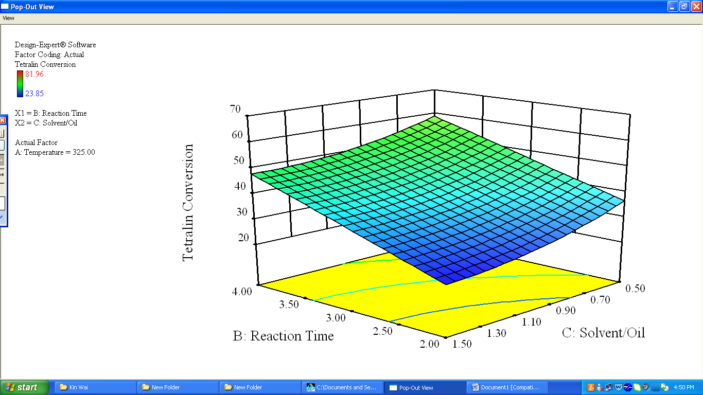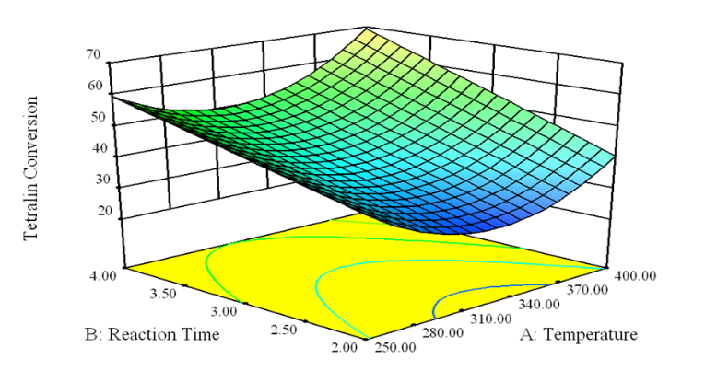

i

iii

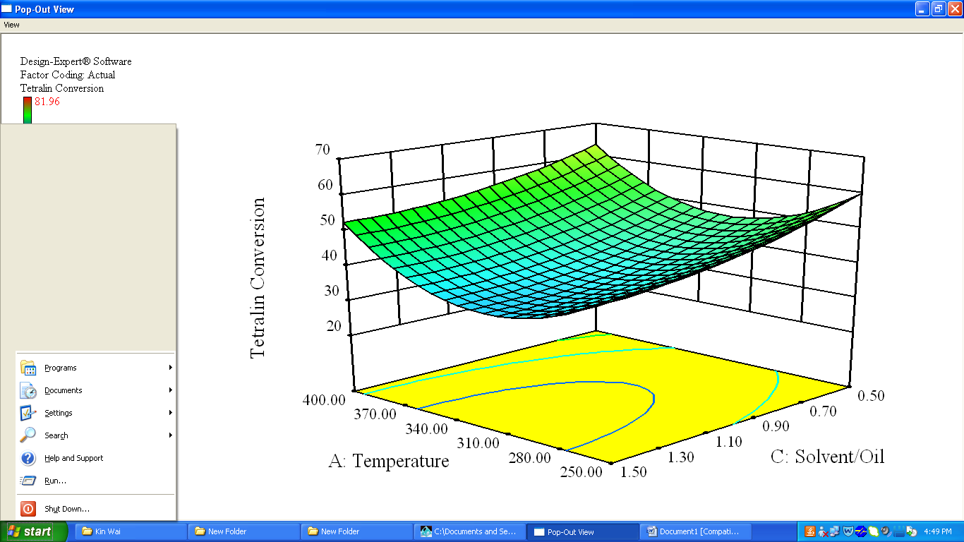

ii

X1

Temperature

X2

Reaction time

X1

Temperature

X3

Solvent to fatty acid mass ratio

X3

Solvent to fatty acid mass ratio

X2

Reaction time

1,2,3,4 – tetrahydronaphthalene Conversion

1,2,3,4 – tetrahydronaphthalene Conversion

1,2,3,4 – tetrahydronaphthalene Conversion

Figure 3. Interaction effects of (i) reaction temperature and reaction time, (ii) solvent to fatty acid mass ratio and reaction temperature, (iii) reaction time and solvent to fatty acid mass ratio on oleic acid conversion.

iii

ii

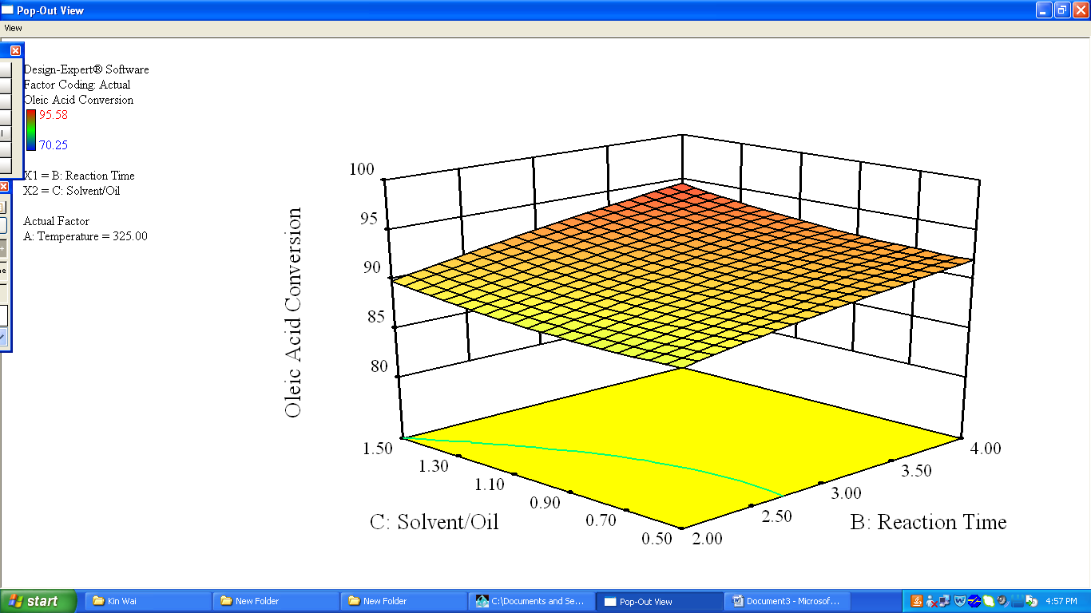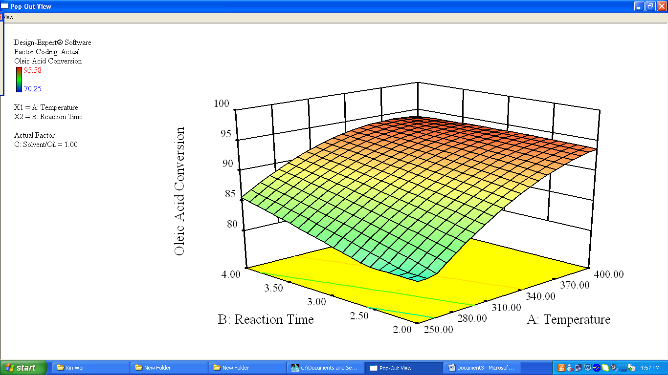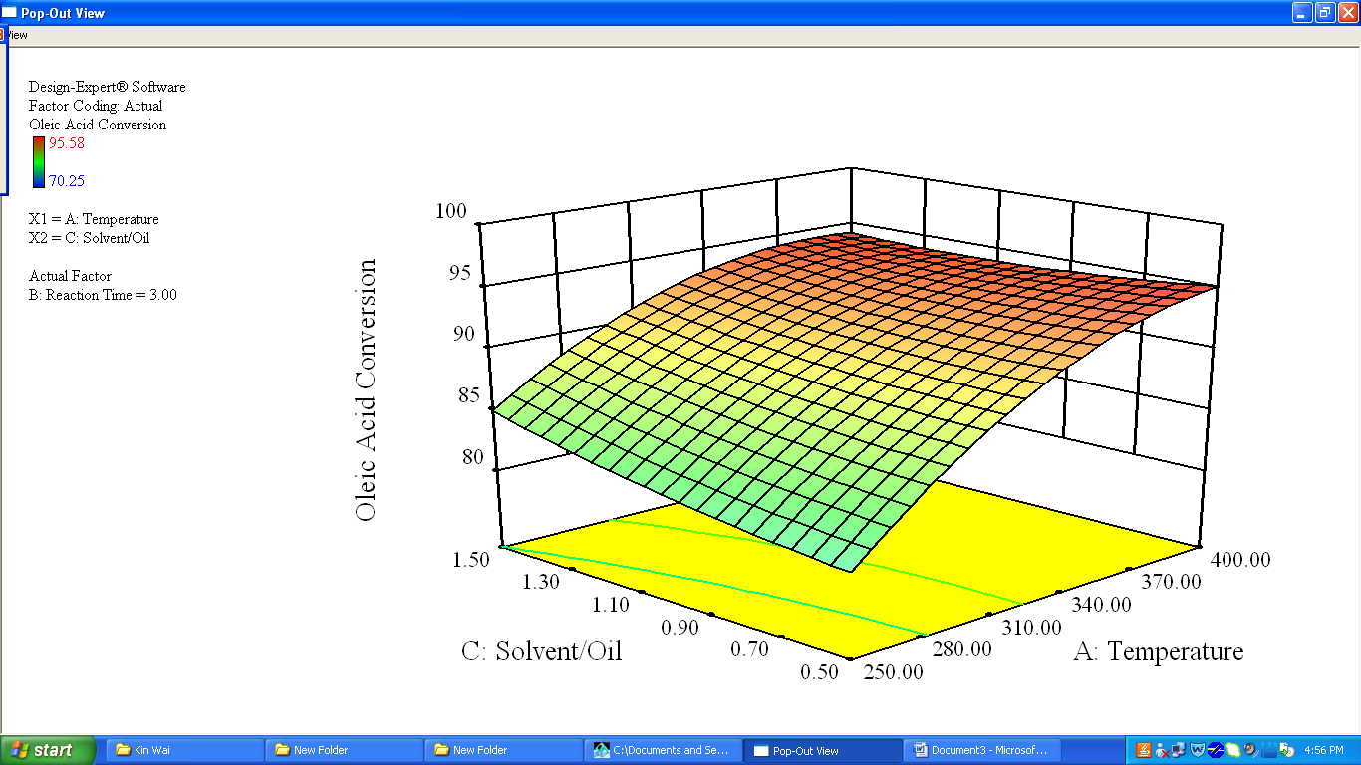

X1

Temperature

X1

Temperature

X2

Reaction time

X3

Solvent to fatty acid   
mass ratio

X2

Reaction time

X3

Solvent to fatty acid   
mass ratio

Oleic acid conversion

Oleic acid conversion

Oleic acid conversion

i

Oleic Acid Conversion

Oleic Acid Conversion

Oleic Acid Conversion

i

**iii**

**i**

Figure 4. Interaction effects of (i) reaction temperature and reaction time, (ii) solvent to fatty acid mass ratio and reaction temperature, (iii) reaction time and solvent to fatty acid mass ratio on diesel hydrocarbon (C15-C18) selectivity.

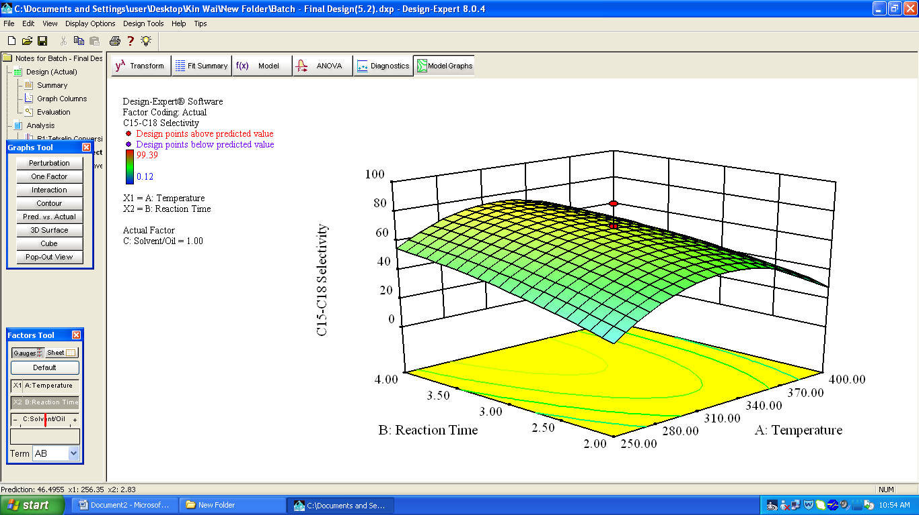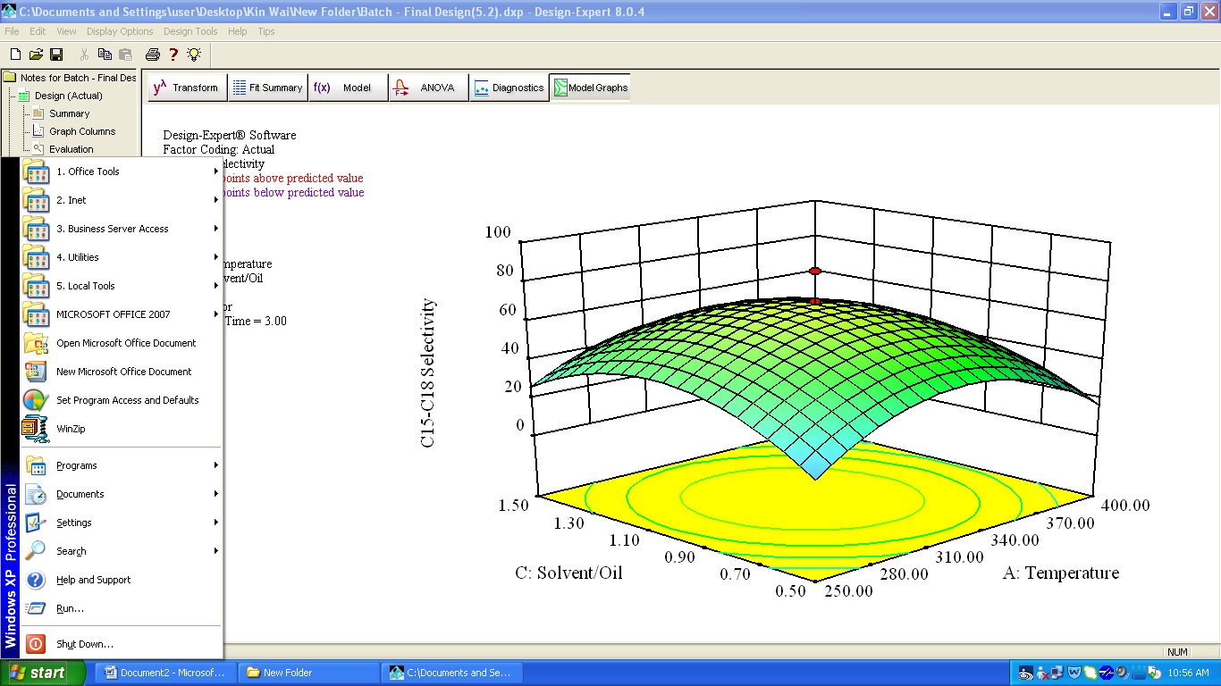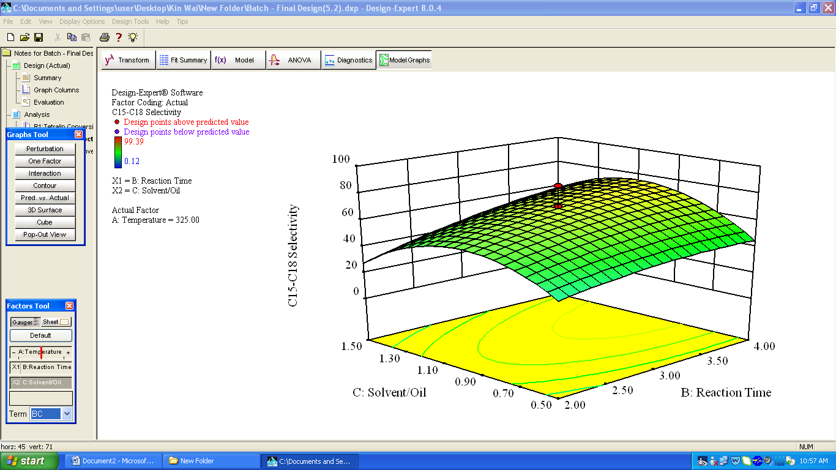

iii

i

ii

X1

Temperature

X3

Solvent to fatty acid   
mass ratio

X1

Temperature

X2

Reaction time

X3

Solvent to fatty acid   
mass ratio

X2

Reaction time

Diesel hydrocarbon selectivity

Diesel hydrocarbon selectivity

Diesel hydrocarbon selectivity