In vitro investigation into the forces involved during lipofilling
Laura J Leslie*¹, Yezen Sheena*², Duncan ET Shepherd³, Amir Ismail², Stephen N Kukureka⁴, Vik Vijh².
* Joint first authors
1 – Aston Institute of Materials Research, Aston University, Birmingham. B4 7ET. UK
2 – Department of Burns and Plastic Surgery, Queen Elizabeth Hospital, Birmingham. B15 2WB. UK.
3 – School of Mechanical Engineering, University of Birmingham, Edgbaston, Birmingham. B15 2TT. UK
4 – School of Metallurgy and Materials, University of Birmingham, Edgbaston, Birmingham. B15 2TT. UK
Corresponding author:
Dr Laura J Leslie,
Aston Institute of Materials Research,
Aston University,
Birmingham,
B4 7ET,
UK.
Email: l.j.leslie@aston.ac.uk
Keywords: Lipofilling, Mechanical Properties, Tactile, Biomedical Devices, Implants/Prosthetics

Abstract
Breast augmentation using implants is the most common aesthetic and reconstructive breast surgical procedure. Complications such as implant rupture maybe related to surgical technique and damage to the implant. Autologous fat transfer (lipofilling) using metallic cannulae has become a standard adjunctive, yet there is little evidence on lipofilling safety in the presence of implants. The aims of this study are to verify the effects of different cannulae and to quantify the forces applied by surgeons during lipofilling.
Silicone gel-filled textured implants (200 mL), mounted in a specially constructed mould were ruptured with two different cannulae: type A (hole at tip: sharp), and type B (hole away from tip: blunt), driven at three speeds (10, 100, and 1000 mm/min), and the force at rupture was recorded. Additionally, the maximum 10 forces over a 30 second period applied by 11 plastic surgeons against a breast implant in an in vitro environment were recorded using a load cell attached to a type A cannula. Statistical analysis of comparative results was performed using t-tests with p<0.05 considered significant.
Results showed that the implant ruptured at forces up to 25% lower when cannula A was used compared to cannula B. This supports current technique in lipofilling in the use of a blunt tipped cannula. There was a significant difference between some displacement rates only, due to the viscoelastic nature of the material. The tactile force that surgeons use during lipofilling was modelled in vitro and showed a range of maximum forces between 0.23 and 16.8 N, with a mean maximum value of 6.9 N.
Limitations of this study are that it may not reflect in vivo behaviour of breast implants. More studies are needed to confirm the safety of breast lipofilling in the presence of implants using these data as a starting point.

Introduction
Silicone breast implants have become a well-established method for cosmetic breast augmentation and reconstruction. The procedure has increased in popularity with 11,123 procedures performed in the UK in 2013 (up 13% on the previous year) (1).
Lipofilling (lipo-remodelling or autologous fat transfer) is the process of transferring fat harvested by liposuction from one body site and injected as a graft to augment another site with a deficit, and has guidelines published on both surgical procedure and training (2). It was first described nearly 30 years ago (3, 4), and popularised in the 1990s by Sydney Coleman (5). Lipofilling is an increasingly common adjunct to aesthetic and reconstructive breast surgery. It can be performed in order to fill residual breast contour defects, improve the skin envelope (especially post radiotherapy), to give added cover over a visible or rippling breast implant, or even for total breast reconstruction (6, 7).
Recent scientific reviews of the evidence have been reassuring regarding the safety of fat transfer to the breast (8). Coleman and Saboeiro (9) and others criticised the out of date 1987 American Society of Plastic Surgeons (ASPS, Arlington Heights, IL, USA, http://www.plasticsurgery.org/) position paper advising against fat grafting to the breast to avoid compromising cancer detection. The ASPS updated their guiding principles giving a more favourable and evidence-based opinion on this in 2012 (10). Although long-term safety data are still lacking, the current evidence is reassuring (11, 12).
However, in breasts with an implant in situ, there is some concern over the risk of damaging the implant with the lipofilling cannulae and potentially rupturing the implant. Guidelines recommend the use of a blunt tipped cannula (2) during the lipofilling process, however this is at the surgeons discretion.
Silicone breast implant durability, changes in mechanical and chemical properties of their shells and fillings over time, and mechanisms for failure have been studied by numerous authors with differing opinions (13-21). The properties, both mechanical and chemical, can vary between different implants, even those from the same supplier (13). The recent reports on the recall of PIP (Poly Implant Prosthèse, La Seyne-sur-Mer, France) implants highlights the importance of understanding the safety and durability of breast implants. PIP implants were reported by the UK National Health Service to have a higher rupture rate with respect to time than other implants, making them substandard and potentially requiring removal (22).
The testing of both breast implant materials and of the finished implants is vital to enhance the understanding and use of implants.
The aim of this study was to assess the effect of different cannulae used during lipofilling and to increase understanding of the forces which breast implants come into contact with during lipofilling.

Materials and methods

Implants & cannulae
200 mL standard textured silicone-filled shell breast implants (GFX200) were supplied by Nagor (Nagor Ltd, Glasgow, UK). These implants did not pass the final stage of quality control (human visual inspection) for human implantation, however, for mechanical testing, they were sufficiently representative.
Two types of fat-injection cannulae suitable for lipofilling were supplied by Cloverleaf Medical (Chalfont St Giles, Buckinghamshire, UK), both with an external diameter of 2 mm. Cannula A has a smaller surface area at the tip than Cannula B due to the location of the outlet port. This makes the contact area with the implant smaller and the tip ‘sharper’ (Figure 1).

Cannula Rupture Experiments
In order to compare the rupture force of the two different types of cannulae, a number of experiments were performed using a Hounsfield HK Tensometer with a 50 N load cell (Tinius Olsen Ltd., Salfords, Surrey, UK).
The silicone breast implants were mounted within a wooden mould that was tightened around the implant, leaving a section on the top and the bottom of the implant open to allow access for the cannulae. This allowed a small force which is spread across the main body of the implant to be applied to the implant. A small area is exposed, and due to the force applied across the un-exposed surfaces, this area has a limited deformation and movement, when the force of the cannula is applied. A small hole is also present in the base of the mould. This allows the cannula to travel through the implant, preventing the cannula from making contact with a hard base, whereby the force would be a measure of the compression of the shell against that base. The aim was to provide a practical method of testing, and to partially simulate the encapsulation which naturally occurs in the body.
The numbers recorded in this experiment are relative only to the experiment in which they are performed, and are not a direct comparison to the in vivo scenario where there are many other variables. However, they do provide a platform on which to introduce variables such as displacement speed and cannula type in order to perform comparisons.
Each cannula was attached to the crosshead of the tensometer in a vertical position (Figure 2). The crosshead was then moved downwards at the speed required, causing it to make contact with the exposed section of the silicone breast implant. The cannula continued moving downwards compressing the implant until implant rupture. The crosshead was then stopped and the maximum force required to cause rupture was recorded.
Each breast implant was tested between three and five times in different positions on the shell. Penetration points were not close enough together to cause degradation in strength at the point of contact.
Silicone rubber has been shown to exhibit viscoelastic behaviour (23) and as such can be sensitive to different loading rates. In order to determine the effect of test speed on these silicone breast implants, three test displacement rates of 10, 100 and 1000 mm/min were used.

Tactile force of surgeons
The forces surgeons use during lipofilling procedures were simulated, in order to investigate the tactile feedback force at which surgeons withdraw the cannula from the patient and therefore, the maximum force the implant is likely to be exposed to. A breast implant was covered with a substitute skin (Professional Skin Pad Mk 2 – Light, Limbs & Things LTD, Bristol, UK) and secured to a wooden board (Figure 3). The skin substitute is comprised of three layers with a dermis, epidermis and fat layer. A small incision was made using a scalpel at the approximate position which would be made for a lipofilling procedure, thereby allowing access to the area immediately around the implant for injection of fat.
A cannula (type B) was connected to a small plastic handle with a 5 kg load cell (Phidgets, Calgary, Canada) being positioned between the two. The load cell was wired via an amplifier to a DAQ (National Instruments Corporation UK Ltd., Newbury, Berkshire, UK) and into the PC where National Instrument software (National Instruments Corporation UK Ltd., Newbury, Berkshire, UK) was used to convert voltage to Newtons (Figure 4). The equipment was calibrated in the laboratory using known masses prior to testing.
Each surgeon was requested to push the cannula through the incision in the model and perform the motion with the cannula as would be done during lipofilling. The surgeons would push forwards with the cannula and draw back at the point of resistance at which they would withdraw from during the process of lipofilling, i.e. the point at which they would feel they had made contact with the implant in the body.
Eleven plastic surgeons, all of whom perform lipofilling on patients, were asked to complete this test. The software was programmed to show the maximum force applied by the surgeon every three seconds. Ten of these maximum forces were measured during each test using the set-up, with each experiment lasting just over thirty seconds. The mean values were calculated for each surgeon, and then the means for all surgeons were calculated. By measuring the maximum force every three seconds, a range of maximum possible applied forces could be recorded and analysed.

Statistical analysis
A Student’s t-test was conducted between relevant sets of results to test the hypothesis of the difference between data sets as being statistically significant. Sample sets were considered as two tailed (i.e. no predefined results direction) and as unpaired with equal variances. Results were considered significant if p < 0.05. The comparison data sets are shown in Table 1.

Results
This study aimed to assess the difference in rupture potential between two different types of cannulae and also to investigate the forces used by surgeons in the process of lipofilling about breast implants.

Cannula Rupture
The mean forces required to rupture the implants at each displacement rate are shown in Figure 5 and the full set of results including statistical significance can be seen in Table 1.
There was a statistically significant difference between the rupture values for cannula A versus cannula B. The mean force to rupture with a standard A type cannula with the outlet port at the tip was 21.4% lower than with a standard B type cannula at displacement speeds of 1000 mm/min. And at 100 mm/min and 10 mm/min, the difference was 17.8% and 24.9% respectively.
For both cannulae A and B, no significant difference was found between the forces at the displacement rates of 1000 mm/min and 100 mm/min. However, there was a significant difference between the forces at displacement rates 1000 mm/min and 10 mm/min for both cannula types. Between speeds of 100 mm/min and 10 mm/min, cannula A showed a difference between the mean recorded forces, whereas cannula B did not (p = 0.0554).

Tactile Force of Surgeons
The maximum force applied by the surgeon from the cannula to the implant was recorded every three seconds during an in vitro test. These values were averaged to obtain the mean value for each surgeon and averaged across all surgeons also. The results show a wide range of mean forces from different surgeons (1.4 to 14.5 N), with an even greater range of individual maximum forces (0.23 to 16.8 N). The mean maximum tactile force plastic surgeons were measured as using was 6.9 N (standard deviation of 3.9 N).

Conclusion
We are not aware of any previous studies to compare our results with, but feel in an era rightly focussed on patient safety first, that there is a need for further studies on this area. In the context that the combination of artificial breast implantation and lipofilling is now commonplace, it would seem appropriate that implant manufacturers consider developing a standard testing protocol for the safety of lipofilling around an implant.
There are significant limitations of our current study. Firstly this in vitro study to analyse the different cannulae was performed on new implants before human implantation and the biomechanical interactions and potential for implant physical property changes, specifically strength degradation with time, could not be assessed. Secondly and related, it is known that implants form a surrounding capsule in vivo and this was not fully modelled in this study and therefore conclusions on the safety of lipofilling at a secondary procedure become harder to interpret. Thirdly, the testing has been performed on one type of breast implant and two lipofilling cannulae. There is a range of implants and cannulae in common practice and any generalisability of our findings is thus limited. Finally we have only tested our implants under one set of controlled conditions. There are many variables to consider and in this way, we have eliminated all those variables save those we wished to change. However, the numbers generated from these tests are comparable only to those tests run under identical conditions and cannot be compared further.
The measurement of tactile force from lipofilling also has limitations. The ethical implication of measuring surgeons during actual surgery is of concern; the knowledge of measurement may alter technique, consciously or subconsciously. For this reason, an in vitro model was developed, alleviating the ethical implications, and providing repeatable and measureable experiment. However, this is not the same as the in vivo scenario and so the limitation must be accepted.
The conclusions drawn from this study are:
- The technique used by surgeons in the procedure of lipofilling around breast implants can result in a wide range of forces
- Cannulae with end positioned outlet holes (type A) can rupture implants with significantly less force than cannulae with outlet holes positioned away from the end (type B) at various displacement rates
- The viscoelastic nature of silicone materials results in a significant difference between the force required to rupture implants at very low compared with very high displacement rates
Silicone breast implants are already rigorously tested and analysed, however with new techniques and equipment being constantly developed and updated, more analysis as to the effects of these techniques needs to be undertaken. As yet there is no standard method for testing lipofilling effects on silicone breast implants (aged and unaged), which could be advantageous to be developed.

Acknowledgements
The authors would like to thank Mr James Duggins for technical assistance and Mr Tarnveer Bhamra for assistance in the experimental phase. We also kindly acknowledge Cloverleaf Medical for supplying the cannulae and Nagor Ltd for supplying the breast implants for this study.

References
1. BAAPS. Britain Sucks The British Association of Aesthetic Plastic Surgeons: The British Association of Aesthetic Plastic Surgeons; 2014 [Available from: http://baaps.org.uk/about-us/press-releases/1833-britain-sucks.
2. Lipomodelling Guidelines for Breast Surgery. Association of Breast Surgery, British Association of Plastic, Reconstructive and Aesthetic Surgeons, British Association of Aesthetic Plastic Surgeons; 2012.
3. Illouz YG. The fat cell "graft": a new technique to fill depressions. Plast Reconstr Surg. 1986;78(1):122-3.
4. Bircoll M. Cosmetic breast augmentation utilizing autologous fat and liposuction techniques. Plast Reconstr Surg. 1987;79(2):267-71.
5. Coleman WP, 3rd. Autologous fat transplantation. Plast Reconstr Surg. 1991;88(4):736.
6. Rigotti G, Marchi A, Galie M, Baroni G, Benati D, Krampera M, et al. Clinical treatment of radiotherapy tissue damage by lipoaspirate transplant: a healing process mediated by adipose-derived adult stem cells. Plast Reconstr Surg. 2007;119(5):1409-22; discussion 23-4.
7. Delay E, Garson S, Tousson G, Sinna R. Fat injection to the breast: technique, results, and indications based on 880 procedures over 10 years. Aesthetic surgery journal / the American Society for Aesthetic Plastic surgery. 2009;29(5):360-76.
8. Chan CW, McCulley SJ, Macmillan RD. Autologous fat transfer--a review of the literature with a focus on breast cancer surgery. Journal of plastic, reconstructive & aesthetic surgery : JPRAS. 2008;61(12):1438-48.
9. Coleman SR, Saboeiro AP. Fat grafting to the breast revisited: safety and efficacy. Plast Reconstr Surg. 2007;119(3):775-85; discussion 86-7.
10. ASPS. 2012 Post-Mastectomy Fat Graft/Fat Transfer ASPS Guiding Principles. American Society of Plastic Surgeons; 2012.
11. Largo RD, Tchang LA, Mele V, Scherberich A, Harder Y, Wettstein R, et al. Efficacy, safety and complications of autologous fat grafting to healthy breast tissue: A systematic review. Journal of plastic, reconstructive & aesthetic surgery : JPRAS. 2013;67(4):437-48.
12. Missana MC, Laurent I, Barreau L, Balleyguier C. Autologous fat transfer in reconstructive breast surgery: Indications, technique and results. European Journal of Surgical Oncology (EJSO). 2007;33(6):685-90.
13. Brandon HJ, Young VL, Jerina KL, Wolf CJ. Variability in the properties of silicone gel breast implants. Plast Reconstr Surg. 2001;108(3):647-55.
14. Marotta JS, Goldberg EP, Habal MB, Amery DP, Martin PJ, Urbaniak DJ, et al. Silicone Gel Breast Implant Failure: Evaluation of Properties of Shells and Gels for Explanted Prostheses and Meta-analysis of Literature Rupture Data. Annals of Plastic Surgery. 2002;49(3):227-47.
15. Marotta JS, Widenhouse CW, Habal MB, Goldberg EP. Silicone gel breast implant failure and frequency of additional surgeries: Analysis of 35 studies reporting examination of more than 8000 explants. Journal of Biomedical Materials Research. 1999;48(3):354-64.
16. Phillips JW, de Camara DL, Lockwood MD, Grebner WCC. Strength of Silicone Breast Implants. Plastic and Reconstructive Surgery. 1996;97(6):1215-25.
17. Adams WP, Jr., Robinson JB, Jr., Rohrich RJ. Lipid infiltration as a possible biologic cause of silicone gel breast implant aging. Plast Reconstr Surg. 1998;101(1):64-8; discussion 9-71.
18. Brandon HJ, Jerina KL, Wolf CJ, Young VL. In vivo aging characteristics of silicone gel breast implants compared to lot-matched controls. Plast Reconstr Surg. 2002;109(6):1927-33.
19. Brandon HJ, Jerina KL, Wolf CJ, Young VL. Biodurability of Retrieved Silicone Gel Breast Implants. Plastic and Reconstructive Surgery. 2003;111(7):2295-306.
20. Greenwald DP, Randolph M, May JW. Mechanical analysis of explanted silicone breast implants. Plastic and reconstructive surgery. 1996;98(2):269-72; discussion 73-5.
21. Necchi S, Molina D, Turri S, Rossetto F, Rietjens M, Pennati G. Failure of silicone gel breast implants: Is the mechanical weakening due to shell swelling a significant cause of prostheses rupture? Journal of the mechanical behavior of biomedical materials. 2011;4(8):2002-8.
22. Keogh B. POLY IMPLANT PROSTHESE (PIP) BREAST IMPLANTS: FINAL REPORT OF THE EXPERT GROUP. Department of Health, NHS Medical Directorate; 2012.
23. Mahomed A, Chidi NM, Hukins DWL, Kukureka SN, Shepherd DET. Frequency dependence of viscoelastic properties of medical grade silicones. Journal of Biomedical Materials Research Part B: Applied Biomaterials. 2009;89B(1):210-6.

Tables

Table 1 Statistical analysis results with t-test p values to 4 decimal places and the statistical significance between data sets
Data set 1 | Data set 2 | p-value
Rupture A (all) | Rupture B (all) | 0.0000 (significantly different)
Rupture A (10 mm/min) | Rupture A (100 mm/min) | 0.0087 (significantly different)
Rupture A (10 mm/min) | Rupture A (1000 mm/min) | 0.0002 (significantly different)
Rupture A (100 mm/min) | Rupture A (1000 mm/min) | 0.9399 (no significant difference)
Rupture B (10 mm/min) | Rupture B (100 mm/min) | 0.0554 (no significant difference)
Rupture B (10 mm/min) | Rupture B (1000 mm/min) | 0.0025 (significantly different)
Rupture B (100 mm/min) | Rupture B (1000 mm/min) | 0.4032 (no significant difference)

Figure Legends
Figure 1 Close up of the cannula tips: A (top left) and B (bottom right)
Figure 2 Schematic of the experimental set-up showing the cannula and implant position prior to test (not to scale)
Figure 3 The in vitro testing model with breast implant secured on the board and covered with the skin substitute. The model was secured using adhesive tape in order to prevent it moving off the board.
Figure 4 Equipment for in vitro force measurement. The cannula was attached to a cutom made handle which incorporated the load cell.
Figure 5 The mean rupture force for each cannula at each displacement rate (error bars show ± 1 standard deviation)

Figures
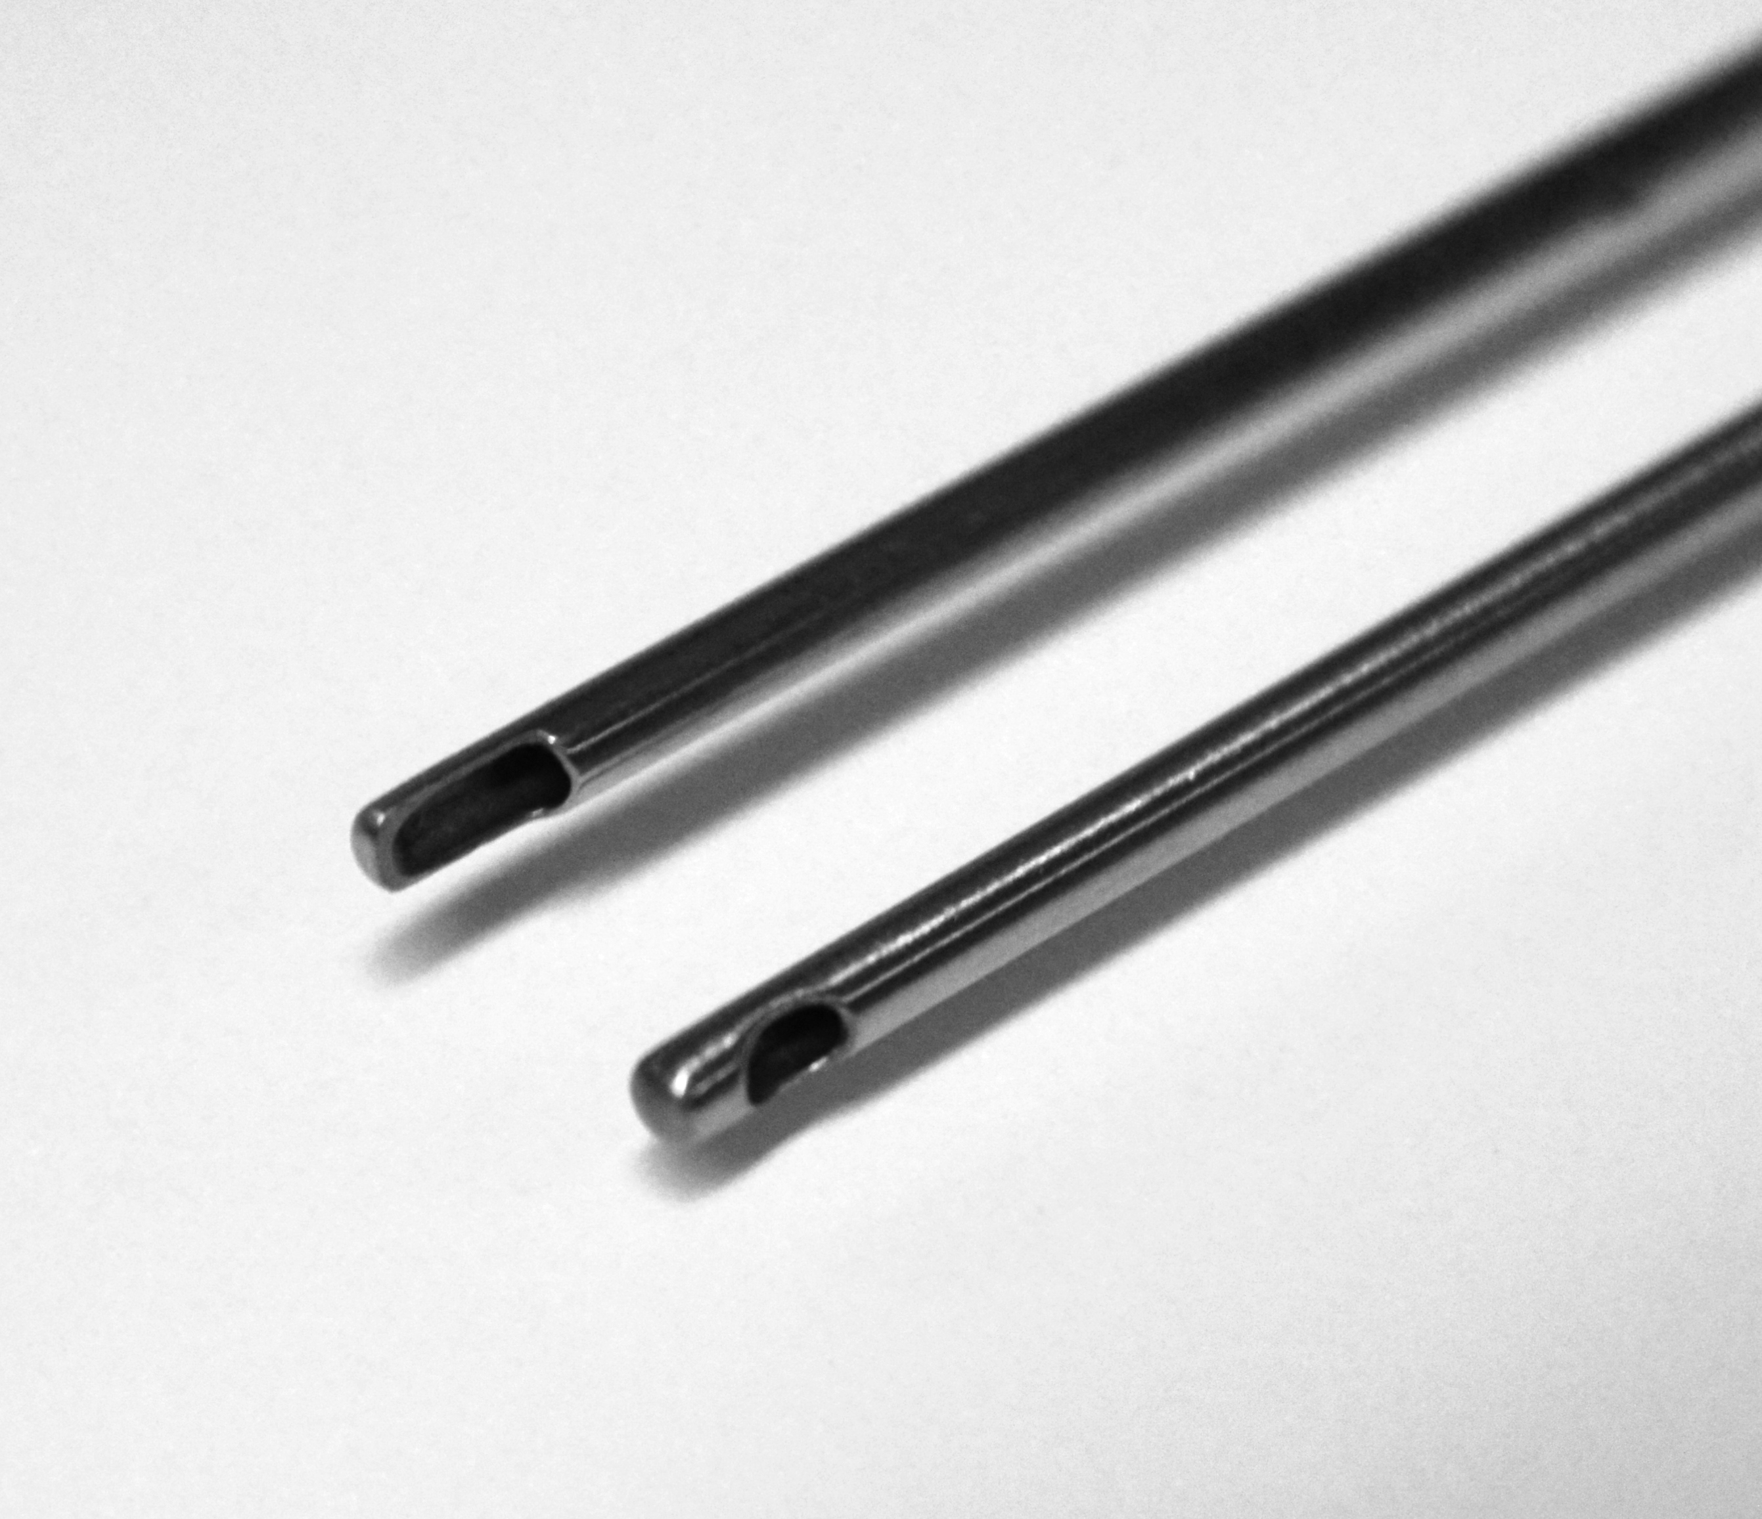
FIGURE 1

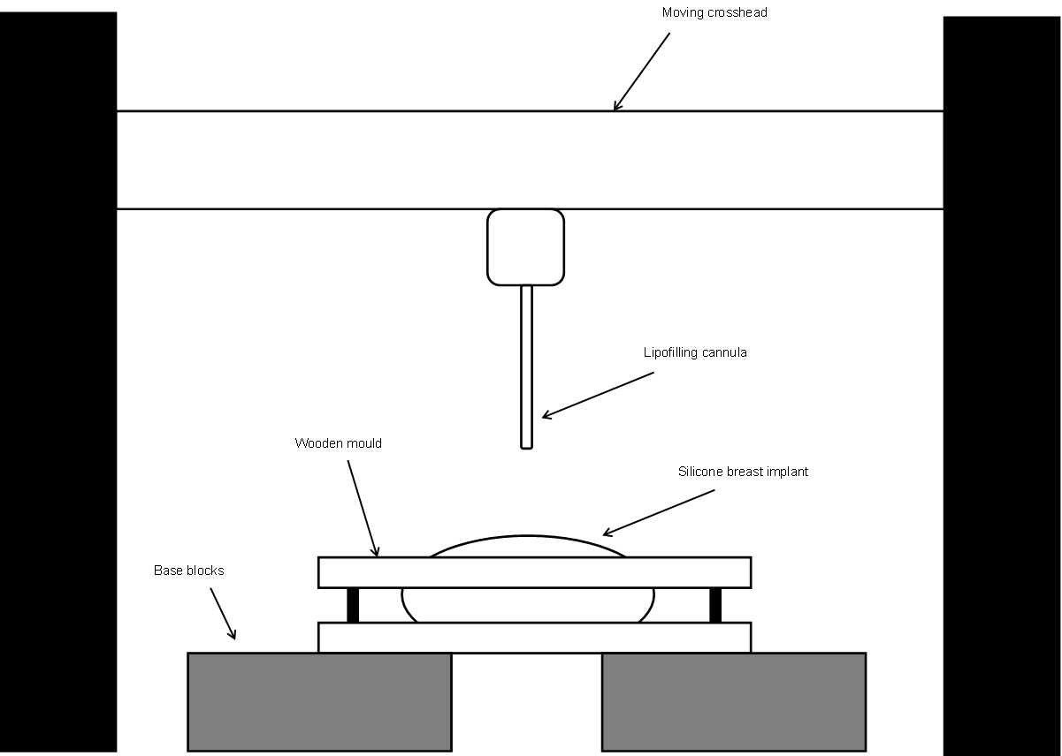
FIGURE 2

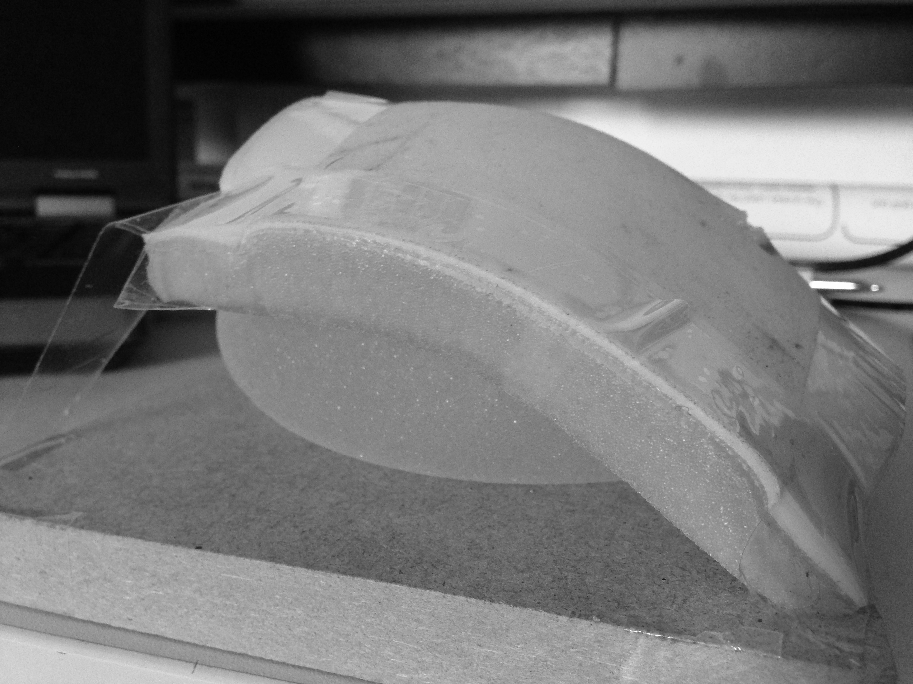
FIGURE 3

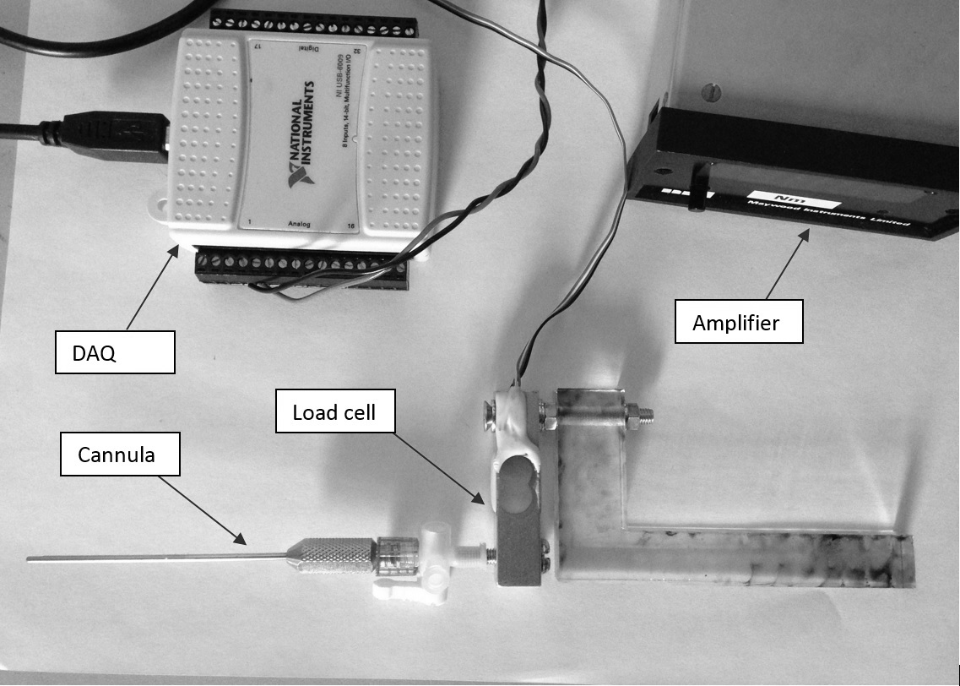
FIGURE 4

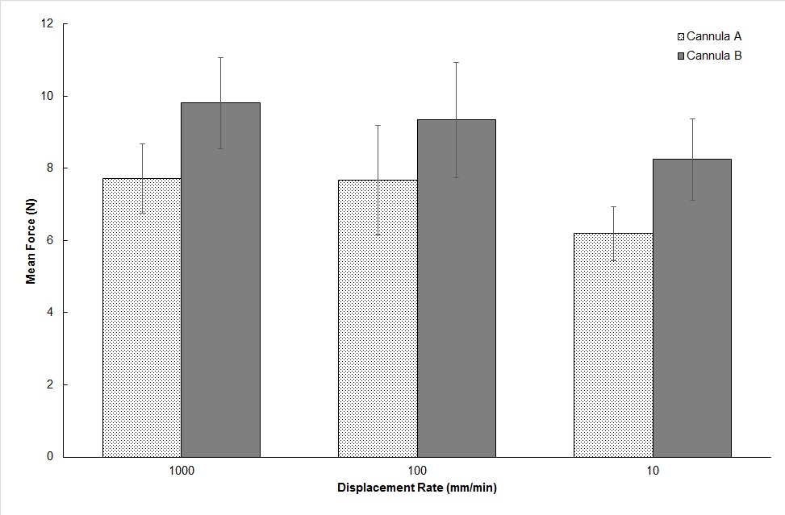
FIGURE 5

